NORTHWESTERN UNIVERSITY

Development of a New Scalable Projection Micro-Stereolithography System towards Direct Digital Manufacturing of Functional Devices

A DISSERTATION

SUBMITTED TO THE GRADUATE SCHOOL

IN PARTIAL FULFILLMENT OF THE REQUIREMENTS

for the degree

DOCTOR OF PHILOSOPHY

Field of Mechanical Engineering

by

Evan Baker

EVANSTON, ILLINOIS

December 2015

ABSTRACT

Direct 3D Printing of Functional Biomedical Devices and the Development of High-Speed Additive Manufacturing.

Evan Baker

Additive Manufacturing (AM) is ushering in a revolutionary change of worldwide manufacturing techniques. Initially cost prohibitive, additively manufactured parts have declined in cost significantly over the past decade. Key innovations have reduced machine cost, increased machining speed, and eased the design process of new parts. A revolutionary new printing technology is just around the corner with [Carbon3D](http://carbon3d.com/)’s continuous liquid interface production (CLIP) based technology which is able to increase part manufacturing speed by 50-100 times and will enable another dramatic price reduction in part cost. While additive manufacturing has shown promising potential, additive manufacturing is just beginning to have a significant impact on the types of parts designed and manufactured for industries worldwide. In industry, companies are beginning produce functional parts using additive manufacturing. Examples include [3DME](http://cubify.com/store/_3dme) that produces action figure replicas of customers on-demand, [Envisiontec](http://envisiontec.com/) that produces the printers responsible for mass producing hearing aids, and dental implants and even custom jewelry for hundreds of thousands of customers around the globe. In addition to polymer based prints, a number of companies have been using additive manufacturing technologies for metal parts, such as [Conformis Inc](http://www.conformis.com/). that produces total customized knee implants for knee replacement surgery, and Boeing, Lockheed Martin and SpaceX that are using selective laser sintering (SLS) technologies to produce low weight parts for their airplanes and rockets that are impossible to manufacture with traditional subtractive techniques.

The major focus of this work are new polymer-based materials, devices and the development of a new CLIP based high-throughput projection microstereolithography system. One of the main reason that our work focuses on projection microstereolithography are because our team believes this technology is uniquely qualified to solve some of the main inherent problems with AM parts. The main problem with existing AM parts are the slow build times, inconsistent mechanical properties when compared with injection molded parts, and cost. CLIP based projection microstereolithography provides a solution to each of those key issues and further details are presented later in the report.

In addition to the previously mentioned manufacturing benefits, AM on projection microstereolithography enables design customization and fabrication of parts with a large variety of material properties, enabling functional micro-devices. The first study of this thesis is in the field of vibration energy harvesting where kinetic energy in the environment is converted into electricity to power actuators, sensors or recharge batteries.

In this work I explore the capabilities of existing PuSL (Projection Micro-Stereolithography) additive manufacturing technologies. I start with the design of functional mechanical parts including springs and mechanical resonators. I continue on and work with Tim Reissman to test those parts’ mechanical properties and explore how changes in the photo-curing process can impact the mechanical parts. After attaining a better understanding of the mechanical properties of the materials, I began work with Katherine Rorscharch, Jaidong Deng and Prof. Wei Chen to develop a topology optimization model and design an ‘optimal’ resonator for low frequency vibration energy harvesting, one possible application for additive manufacturing that we’ve explored.

After designing an optimal low-frequency resonator we decided to move onto developing new types of functional materials for our existing 3D printer. The reason we are interested in developing new functional materials is to broaden the types of micro-devices able to be manufactured using the PuSL process. Specifically, our lab developed two new multi-functional materials including a bio-compatible, bio-degradable material to be used for drug delivery and a second piezoelectric material that can be used for designing functional 3D printable piezoelectric devices such as vibration energy harvesters, vibrating notification systems, and actuators for micro-designed 3D printed parts.

The culmination of this thesis is the design and assembly of a new 3D printer based on continuous liquid interface production (CLIP) technologies for the rapid prototyping lab here at Northwestern University. This printer is to be based on projection-stereolithography fabrication techniques and will be the most capable machine designed by our lab to-date. The CLIP PuSL 3D Printer, has the potential to print 50-100 times faster than our existing machine. The faster print time is enabled by an increased UV lamp power intensity from the previous maximum of 1.4 W to a new maximum of 50W. Also, the inverted platform fabrication technique through an oxygen permeable membrane allows a total elimination of the 30 second ‘dwell’ time per layer. The printer has a fabrication area that is over 100 times larger, increasing from a 0.75cm by 1cm fabrication area to a 10cm x 10cm square fabrication area. The CLIP PuSL 3D Printer will be compatible with multiple multi-functional materials including piezoelectric and bio-compatible materials, capable of being printed at extraordinarily high resolutions. The range of possible resolutions for the new printer are limited by the possible positions for the optics. The printer is designed in such a way that the central UV focusing lens can be moved over a 5cm distance to change the focusing resolution between 0.7x and 1.3x the 10um mirror size. Even higher resolution is possible with the 10nm stepping x-y resolution of the stepping platform. With these enhanced features, the new projection system will enable Northwestern University students to design and fabricate higher resolution and more complicated devices than are currently possible with any of the school’s existing rapid prototyping machines. The CLIP PuSL 3D Printer will also be built on an easy to understand, open-source platform to enable further improvement by future Northwestern graduate students well into the future.

**Keywords:** Additive Manufacturing, Continuous Liquid Interface Production, CLIP, PuSL, uSL, Rapid Prototyping, Projection Micro Stereolithography, electromagnetic, piezoelectric, vibration energy harvesting, kinetic energy harvesting, topology optimization, biocompatible materials, bio-resorbable materials

**Acknowledgments:**

First I would like to thank my family for encouraging me and supporting me through the long process of attaining my PhD. Jen, you put in many hours and late nights to edit my papers and talk through ideas and research, and made many sacrifices to make sure that our lives were running smoothly even in the most stressful periods of study at Northwestern. I am so grateful. My parents were my research inspiration from a young age, and having an engineer and virologist in house for free consulting proved invaluable while growing up and as I completed this project. Thank you to my mom and dad, Michael and Susan, for your guidance and support. To my father-in-law, Pete, thank you for your support and friendship in the past decade and for sharing your mechanical expertise teaching me how to fix and manufacture anything I could ever dream of. You gave me hands-on skills that I never could have gained anywhere else and you are always a sounding board for my ideas and projects. Thank you to my sister and sister-in-law, Katherine and Kim, for visiting Northwestern and spending many dinners listening to talk about my research. To my grandparents, Howard, Sue, Ruth, and Lou, I am lucky to have all four of you in my life as mentors and examples of hard work, thank you for encouraging me in my academic career and for never missing a graduation. I could not have asked for a better support system at home as I completed this project.

I would also like to thank all of the graduate students and professors that helped make this research possible including my PI Professor Dr. Cheng Sun, and my co-advisors Dr. Wei Chen and Dr. Guillermo Ameer.  Dr. Sun, thank you for taking me on as an intern and having faith in my abilities to succeed as a PhD student here at Northwestern. Thank you for working so hard to secure funding for all your students’ projects, for taking into consideration my personal goals when assigning projects, giving me the opportunity to manage a team of summer interns each year, and for your constant feedback and guidance with each step I took throughout this program. I graduate with more knowledge of our field and industry and practical skills than I could have every imagined and I thank you for that. Thanks to Dr. Wing Liu for attending countless weekly meetings and helping to advance my research with thoughtful advice and mentorship.

As I found passions outside the lab and connected my research to real-world problems and entrepreneurial ventures, I thank Dr. Chris Malaisrie, a cardio-thorasic surgeon who I worked with in NUVention Medical. Thank you for taking time out of your incredibly busy schedule to mentor me and letting me join surgeries with you. Our relationship is one I know I’ll value for a long time. Thank you to Dr. Scott Resinick, a vascular surgeon at Northwestern Medical Hospital, for giving us advice on how to sheath stents and providing us with stent samples. I greatly appreciate you taking the time to personally show me how stents are delivered. Dr. Robert Van Lith, thank you for believing in the stent project and working so hard with us to synthesize the material and run mechanical biodegradability and biocompatibility testing. Your expertise has strengthened the narrative of this project to optimize its impact and I can’t wait to see the final publication. Dr. Jian Yang, thanks for taking the lead on the patent work for what turned out to be one of the most fascinating parts of my NU career.

Thank you to Dr. Wei Chen’s graduate students Katherine Rorschach and Jiandong Deng for helping to solve the topology optimization problem. Also, thank you to Ying Li from Dr. Wing Liu’s lab for his theory involving the bandgap vibration energy harvester design.  I would like to thank Dr. Fan Zhou for his patience with me as he taught me everything he knew about the projection micro-stereolithography fabrication process, and for helping me rise in the ranks from intern to graduate student. Fan, Chen Wang, Zhen Zhang, Biqin Dong and Xiangfan Chen were the best crew to work with each day and I am so grateful for their friendship. Thank you to Dr. Tim Reissman for working so closely with me the first two years at Northwestern University on vibration energy harvesting. With his 5+ years of experience in the field he was able to get me up to speed on state of the art performance requirements of vibration energy harvesting designs and point out many of the best works in the literature. This was invaluable for completing this research and project in a timely manner. A final thank you to our lab’s most recent addition Henry Ware – I am astounded at what you’ve accomplished so far in working on our printer design and stent design, simulations, and printing. I know you have great things ahead and it’s been an honor to work alongside you my final year.

In addition to all of these great professors, doctors, graduate students and post-docs I would like to send a shout out to all of the fantastic interns I had the opportunity to manage throughout this PhD journey.  First of all, thanks to my first intern Beau Becker for helping with the RF sensing project. I’ll always remember your enthusiasm and our work picking out the network analyzer.  Thanks also to Noah Shaw, who helped greatly to obtain our first conference publication in the RF sensing field. Jahan Alam for helping to design the diatom light trapping experiment and for learning how to keep those buggers alive.  Steven Schleibaum for your mastery of Solid-Works including designs of Wave Springs and Halbach Arrays and changing the dimensions of the helical springs whenever needed.  Brian Sorich for your hours spent in the machine shop designing and building the test stand used in the vibration energy harvesting project and the PuSL plexi-glass chamber. Both of those additions have been invaluable and are part of the final design.  Thanks also, Brian, for the collection of the Slam Stick vibration data and for traveling around Evanston to find the best sources.  In Brian’s second summer with us, he learned PuSL fabrication and assisted in the manufacture of the topology-optimized designs. Brian also took the UV measurements of the PuSL system and oxygen sensor, and collected data involving the curing depth of our PuSL system. Last but not least, thanks to Robert Mills for your work on the RF sensing project -- your initiative was fantastic and you were always able to figure out the next step with only minor guidance required.  Great job figuring out the PVDF coating for the ring resonators and the new antenna setup, and learning SolidWorks to design parts for the RF and vibration experiments.

Lastly I would like to thank my funding sources for making it possible to do this research. They include partial support from the National Science Foundation under grants CMMI-1130948, CMMI-0955195, and CMMI-0751621. Additional support comes from the Intelligence Community Postdoctoral Fellowship Program and a booster award from the Initiative for Sustainability and Energy at Northwestern (ISEN). This work made use of Central Facilities supported by the MRSERC program of the National Science Foundation (DMR-0520513) at the Northwestern University Materials Research Science and Engineering Center.

**CONTENTS**

**LIST OF FIGURES** 14

**Chapter 1: INTRODuCTION** 17

**1.1 History of Projection Micro-Stereolithography** 18

**1.2 Survey of Vibration Energy Harvesting Landscape** 18

**1.3 Topology Optimization of PuSL-VEH designs** 21

**1.4 3D Printing Metamaterials to Simultaneously Dampen and Harvest Energy** 22

**1.5 Developing a New Piezoelectric Additive Manufacturing Material for Sensors and Energy Harvesting** 23

**1.6 The Unique Role of Piezoelectric Materials** 24

**1.6 Novelty and Utility of B-ink Stent Designs** 27

**1.7 Design and Construction of a New Inverted Projection Stereo-lithography system.** 30

**chapter 2: projection micro-stereolithography system** 31

**2.1 Background** 31

**2.2 Projection Micro-Stereolithography Technique** 31

**2.2.1 Postcure Process** 33

**2.3 Optimizing the Projection Micro-Stereolithography System** 34

**2.3.1 Plexiglass Chamber & Nitrogen Flow Meter** 34

**2.3.2 Oxygen Sensor** 35

**2.3.4 UV Intensity Measurements** 35

**2.3.5 Cure Depth Analysis** 36

**2.3.6 Software to Splice CAD into bitmap and .txt run files** 37

**chapter 3 PRELIMINARY EXPERIMENTAL DEMONSTRATION: ELECTROMAGNETIC VIBRATION ENERGY HARVESTING** 43

**3.1 Background** 43

**3.2 Electromagnetic energy harvester design** 45

**3.2.1 Helical Spring Constant** 47

**3.2.2 Acceptable Load Mass** 49

**3.3 Tuning the mechanical properties with the PuSL system** 50

**3.4 VEH Experimental Characterization Setup** 50

**3.4.1 Setting up the constant acceleration loop and control theory** 52

**3.5 Results and Discussion** 53

**3.6 Conclusion** 54

**chapter 4 Experimental fabrication & testing of topology optimized designs** 56

**4.1 Background** 56

**4.2 Topology Optimized Electromagnetic Energy Harvester Design** 56

**4.2.2 Adjoint Sensitivity Calculation** 58

**4.2.3 Optimization Flow Chart** 58

**4.3 Optimization Results (Simp & Level Set Methods)** 59

**4.4 Fabrication** 59

**4.5 Testing** 60

**4.4 Conclusion** 63

**CHAPTER 5: Metamaterials for Simultaneous vibration isolation and energy harvesting** 64

**5. Material development for Piezoelectric Designs** 64

**5.1 Background** 64

**5.2 Theory** 65

**5.3 Finite Element Analysis** 66

**5.4 Experimental Design** 70

**5.5 Results and Discussion** 73

**5.7 Conclusion** 75

**CHAPTER 6: PROPOSED RESEARCH Material development of bio-compatible and piezoeletric resins & new pusl printer design.** 76

**6. Material development for Piezoelectric Designs** 76

**6.1 Background** 76

**6.2 Introduction to the need for piezoelectric materials** 77

**6.3 Piezoelectric Material Theory** 80

**6.3.1 PVDF Theory** 80

**6.3.2 Temperature vs. Polling PVDF Theory** 81

**6.3.2 Mechanical Strain vs. Polling PVDF Theory** 82

**6.4 Experimental Fabrication** 82

**6.4.1 Experimental Fabrication** 82

**6.4.2 Fabrication of V-Ink Sensors** 84

**6.5 Experimental** 84

**6.5.1 Experimental Design** 84

**6.5.2 Varying PVDF Material Concentration** 85

**6.5.3 Varying the Poling Electric Field** 86

**6.5.4 Viscosity vs. % Concentration of PVDF** 87

**6.5.5 Experimental Verification of Suspension** 88

**6.5.6 Experimental Demonstration of High Resolution: St. Basil’s Cathedral** 91

**6.6 Recommended Next Steps in Piezoelectric Material Development** 92

**6.7 Summary of New Piezoelectric 3D Printable Polymer Results** 93

**CHAPTER 7: Material development of bio-compatible resins & STENT DEVICES** 93

**7.1 Novelty and Utility of B-ink Stent Designs** 93

**7.2 Background** 94

**7.3 Methods** 96

**7.3.1 Polymer Synthesis and characterization** 96

**7.3.2 Biomaterial ink formulation and rheological characterization** 97

**7.3.3 Projection microstereolithography printer design and fabrication** 98

**7.3.4 Stent Design** 100

**7.3.5 Morphological assessment of the stents** 101

**7.3.6 Mechanical Testing** 101

**7.3.7 Numerical Simulation** 101

**7.4 Results and Discussion** 102

**7.4.1 Polymer synthesis and characterization** 102

**7.4.2 Biomaterial ink formulation and rheological characterization** 103

**7.4.3 Projection microstereolithgoraphy printer design and fabrication** 105

**7.4.4 Morphological Assessment of the Stents** 105

**7.4.5 Mechanical Testing** 107

**7.4.6 Numerical simulation of the stent design** 108

**7.5 Conclusion** 111

**7.6 Claims** 111

**7.7 B-Ink Viscosity Testing** 112

**7.8 New Design inspired by commercially available stents.** 113

**7.9 Preliminary Stent Compression Testing** 115

**7.9 Preliminary Stent Compression Testing** 116

**CHAPTER 8: new pusl printer design** 117

**8.1 Design and Construction of a New Inverted Projection Stereo-lithography system.** 117

**8.2 Similarities and Differences between the ‘New’ and ‘Existing’ PuSL Systems.** 118

**8.3 Component Selection for the new PuSL System** 121

**8.3.1 Selecting the Dynamic Mask** 122

**8.3.2 Selecting the UV Lens** 122

**8.3.3 Selecting the Motorized Stages** 122

**8.3.4 Selecting the Oxygen Permeable Transparent Thin Film** 123

**8.3.5 Selecting UV Mirror** 123

**8.3.5 Selecting a Beamsplitter** 124

**8.3.6 UV Collimating Parabolic Mirror.** 125

**8.3.7 Optimizing UV LED Power with a parallel combining lens.** 125

**8.4 Software for the New PuSL System.** 127

**8.4.1 LabVIEW Software Graphical User Interface. Focusing/Alignment** 127

**8.4.2 LabVIEW Software Graphical User Interface. Fabrication** 131

**8.5 Alignment Process.** 133

**8.6 Summary of the Expected Impact of CLIP Technology** 140

**8.7 Recommended Additions to the PuSL System.** 142

**8.7.1. Pitch/Yaw Control Behind Dynamic Mask** 142

**8.7.2. A new Heat-Sink** 142

**8.7.3. A Physically Smaller Light Gate, Optimized for 365nm UV.** 142

**8.7.4. An Upgraded Circuit Board from Vialux that is compatible with 8-bit grey-scale images. Potentially even a 4k dynamic mask if that becomes available.** 142

**8.7.5. Collimating Lenses (50mm, 60mm, 70mm, 80mm).** 143

**references:** 144

**ANNEX A:** 149

**ANNEX B:** 150

**ANNEX C:** 151

**ANNEX D:** 155

# **LIST OF FIGURES**

Figure 2. Nitrogen chamber for the PuSL system & Flow Meter/Regulator 34

Figure 3. UV Intensity vs. Current Input & UV Intensity vs. Projector Grayscale. 36

Figure 4. Cure Depth vs. Exposure time & Grayscale 36

Figure 5. Cure Depth vs. Exposure time for varying gray-scale values. Cure Depth vs. Gray Scale at 0.4A current input and 16 seconds of exposure. 37

Figure 6 New software designed to reduce print time for new designs from days to minutes. ‘Left’shows the process flow for the ‘old way’ of designing and splicing files. And ‘right’ shows the capabilities of the new all-in-one splicing program. 38

Figure 7 Graphical User Interface for the PuSL Splicing Program. 41

Figure 8 Location for access to modifying the .fig file. 41

Figure 9. Impacts of CAD Splicing program on research productivity. (left) depicts devices designed between 2010-2013 and (right) depicts devices developed utilizing CAD design software and the new CAD splicing software for PuSL. 42

Figure 11. (a) A 3D CAD of the polymeric soft wpring structure. (b) Design geometry of an individual coil. (c) SEM image of coil array fabricated using PμSL method. Inset shows the top view of the individual coil 48

Figure 13 Power vs. frequency for 1-3 minutes of post-exposure. Resonant frequency shifts 53.5-80.5 Hz and power output increases from 55.4 to 119.6 μW (when excited at a constant acceleration of 6.06 ±0.06 ms-2) Figure 14. Voltage vs. frequency for 1-3 minutes of post-exposure, resonant frequency shifts 53.5-80.5 Hz and power output increases from 55.4 to 119.6 μW (when excited at a constant acceleration of 6.06±0.06 ms-2) 54

Figure 15. Parasitic damping coefficient [kg/s] vs. postcure time [min] for four spring structures cured at 1, 1.5, 2 and 3 minutes with a 1.184g load mass. Figure 16. Elastic Modulus [MPa] vs. Postcure Time[Min] for four spring structures cured at 1, 1.5, 2 and 3 minutes with a 1.184g load mass. 54

Figure 18. Resonator Optimization Load Cases 57

Figure 19. SIMP and Level Set Method Optimization Process 59

Figure 23. Image description of the piezoelectric effect and pyroelectric effect for PVDF polymer films. (27) 81

Figure 24. PuSL System Flow Diagram. 83

Figure 25. Sensor & Experimental Design.  a) depicts a side view of the fabricated sensor including the one example 900um thick sample with 148um thick conductive layer  b) represents a top view of the fabricated sensor and c) depicts the force application and data collection setup. 85

Figure 26. Voltage output versus Force for 15 to 35% PVDF concentration materials(figure a), and measured g33 for 15 to 35% PVDF (figure b) 85

Figure 27. Force Applied N for materials subjected to various polling voltages (figure a) and Measured g33 vs. Polling Electric Field Voltages for 30% PVDF and for Pure PVDF(figure b). 87

Figure 28. Complex viscosity for materials subjected to various angular frequency (figure a) and complex viscosity for various percentage of PVDF (figure b) 88

Figure 29. Complex viscosity for 40% PVDF over 32 minutes (figure a) and  Complex viscosity for 30% PVDF over 31 minutes (figure b) 89

Figure 30. Optical Images of 60ml beaker mixtures of material.  Left beaker contains 15% PVDF V-Ink and the right beaker contains 15% PVDF V-Ink with 8 grams of added surfactant.  Even after 7 hours and 15 minutes, PVDF particles in the left beaker are still dispersed throughout the material.  Significant ‘settling’ of the material can be noticed by 60 minutes after the V-ink material is mixedremains quite stable between 2 and 7 hours when compared with the material with added surfactant (right). 90

Figure 31. Scanning Electron Microscopy Images of St. Basil’s Cathedral. 92

Figure 32. Schematic of PuSL System and process flow 99

Figure 33. Chemical structure and proton nuclear magnetic resonance spectrum of methacrylated poly(1,12-dodecanediol citrate) polymer (left); schematic showing the reaction due to exposure to UV (right). 103

Figure 34. (a) UV/Vis absorption spectra of Irgacure 819, Camphorqinone and 2-hydroxy-2-methylpropiophone (Homp) in ethanol; (b) UV/Vis absorption spectra of Camphorqinone at different concentrations; (c) Dynamic viscosities of mPDC polymer solutions with different amount of ethyl acetate; (d) Compression strength of in-situ mPDC stents of different thicknesses, the stent is 21.8 mm x 5.0 mm (length x outer diameter). 104

Figure 35. (a) Sketch and gross image of typical repeating stent element and full 3D CAD Design of the stent; (b & c) Scanning electron microscopy images of a printed mPDC stent showing the 20um layers. 106

Figure 36. (a & c) low and high magnification of SEM images of a mesh mPDC-HDDA stent., CAD design shown in the top right corner; (b & d) low and high magnification of SEM images of sinusoidal an mPDC-HDDA stent. CAD design shown in the top right corner. 107

Figure 37. (a) Schematic view of 3-point bending experiment with a gap of 16 mm and compressive displacement of 3.2 mm for stent with 5 mm outer diameter; (b) compressive displacement and resilience of Nitinol ( 21.8 mm x 5.0 mm x 0.2 mm) and mPDC stent (21.8 mm x 5.0 mm x 0.5 mm, (length x outer diameter x thickness)); (c) Simulated maximum force-displacement curves for different thickness stents and force-thickness curve at onset of kinking in 3-point bending simulation; (d) Simulated loading and displacement field for 350um stent in 3-point bending simulation. 109

Figure 38. (a) Scaled Applied Force vs. Maximum Displacement profile of stents with 300um, 350um and 400um in thickness. (b) Compressive strength of Nitinol BMS (21.8 mm x 5.0 mm x 0.2 mm), HDDA and mPDC printed stents with 9.1 mm x 5.5 mm in length x outer diameter, the thickness of printed stent is 500um;. (c) Scaled Maximum Usable Applied Force vs. Stent Thickness curve. (d) Typical Displacement distribution for Parallel-Plate Compression simulation of stent with 400um in thickness. 110

Figure 39. (left) Pure B-Ink prior to adding solvent, UV absorber, or photoinitiator at various temperatures and (right) various potential 3D printing materials 112

Figure 40 New stent design inspired by commercial designs. 115

Figure 41. Mechanical Compression Testing of 3mm stents (left) with a low energy post cure and (right) under a high intensity (100x) post-cure. 116

Figure 42 Preliminary Stent Compression Testing. 117

Figure 43 CAD of new projection System Design Side View 118

Figure 44. Broadband reflection specrum for the BB2-E01-02’’ Broadband Dielectric Mirror. 124

Figure 45. BP208 Pellicle Beamsplitter reflection and transmission curves. 125

Figure 46. MPD508762-90-F01 off-axis parabolic mirror 125

Figure 47. In this figure ‘Focusing/Alignment’ is enabled, the button is highlighted green and the ‘Fabrication’ section is disabled. 128

Figure 48. Toggle switches and their corresponding projected patterns on the dynamic mask. Black areas in the attached .jpg will be projected. 128

Figure 49. Code for the ‘focusing image’ input. 129

Figure 50. Pressed Button enabling the UV light during Focusing/Alignment. 129

Figure 51. Alignment and Focusing Controls for various motorized stages. 130

Figure 52. 45 degree UV Mirror (left) and rotational ball joint (right) for inverted platform. 140

# **Chapter 1: INTRODuCTION**

Additive manufacturing has been employed to great success in the past several decades for creating various objects and parts that are fundamentally impossible through traditional mechanisms such as molds and subtractive manufacturing techniques. There are several key types of technologies that are typically referred to as additive manufacturing: selective laser sintering, stereolithography, projection stereolithography, and fused deposition modeling. Selective laser sintering is a technology commonly used by Boeing, Lockheed Martin, and SpaceX that utilizes a high-powered laser to melt material (typically metal) in a powder bath. One major application is to manufacture low volume and low weight metal parts with strength to weight ratios not possible with traditional manufacturing techniques. Fused deposition modeling occurs when a plastic filament is extruded through a heated nozzle and a 3-dimensional structure is drawn on a heated platform. FDM is typically used to create prototypes for a variety of industries because of its relative speed and low material cost, but one drawback is its lower than ideal resolution. Stereolithography is a technology where a UV laser is used to cure material in a liquid resin bath. The path of the laser is guided by a galvanometer to enable extremely fast and precise placement of the focused laser beam, giving the product higher resolution than is possible with FDM. And finally, projection stereolithography has a UV LED source that is reflected off of a projector chip, and the pattern is projected into a liquid resin bath. Instead of curing one point as in stereolithography, you can cure an entire plane at the same time. This leads to vast improvements in speed compared to other additive manufacturing techniques. Continuous Liquid Interface Production (CLIP) takes this technology to a whole new level by placing a thin oxygen permeable membrane at the bottom of the resin bath. This membrane creates a dead zone where no cured material will stick to the bottom of the resin bath and it enables continuous printing at speeds 50-100x faster than projection stereolithography. This thesis will focus on the latter technologies of both CLIP and projection stereolithography and their various potential applications to fields of energy harvesting and medicine.

## **1.1 History of Projection Micro-Stereolithography**

Projection micro-stereolithography was first developed at U.C. Berkeley by Xiang Zhang who holds an original patent for the projection design [1]. The purpose of this technology was to greatly speed up the well-known micro-stereolithography process. In recent years, a number of companies have formed to take advantage of both the projection micro-stereolithography and the stereolithography processes. Some of those companies include Formlabs, EnvisionTec, Nanoscribe and Objet, which was purchased by Stratasys in 2012. Each of these companies utilize UV curable resins in different ways to rapidly create macro, micro and nano-scale structures for a variety of industries. We saw the potential for this technology to further reduce the size of vibration energy harvesting devices in use, so ultimately they could be used inside of portable electronic devices.

## **1.2 Survey of Vibration Energy Harvesting Landscape**

The need for miniaturized, multifunctional electromechanical structures and material systems with the capability to harvest energy from the environment has grown significantly in recent years in response to the proliferation of portable electronic devices and wireless sensors [2-5]. At the present time batteries are the primary power source for these portable devices. Unfortunately, batteries suffer from a limited lifetime requiring periodic recharging or replacement [6]. Thus, harvesting energy from the environment offers an autonomous means to recharge or directly powerconventionally battery-operated devices. In evaluating the available energy harvesting technologies, environmental vibration is an attractive energy source because of its abundance in nearly all environments, spanning a wide environmental frequency spectrum (~sub- 100 Hz) [7]. This has led to the research field known as vibration energy harvesting (VeH), which explores using different principles of transduction to convert available vibration energy into electricity [8-12].

In attempting to miniaturize VeH devices, a major issue with the mismatch between device resonant frequencies and the environmental vibration frequency spectrum has plagued development. This is due to many micro-fabrication techniques being limited to primarily two-dimensional (2D) topologies and to using materials with high elastic moduli, such as piezoceramics and silicon, for their spring components. Consequently, miniaturized devices have had high resonant frequencies, which optimally harvest energy only at the kilohertz frequency range and above [6, 13]. Thus, to reduce the operation frequency range to the available energy range required proportionally scaling up the device dimensions or adding an excessive amount of mass [7]. These options run counter to the motivation of using this technology as miniaturized power sources.

However, in a recent work [14] we presented a photopolymer-based electromagnetic design which changed the way in which miniaturized VeH fabrication could be approached. The process, known as projection microstereolithography (PμSL) [15], allowed for the fabrication of a compliant three-dimensional (3D) helical spring components made of a photopolymer mixture of 1,6-hexanediol diacrylate (HDDA, Sigma-Aldrich), 2% photoinitiator (Irgacure 819, Ciba), and 0.22% UV absorber (Sudan I, Sigma-Aldrich). The resultant structure had a significantly lower elastic modulus (530 MPa) when compared to metals and ceramics and was compact in design, with a maximum spring feature size of only 3.4 mm, and exhibited a low 61 Hz resonance, when combined with a load of 1.236-gram.

While these results illustrated the capability of miniaturized device with sub- 100 Hz resonance, the electrical output was low with a maximum 143.6 mV at open-circuit and 2.114 μW under an optimal resistive load (when operating at resonance with an acceleration of 2.27 ± 0.1 ms-2). Investigating the cause of the electrical output issues, it was found that the mismatch of the structure's high parasitic (viscous) damping coefficient (=0.0671 kgs-1) when compared to the low electrical damping coefficient (=0.0139 kgs-1), caused sub-optimal performance (an optimized system would operate at resonance with equivalent damping coefficients). While it was noted that the electrical damping could be increased by decreasing the separation distance between the magnetic coil and the moving magnet load, the issue of the high cp coefficient still raises issues on whether this photopolymer material is effectively a spring- or damper-like component.

To address this concern, and see if the parasitic damping coefficient could be manipulated, we investigated the same geometric spring as in our previous study [14] but with different ultraviolet (UV) postcure exposure times for each spring component. This approach was inspired by Manias et al. [21], who demonstrated the effective elastic modulus of a photopolymer could be tuned from 200–930MPa by simply adjusting the postcure time. Thus, by following the same approach, we sought to tune each geometrically equivalent structure (including the same load mass and structural material) to have different resonant frequencies, and potentially different intrinsic parasitic damping, by altering the postcure times. The result shows a method to improve the tuning capability and electrical performance of miniaturized, photopolymer-based VeH devices, especially at the sub- 100 Hz (naturally occurring) vibration frequencies.

We will continue to give insight into our progress on the study of vibration energy harvesting and our use of projection microstereolithography to solve material and structural concerns later in this document. A brief overview of the PμSL fabrication process is given along with the postcure process. Then, basic theory on electromagnetic VeH design is given, which emphasizes the importance of matching the resonance of the structure with the vibration frequency of the source, as well as matching the parasitic damping with the electrical damping for optimal performance. Afterwards, the experimental setup which simulates a harmonic vibration source is introduced, along with the results for the varying postcure exposure times. Lastly, we discuss the results with comparisons made to the literature.

## **1.3 Topology Optimization of PuSL-VEH designs**

The energy harvester concept for which the structural optimization was performed is the same as in previous works in this thesis. The voltage is generated by the motion of a magnet in and out of a coil attached to circuitry for energy storage. The magnet’s motion is caused by environmental vibration in the vertical direction and can be maximized for the expected frequency spectrum by the design of the polymer structure, depicted as a spring in this figure. In all, the design was optimized for vibrations of a single frequency $ω$.

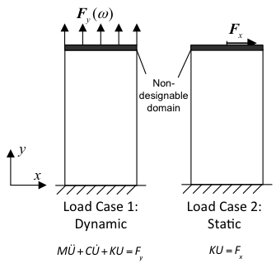

The load cases as modeled in the optimization are shown in Figure 1. The first is a vertical oscillating force distributed across the top of the structure, representing the environmental vibration energy to be harvested. The second is a perpendicular static force at the top, representing non-useful forces in the environment. This topology optimization enabled the design of spring-like structures with low frequency resonance, large displacement, and without the lateral motion that is generated by a traditional spring.

Figure . Resonator Optimization Load Cases

## **1.4 3D Printing Metamaterials to Simultaneously Dampen and Harvest Energy**

Metamaterials are artificial materials engineered to have exceptional mechanical[16, 17], optical[18, 19], thermal[20, 21] or electromagnetic[22, 23] properties not found in nature. They are usually made by conventional materials, e.g. metals and plastics, and arranged into periodic patterns in the space to achieve these exceptional properties. For instance, Fang et al. have demonstrated one-dimensional ultrasonic metamaterials through using an array of subwavelength Helmholtz resonators with carefully designed acoustic inductance and capacitance[17]. Near the resonant frequency of the Helmholtz resonators, these metamaterials displayed effective negative dynamic modulus[17], which sounds counterintuitive and has not been realized in nature. With the help of these unusual properties, e.g. effective negative dynamic modulus and density, many important applications, including negative refraction[24, 25], cloaking[26-28] and superlensing below the diffraction limit[29-31], could be achieved through these metamaterials. More interestingly, these unusually properties of metamaterials originate from their designed microstructures, not from the building materials. Thus, the shape, size, orientation and arrangement of internal microstructures determine the properties of metamaterials.

The design of mechanical metamaterials has attracted the attention of many in recent years. For example, Wang et al. demonstrated that the bandgap of acoustic metamaterials can be controlled and tuned through the buckling of microstructures[32]. Moreover, the buckling of microstructures is also found to be able to induce the auxetic behavior of 3D soft mechanical metamaterials, creating a new class of new materials “Bucklicrystals”[33]. Through direct lattice transformation, Bückmann et al. explored the mechanical cloaking behavior of 2D lattices[34]. They found that a 2D discrete lattice can be used to cloak a void with respect to static uniaxial compression, after the spatial coordinate transformation. All these works shed light on how microstructure design of mechanical metamaterials can be manipulated to enable a variety of applications.

In this thesis, we report a design of mechanical metamaterials for simultaneous vibration isolation and energy harvesting, through finite element analysis (FEA) and 3D printing-assisted experimental validation. Using a square periodic lattice as the primary structure, we attach extra cantilevers (auxiliary structure) to the primary, which can oscillate at their natural frequency. Due to the local resonant behavior of the auxiliary structure, a complete band gap can be created in the natural frequency range of the auxiliary. The suppression of the vibrations is achieved through the transfer of kinetic energy into the auxiliary in the band gap frequency range. By coating the piezoelectric thin film, polyvinylidene fluoride (PVDF), on the auxiliary cantilever, the kinetic energy can be further converted into electric energy for powering other devices. In this way, two distinct functions, vibration isolation and energy harvesting, are achieved simultaneously through the designed mechanical metamaterials, as byproducts of the same physical mechanism. This study reveals the energy harvesting mechanisms of microstructured mechanical metamaterials through a deep understanding of the interplay between phononic bandgaps and the mechanical-electrical coupling in the electroactive polymer materials.

## **1.5 Developing a New Piezoelectric Additive Manufacturing Material for Sensors and Energy Harvesting**

In addition to developing bio-compatible materials for bio-medical implants and drug delivery, our group is interested in developing piezoelectric material to enable new types of multi-functional devices from micro-actuators and vibration warning systems to micro piezoelectric energy harvesters capable of powering wireless sensor nodes.

To enable the construction of these types of devices with additive manufacturing new types of piezoelectric resins and conductive resins must be developed. This next section focuses on the development of a new piezoelectric resin for projection micro setereolithography systems. This specific resin will be tested and developed on our exiting 3D printer and will be simultaneously used in the new inverted 3D projection system that we have constructed. In preliminary designs 30% PVDF by volume is mixed with 67.8% HDDA, 2% Irgacure 819 and 0.2% Sudan I to create this piezoelectric resin, however initial designs have proven difficult to pole and test, our group is currently exploring a number of solvents including (dimethyl acetamide, dimethyl formamide, and dimethyl sulfoxide) to dissolve PVDF material in HDDA this will reduce the viscosity of the material and enable a consistent mixture of materials. After extensive testing, we have demonstrated a viable piezoelectric material with Diethyl Fumarate.

## **1.6 The Unique Role of Piezoelectric Materials**

Piezoelectricity, also called the piezoelectric effect, is the ability of certain materials to generate an alternating current (AC) voltage when subjected to a mechanical stress or vibration, or to vibrate when subjected to an AC voltage, or both (1). Piezoelectric materials are important because their properties enable a broad range of unique and useful devices.  One such group of devices are piezoelectric transducers, such as intrusion detectors and alarms.  Piezoelectric devices are also employed at audio frequencies (AF) as pickups, microphones, earphones, beepers, and buzzers. In wireless applications, piezoelectricity makes it possible to use crystals and ceramics as oscillators that generated predictable and stable signals at radio frequencies (RF) (1).

Today the vast majority of piezoelectric films are rolled (18) or spin coated (16,17) onto a planar surface.  Although these coatings (especially rolling) are low cost and high volume, they limit a designer’s ability to use piezoelectric materials in new ways.  To simplify the production and prototyping of devices with piezoelectric and conductive components our group has been pursuing new multi-functional materials for stereolithography printing technologies.

Stereolithographic printing technologies cure liquid resin with a UV laser or a projected UV pattern.  Examples of commercial companies selling these printers include EnvisionTec(19), which sells micro stereolithography and projection stereolithography printers; Stratasys (20), which sells ink-jet printers based on a UV curable resin; and two new low cost entrants:  Formlabs (21), selling $3000 micro stereolithography printers and MakeX, selling a $2000 projection stereolithography printer. A final example is Carbon3D, which is developing a printer based on projection techniques and CLIP technology and is able to print designs 25-100 times faster than all of the previously mentioned competing technologies. As the new low cost options begin to proliferate, the demand for multi-functional resin materials will continue to increase.  The piezoelectric material we are describing in this work could be modified easily to function on any of these existing commercial printing technologies.

To address the gap in functional materials available, a number of groups have been exploring the possibility of additive manufacturing of piezoelectric materials. Notably Sun et. al (2,3) developed a piezoceramic able to 3D print detailed designs out of a piezoelectric material. However, the material was very brittle, required a post process step of baking at hundreds of degrees C which caused large internal stresses and would deform designs, addressing this issue was what inspired the development of our polymer PVDF-based piezoelectric material.

In addition to piezoelectric materials other groups have developed conductive stereolithography materials.  In 2006, Sandoval et al. functionalized a stereolithography resin by integrating carbon nanotubes, enabling conductive properties of the material.  In 2014, a conductive transparent material using a polymer ionic liquid was developed and printed in high resolution on a projection micro stereolithography machine (23).In addition to conductive materials, Polymer Supermagnetic (13), magnette/thermoplastic material (14), Magnetic Nano-Composite Resins (10) have been developed.

The material we have developed contains PVDF, a piezoelectric polymer which possesses 10 times the piezoelectric properties of a similarly sized quartz crystal (24).  Although PVDF was initially the obvious choice to mix into projection resins, past researchers have had extreme difficulty integrating PVDF into a functional piezoelectric resin. (26) After running our own experiments we found this difficulty was due to the extremely high viscosity of PVDF when mixed with most solvents, dealing with a quickly separating suspension and solvent evaporation problems.  We have addressed these issues by identifying the ‘gold standard’ solvent DEF (Diethyl Fumarate).  This solvent has an extremely low evaporation rate, an extremely low viscosity, completely dissolves PVDF in HDDA, along with Sudan I and Irgacure 819.  This solvent also holds the PVDF in suspension for up over 48 hours, (figure 8) enabling a large number of prints before the material needs to be re-mixed (sensors were printed mixing the resin every 2 hours).  By using this solvent in concentrations of 15-25% by mass we have been able to successfully print 15-25% by mass PVDF concentration imbed in 30-40% HDDA with 20-30% DEF. Not only can we print at resolutions approaching 7um with layer depths of 20um (Figure 9), this material maintains strong piezoelectric properties and we have measured g33 over 100 V*m/N*10^-3.

Further in the thesis, we will show a theory section focusing on how piezoelectric materials (specifically PVDF) work, and how temperature can impact the PVDF polling results.  It is followed by an experimental fabrication section where the custom 3D printer we are using in our lab is explained in detail as well as the fabrication of each individual sensor.  The next section are the experimental results, including g33 measurements of sensors with different concentrations of PVDF, poled at various temperatures, and the impacts of temperature and PVDF concentration on the material’s viscosity and printability. Those graphs are followed by a time-lapse of the suspension separation and a section demonstrating the high resolution capabilities with this material through a print of St. Basil’s Cathedral.  Lastly, the information is summarized in the conclusion where future methods to improve piezoelectric coefficients are also discussed.

## **1.6 Novelty and Utility of B-ink Stent Designs**

This thesis reports a method for rapid fabrication of endovascular stents using a biomaterial ink (BInkTM) via 3D printing or additive manufacturing processes with micrometer accuracy. The method includes preparation and optimization of the BInk to be suitable for the 3D printing process, digital representation of stent design using Computer-aid design (CAD) modeling, optimize the stent mechanical properties using numerical simulation, fabrication processing parameters for device prototype and scalable manufacturing. BInk can be photopolymerized by ultraviolet or visible light at various wavelengths. Different stent structures such as sinusoidal formed wire, helical wrap or laser fused strut can be customized with patient-specific features in the CAD model and subsequently fabricated using the 3D printing system with high fidelity. By optimizing the stent geometry, polydiolcitrate solution composition, initiator concentration, and curing conditions, the mechanical properties of printed stents can be tailored to closely match with blood vessel or a bare metal stent. The kink-resist stent design can be obtained by incorporating the stent strut exhibiting near-zero or negative Poisson’s ratio. Finally, the use of biodegradable materials allows for the encapsulation and slow release of drugs from the bulk of the stent rather than a coating that is applied to the stent struts.

Percutaneous coronary intervention (PCI) is a commonly performed procedure in cardiovascular medicine [35]. Since the implantation of the first bare metal stent (BMS) was reported in 1986 [36], coronary artery stenting quickly established its role in angioplasty [37]. Although stenting improved the outcome of balloon angioplasty, in-stent restenosis due to neointimal hyperplasia remains a challenging problem in the treatment of vascular occlusions [38]. Stents that elute drugs such as paclitaxel or sirolimus have shown some improvement regarding the inhibition of neointimal hyperplasia and a number of second-generation drug-eluting stents (DES) have received CE Mark for clinical use in Europe, or approved by the US Food and Drug Administration [39-41]. However, DES have a relatively higher late-stent thrombosis rate than BMS [42]. Biodegradable stents (BDS), both metallic and polymeric, offer a promising alternative to conventional BMS and DES in providing temporary drug release for vessel patency, resisting late stent thrombosis due to uncovered struts, and potential reduction in the usage of antiplatelet drugs [38, 43]. Moreover, disappearance of BDS over time allows for eventual recurrence of natural vasomotion.

Among natural and synthetic biodegradable polymers, chitosan [44], poly(4-hydroxybutyrate) (PHB) [45], poly(-caprolactone) (PCL) [46], poly(L-lactide) (PLLA) and poly(D,L-lactide) (PDLLA) [47], [48] and its copolymers or composites [49, 50] have been extensively investigated for use in resorbable devices. In particular, a polylactide stent (Igaki Tamai or BVS) has been shown to degrade into metabolites such as lactic acid, CO2 and H2O in two years and to date appear to be safe when used in human coronary arteries [47]. Relative to a BMS, the self-expandable PLLA stents require 8 min for full-expansion in an aqueous environment due to the viscoelastic behavior of polymer 37oC [51], which increases the risk of ischemia and myocardial infarction. Late shrinkage after degradation also remains a concern. It’s important to note that as with metal stents, there are manufacturing challenges for strut design, processing, and fabrication.

Over the last decades, rapid prototyping techniques such as stereolithography, selective laser sintering, fused deposition modeling and others have been developed for high precision manufacturing of customized biomedical devices, greatly expanding in biomedical research and tissue engineering for a broad range of functional and structural materials such as hydrogels, polymers and ceramics [52, 53]. Melgoza et.al. optimized the continuous tool path planning strategies for open sourced and commercial fused deposition machines (FDM), making a customized tracheal stent rapidly and affordably [54]. In comparison to selective laser sintering and solid ground curing, stereolithography offered the best surface finish in the process of customized tracheobronchial stents, while selective ground curing had the best repeatability of length [55]. Unlike the above large-size stents, Park et.al. was able to extrude a bioabsorbable drug-coated stent with a 300um strut diameter using PCL polymer and a rapid prototyping technique [56]. These stents showed to be effective in reducing neointimal hyperplasia, inflammation and thrombosis formation. Sun et. al. disclosed a 3D micro-jetting free molding technique to fabricate slide or snap fastener biodegradable stents with polydioxanone (PDO) [57]. Different from extrusion techniques in 3D printing, projection microstereolithography (PµSL) offers a high precision and high resolution processing method with a digital micromirror device (DMDTM, Texas Instruments) as a dynamic mask [58, 59]. Using a photo-curable polymer, complex 3D microstructures can be created. The Ameer lab has developed a series of citrate-based polymers with a wide range of properties such as controllable elasticity, biodegradability, shape-memory and antioxidant properties [60, 61]. After methacrylation with glycidyl methacrylate, this polymer can be printed via projection stereolithography under the appropriate solvent and additive conditions. Here we show the feasibility to 3D print complex strut structures in a micron scale with the biodegradable polymer.

## **1.7 Design and Construction of a New Inverted Projection Stereo-lithography system.**

To further advance the field of rapid prototyping and design for micro-manufactured parts, we have designed and constructed a new rapid prototyping system for Northwestern University’s rapid prototyping lab. With recent advances in inverted platform printing technologies, throughput for projection stereolithography machines has increased by an order of magnitude, with drastic reductions to wasted material power consumption, and improvement to the surface finish of completed parts. The final CAD design for this system is displayed in the figure below. The rest of this thesis will discuss the sections outlined above, in addition to the specifications for creating a printer of this likeness, material recommendations, advantages of this specific technology and ultimately the incredible products that can be created using this technology that otherwise could not exist.

# **chapter 2: projection micro-stereolithography system**

## **2.1 Background**

Projection micro-stereolithography was first developed at U.C. Berkeley by Xiang Zhang who holds an original patent for the projection design[1]. The purpose of this technology was to greatly speed up the well-known micro-stereolithography process. In recent years, a number of companies have formed to take advantage of both projection micro-stereolithography and stereolithography processes. These companies include Formlabs, EnvisionTec, Nanoscribe and Objet, which was purchased by Stratasys in 2012. Each of these companies utilize UV curable resins in different ways to rapidly create macro, micro and nano-scale structures for a variety of industries.

## **2.2 Projection Micro-Stereolithography Technique**

To explain this fabrication process, PuSL works by building microstructures from a photo-curable resin in a layer-by-layer fashion directly from a 3D CAD design. This fabrication process has enabled a broad range of applications from tissue engineering scaffolds and micro-fluidic channels to the development of sensors and actuators for vibration energy harvesting.

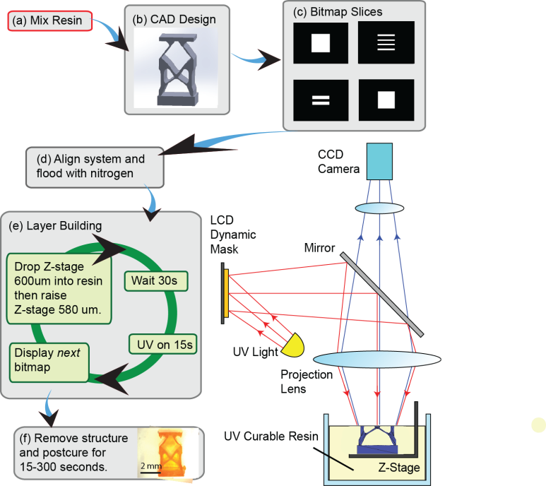

Figure 2. Projection Microstereolithography Process Flow

The core of this technology rests in the use of a spatial light modulator (SLM) as a dynamic mask. It can be either a liquid crystal display (LCD) panel or a digital micro-mirror device (DMD) panel. Instead of fabricating 3D structures in the point-by-point scanning fashion of micro-stereolithography (μSL), PμSL uses a dynamic mask (in our setup, a 1400 ×1050 pixel array) to fabricate an entire 2D pattern in a single exposure. This allows for a drastic reduction in fabrication time compared with μSL systems.

Figure 2 was developed to demonstrate the complete process flow of this fabrication technique. The process is compatible with various photopolymers. For the microfabrication in this paper, the resin is mixed as a combination by mass of 97.78% 1,6-Hexanediol Diacrylate (HDDA, Sigma-Aldrich) as the low viscosity monomer, 2% photoinitiator (Irgacure 819, Ciba), and 0.22% UV absorber (Sudan I, Sigma-Aldrich). The UV absorber and light intensity concentration was finely tuned to obtain a curing depth of 20 μm. This is the same resin concentration as used in our previous work as in [14].

The 3D microstructure (Figure 2.b) was developed on the CAD software Solidworks. Previously VisCAM RP Demo was used to splice the CAD images into a series of bitmap images (Figure 2.c) however more recently a MATLAB code was developed to directly convert CAD .stl files into the necessary .bmp slices.

The silicon wafer is then aligned with the top of the liquid resin layer using a series of displacement sensors monitoring the wafer height and the liquid resin height.

The 160 liter PuSL chamber is then flooded with nitrogen gas at a rate of 20 liters per minute for 40 minutes (Figure 2.e) to reduce the concentration of oxygen within the chamber and ensure optimal solidification and resolution of the photo-curable resin.

After the oxygen concentration is sufficiently reduced in the chamber and the polymer resin is sufficiently enriched with nitrogen the layer building process begins (Figure 2.f). In this process the first bitmap image is displayed on the LCD dynamic mask. In Fig.1.f *next* is placed in italics indicating that the next image is displayed in each iteration after the first. The z-stage is dropped 600um into the liquid resin over about 2 seconds and then raised 580um also over 2 seconds (Figure 2.f). The system then waits for 30 seconds for the 20um layer of resin directly above the wafer to settle. The UV lamp is then turned on for 16 seconds, reflects, off a beam splitting mirror, passes through a reduction lens and finally projects on the top surface of photo-curable polymer resin in high resolution, with each pixel corresponding to 7.1×7.1 μm2.

This projected image is also reflected off the resin surface and captured by a CCD camera so each layer can be closely monitored for resolution. This process then repeats for each bitmap layer in the fabrication. The spring microstructure in this case contains 160 bitmap layers. The micro-structure is then removed from the PμSL machine (Figure 2.g). After the structure is removed, it is cleaned with IPA, Acetone and distilled water, placed in an aluminum box to prevent UV exposure from ambient light and let sit for 24-48 hours.

## **2.2.1 Postcure Process**

The postcure process (Figure 2.h) occurs after the structure is removed from the nitrogen-enriched chamber, cleaned and the liquid polymer resin within the structure has not completely solidified. This stage is known as being close to the green (compliant) state. To further solidify or convert the photopolymer from the green to the bulk (rigid) state, the structure is exposed to UV light, this process is known as postcuring. For our study, we use the F300S floodlight exposure system to do the postcure. With this system, the UV curable polymer is exposed to a variety of UV intensities. In our case we found that varying the exposure between 0 and 150 Joules lead to the most drastic variation in Young’s Modulus.

## **2.3 Optimizing the Projection Micro-Stereolithography System**

After starting in Professor Cheng Sun’s lab in the summer of 2011, I had access to a projection-micro stereolithography machine. This machine was not an ‘off-the shelf’ system but one that had been home built by Dr. Cheng Sun and his first graduate student Fan Zhou. Once trained on the system there were a number of improvements I was interested in making to increase ease of use and access for myself and to future graduate students and observers. These improvements included:

1. Building a new transparent plexiglass chamber to house the PuSL System.
2. Installing a flow meter to monitor the rate of nitrogen flow into the chamber.
3. Installing an oxygen sensor to determine N2 fill rate and reduce fabrication time.
4. Measure the UV intensity of the PuSL machine and post-cure machine.
5. Characterizing the curing depth of our machine for different input intensities.
6. Characterizing the effect of using a variety of gray scales on our machine.
7. Developing software that can splice CAD designs into the necessary bitmap and .txt files.

## **2.3.1 Plexiglass Chamber & Nitrogen Flow Meter**

I designed and helped construct along with interns Noah Shaw, Jahan Alam and Brian Sorch a new plexiglass chamber for the PuSL Machine. The plexiglass chamber enables easier use and gives a more professional look for visiting scholars to the PuSL printer.

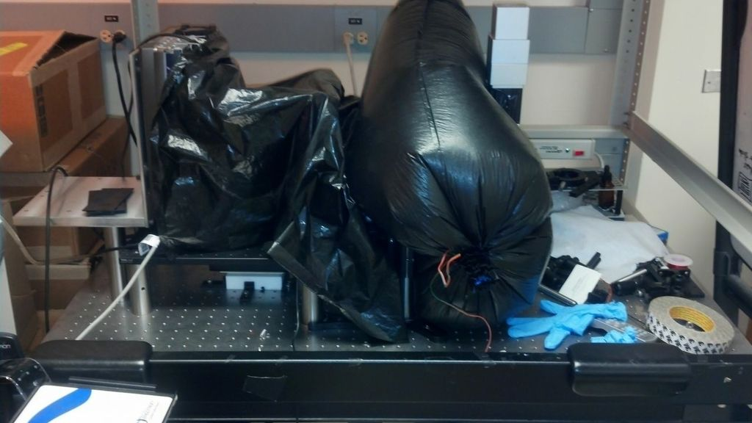 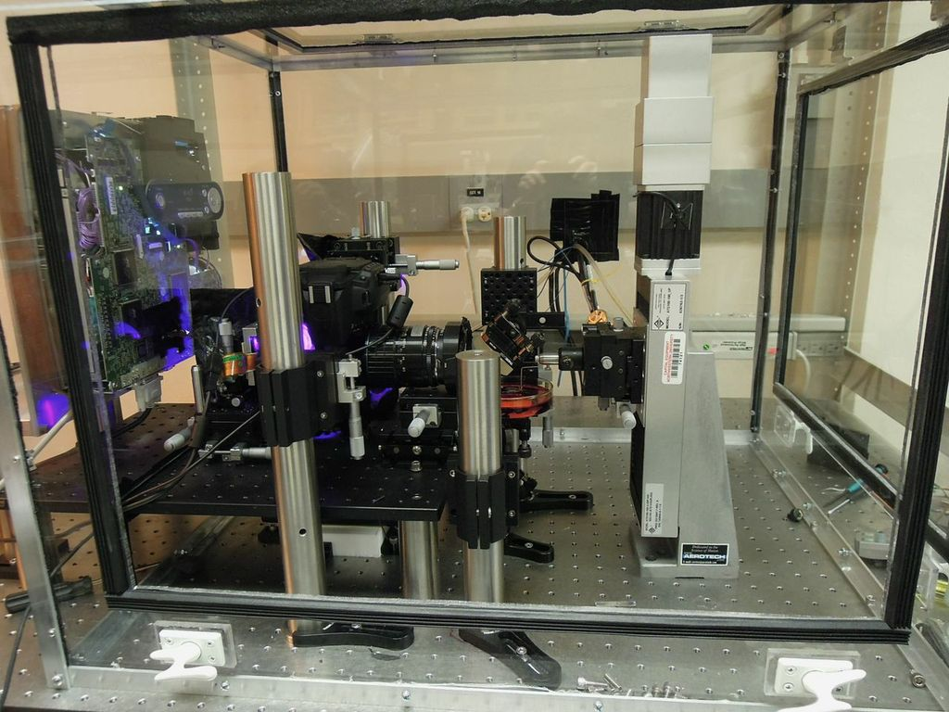 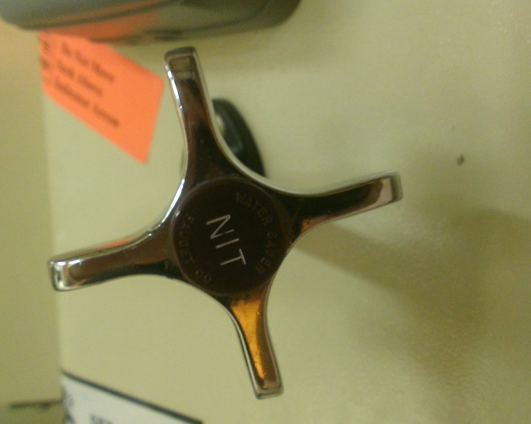 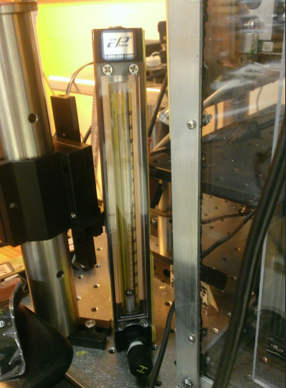

Figure 3. Nitrogen chamber for the PuSL system & Flow Meter/Regulator

A nitrogen flow meter was installed so that we could determine the cost-per print of this particular projection stereo-lithography system. We were also interested in speeding up the printing time by minimizing the ‘nitrogen fill’ time and to do this it was critical to monitor the nitrogen flow. We are working to minimize the flow rate to reduce cost/print and wasted N2 gas.

## **2.3.2 Oxygen Sensor**

To further reduce the print time and improve the consistency of prints, an Oxygen sensor was installed to monitor O2 concentration in the chamber. Oxygen inhibits the reaction between UV light and Irgacure 819 the photoinitiator so it is critical to understand the concentration of Oxygen in the system.

Previously, the system required a 3 hour fill time for each print. After the installation of the Oxygen sensor it was clear 40 minutes was sufficient time for the system to be purged of enough oxygen to print successfully. The flow rate was determined to be 39870 mL/min. Further work is being done to reduce this flow rate and thereby reduce the cost per print.

## **2.3.4 UV Intensity Measurements**

We have completed two separate analyses of UV intensity as a function of the current input into the UV lamp and as a function of the graysacle used. The first analysis was a comparison of UV intensity vs input current into the UV lamp at grayscale 255. One hundred samples of UV intensity are collected and averaged and at each input current. The plot of UV data shows that intensity of UV light increases linearly with input current into the UV bulb. The slope of this line is 6.35*10-5.

Figure . UV Intensity vs. Current Input & UV Intensity vs. Projector Grayscale.

The second test conducted was a study of how input grayscale values into the projector changed the UV intensity for four different current values. The relationship is non-linear. These tests enable the user to identify a desired intensity input based on current and grayscale.

## **2.3.5 Cure Depth Analysis**

A wide range of printing tests were conducted in order to further understand how different variables affect the depth of curing for a single layer. A tower structure was built with single layer exposures giving us the ability to measure the thickness of the single layer at various settings. Here is a picture of the structure and measurements that were taken, where exposure time is varied.

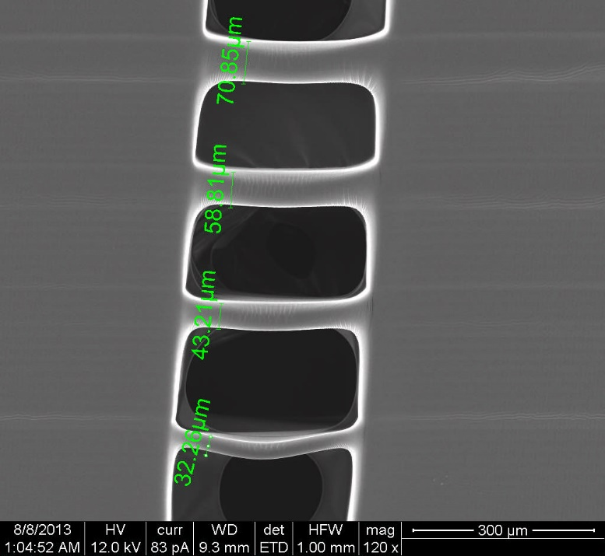

Figure . Cure Depth vs. Exposure time & Grayscale

These tests included 3 variables: input current to UV lamp, grayscale value, and exposure time for each layer. The first set of plots show how cure depth varies with exposure time and grayscale while current is kept constant.

These tests yielded positive results showing a clear relationship between grayscale value and cure depth. In current print settings the input current to the UV bulb is constant, so by using these plots and setting a given input current, one can control the curing depth more precisely and hopefully attain higher resolution prints. Another analysis of this data shows another useful relationship possibly to be used in future printers. The variables involved in each plot are exposure time and input current, while the separate plots are two different grayscales.

Figure . Cure Depth vs. Exposure time for varying gray-scale values. Cure Depth vs. Gray Scale at 0.4A current input and 16 seconds of exposure.

## **2.3.6 Software to Splice CAD into bitmap and .txt run files**

One of the greatest drivers of research and innovation in design is ‘ease of use’ for all of the necessary tools. If a process is too difficult, or takes too much time then that tool will not be heavily used by other researchers in the lab.

When I arrived at Northwestern University, we had a state of the art projection stereolithography machine that had already been built. This machine was capable of 7um resolution and had already manufactured a handful of incredible devices including invisibility cloaks and Terahertz Optics and, in my first year at Northwestern, micro springs. However, to design and print objects on this printer, a custom MATLAB program had to be written that would generate all of the bitmap slices for each individual design. The MATLAB code required to print a single spring design took me a few weeks to develop. To drastically reduce the complexity of this process and enable a variety of designs, I wrote new software in MATLAB that can take any 3D designed .stl file as an input, voxelize that CAD design and incorporate each layer of voxels into their corresponding bitmap layers, the first version of that software is attached in Appendix C. This reduced the time required to go from design to a new print from days to a matter of minutes (Figure 7).

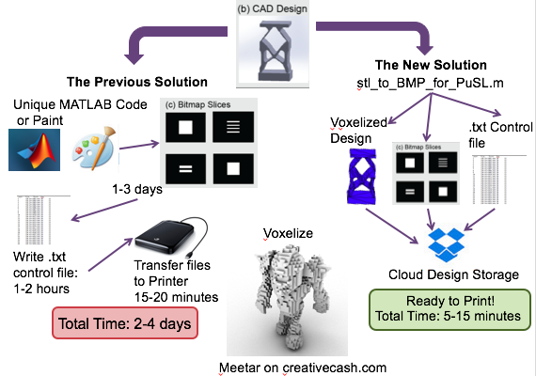

Figure New software designed to reduce print time for new designs from days to minutes. ‘Left’shows the process flow for the ‘old way’ of designing and splicing files. And ‘right’ shows the capabilities of the new all-in-one splicing program.

To further increase the ease of use of this MATLAB splicing program, I created a graphical user interface (GUI) easy for any user to understand. That GUI is displayed in Figure 8. It is not yet its own stand-alone program and still must be opened inside of MATLAB, but it is much easier to use and has added features not available in the previous software. To run the program, the user must be sure that the current working directory of MATLAB contains the file that they want to splice. After the current working directory has been set, the user decides on a new file name where they want their new images to be stored, and it should be typed into the ‘New Folder/BMP Prefix’ text box. Then, the user selects the .stl file that they want to splice. They press the ‘Choose .stl file’ button which will bring up a file menu that the user can search through and select the file they want to splice – again this file must be in the current working directory of MATLAB. After selecting the file, the user needs to know what orientation the file was designed in, usually files on SolidWorks are designed with the Y orientation being ‘up’, however if the file was downloaded from an online source like thingiverse.com then the orientation is typically set with Z being up. This software can take in any file with X, Y or Z being oriented in the ‘up’ direction, as long as the correct option is chosen by the user. Once the orientation is set properly the user should set the layer thickness between 10um and 50um, the default recommended layer thickness is 20um, but it depends on the material composition and UV intensity and exposure time. The user then sets the UV exposure per layer and if more than one design is being printed the user can set the ‘gap between multiple designs 60-100pixels’. The user can then decide how many copies of the design that they want to print. This software is capable of printing 1, 2, 3 or 4 copies of the same design at once. The user also has the ability to ‘scale’ the original input design, this is a critical feature for a micro-printer as most designs available online are at much larger scales. After typing the desired ‘scaled magnification’ quantity (0-100%) the user should press the ‘calculate stl dimensions’ button and it will automatically populate the X Length, Y Length and Z Length quantities so the user can decide if those quantities reflect the size that they would like to print their new structure.

In the ‘Optional’ section, the user can add a second .stl file that they would like to print. Each of the features available for the second file are identical as the features available for the first file, except for the layer thickness which has already been chosen for the first design and cannot be altered within the same print even for a second design. However, if ‘number of files’ is set to ‘Two’ the maximum ‘# of designs’ that can be set is 2. In that case 2 designs of each file type will be printed distributed evenly across the projection plane.

The MATLAB program for this graphical user interface is attached in Appendix D. The key functionalities that the GUI has that are not available in original code from Appendix C are as follows:

1. The code directly measures the bounding box (size) of the .stl file that you load.
2. The new GUI can splice designs in any orientation, the old code only worked with Y-orientation files.
3. Each of the required inputs are much easier for the user to find, rather than looking through hundreds of line of code.
4. The user has the ability to scale their design by any desired magnification, this is possible as well with the old code, but you have to do the math to define your proper bounding box size without distorting your original design file.

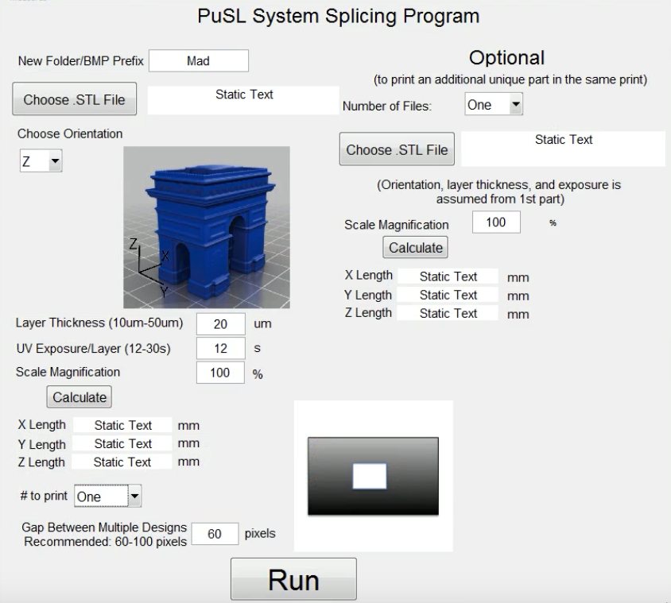

Figure Graphical User Interface for the PuSL Splicing Program.

If you would like to edit the MatLab graphical user interface, you can modify the look by first editing the .fig file.

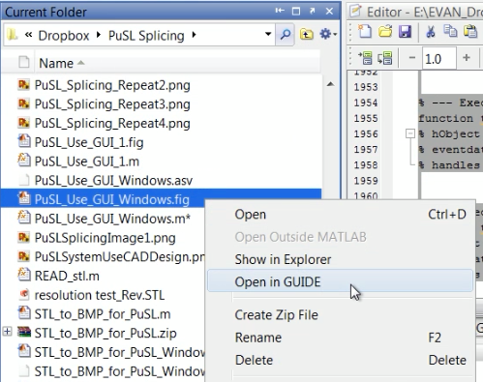

Figure Location for access to modifying the .fig file.

This software has enabled researchers to design, fabricate and test new devices faster than ever before. Although originally completed in 2010, in the first three years the printer was functional at Northwestern only two to three novel devices were developed, printed and published using this printer. Since late 2013 when I completed the MATLAB splicing software, a host of new vascular stent designs, intraocular lens designs, and intraocular lens haptics have been developed and printed as shown in Figure 10. In addition to more designs being developed and printed, more complex designs are now easier to make than ever before. The capability to print new devices with ease has led our group to develop two new materials, a bio-degradable material for stents and a piezoelectric material for vibration energy harvesting devices and sensors.

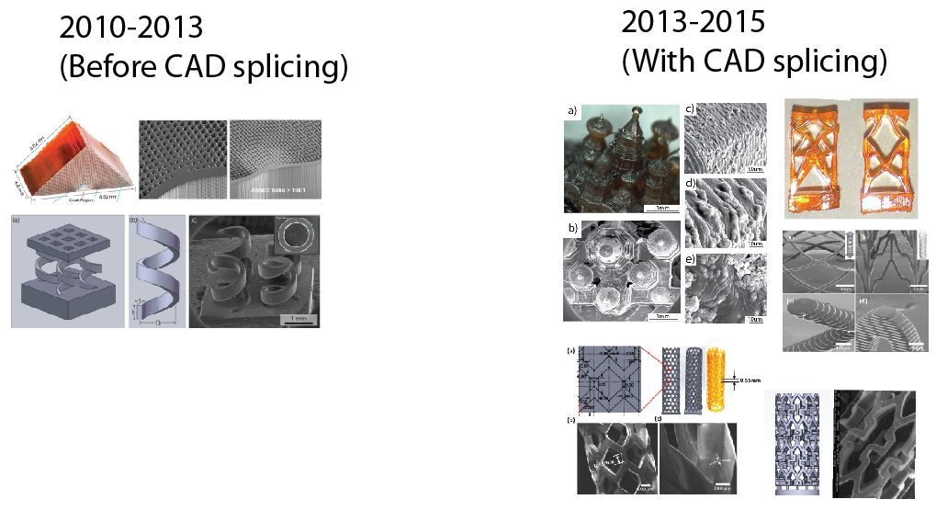

Figure . Impacts of CAD Splicing program on research productivity. (left) depicts devices designed between 2010-2013 and (right) depicts devices developed utilizing CAD design software and the new CAD splicing software for PuSL.

# **chapter 3 PRELIMINARY EXPERIMENTAL DEMONSTRATION: ELECTROMAGNETIC VIBRATION ENERGY HARVESTING**

## **3.1 Background**

The need for miniaturized, multifunctional electromechanical structures and material systems with the capability to harvest energy from the environment has grown significantly in recent years in response to the proliferation of portable electronic devices and wireless sensors [2-5]. At the present time batteries are the primary power source for these portable devices. Unfortunately, batteries suffer from a limited lifetime requiring periodic recharging or replacement [6]. Thus, harvesting energy from the environment offers an autonomous means to recharge or directly powerconventionally battery-operated devices. In evaluating the available energy harvesting technologies, environmental vibration is an attractive energy source because of its abundance in nearly all environments, spanning a wide environmental frequency spectrum (~sub- 100 Hz) [7]. This has led to the research field known as vibration energy harvesting (VeH), which explores using different principles of transduction to convert available vibration energy into electricity [8-12].

In attempting to miniaturize VeH devices, a major issue with the mismatch between device resonant frequencies and the environmental vibration frequency spectrum has plagued development. This is due to many micro-fabrication techniques being limited to primarily two-dimensional (2D) topologies and to using materials with high elastic moduli, such as piezoceramics and silicon, for their spring components. Consequently, miniaturized devices have had high resonant frequencies, which optimally harvest energy only at the kilohertz frequency range and above [6, 13]. Thus, to reduce the operation frequency range to the available energy range required proportionally scaling up the device dimensions or adding an excessive amount of mass [7]. These options run counter to the motivation of using this technology as miniaturized power sources.

However, in a recent work [14] we presented a photopolymer-based electromagnetic design which changed the way in which miniaturized VeH fabrication could be approached. The process, known as projection microstereolithography (PμSL) [15], allowed for the fabrication of a compliant three-dimensional (3D) helical spring components made of a photopolymer mixture of 1,6-hexanediol diacrylate (HDDA, Sigma-Aldrich), 2% photoinitiator (Irgacure 819, Ciba), and 0.22% UV absorber (Sudan I, Sigma-Aldrich). The resultant structure had a significantly lower elastic modulus (530 MPa) when compared to metals and ceramics and was compact in design, with a maximum spring feature size of only 3.4 mm, and exhibited a low 61 Hz resonance, when combined with a load of 1.236-gram.

While these results illustrated the capability of miniaturized device with sub- 100 Hz resonance, the electrical output was low with a maximum 143.6 mV at open-circuit and 2.114 μW under an optimal resistive load (when operating at resonance with an acceleration of 2.27 ± 0.1 ms-2). Investigating the cause of the electrical output issues, it was found that the mismatch of the structure's high parasitic (viscous) damping coefficient (=0.0671 kgs-1) when compared to the low electrical damping coefficient (=0.0139 kgs-1), caused sub-optimal performance (an optimized system would operate at resonance with equivalent damping coefficients). While it was noted that the electrical damping could be increased by decreasing the separation distance between the magnetic coil and the moving magnet load, the issue of the high cp coefficient still raises issues on whether this photopolymer material is effectively a spring- or damper-like component.

To address this concern, and see if the parasitic damping coefficient could be manipulated, we investigated the same geometric spring as in our previous study [14] but with different ultraviolet (UV) postcure exposure times for each spring component. This approach was inspired by Manias et al. [21], who demonstrated the effective elastic modulus of a photopolymer could be tuned from 200–930MPa by simply adjusting the postcure time. Thus, by following the same approach, we sought to tune each geometrically equivalent structure (including the same load mass and structural material) to have different resonant frequencies, and potentially different intrinsic parasitic damping, by altering the postcure times. The result shows a method to improve the tuning capability and electrical performance of miniaturized, photopolymer-based VeH devices, especially at the sub- 100 Hz (naturally occurring) vibration frequencies.

The paper is organized as follows: A brief overview of the PμSL fabrication process is given along with the postcure process. Then, basic theory on electromagnetic VeH design is given, which emphasizes the importance of matching the resonance of the structure with the vibration frequency of the source, as well as matching the parasitic damping with the electrical damping for optimal performance. Afterwards, the experimental setup which simulates a harmonic vibration source is introduced, along with the results for the varying postcure exposure times. Lastly, we discuss the results with comparisons made to the literature.

## **3.2 Electromagnetic energy harvester design**

The response of an electromagnetic VeH to a vibration energy source can be approximated using the simple model of a damped spring-mass system, with a spring $k$, a mass $m$, a base-excitation force $F\left(ω\right)$, and two dashpots in parallel representing the parasitic damping $c_{p}$ and the electrical damping (energy conversion) $c_{e}$, see Figure 11. As was shown by the authors previously [14], if the effective damping is considered small, then the maximum power generation occurs when the frequency of the excitation force is near the undamped, natural frequency of the system model, i.e. $ω=ω_{n}=\sqrt{k/m}$. Thus, to achieve maximum performance of a miniaturized, electromagnetic VeH device, which has an assumed small damping present, requires precise tuning of the design for the ratio of the spring constant $k$ and mass $m$ to be near resonance.

With traditional silicon micromachining processes, geometries are limited to suspended 2D structures, which results in many designs fundamentally reducing to cantilever beam configurations in order to achieve low flexural rigidity. With such a configuration, the spring constants are proportional to a function of the maximum feature length, resulting in low resonance designs which are small in volume but large in a single direction. Additionally, for many engineering materials used in traditional micro-fabrication, the properties of elastic modulus and density are correlated along the diagonal line, as evidenced by the well-known Ashby chart.

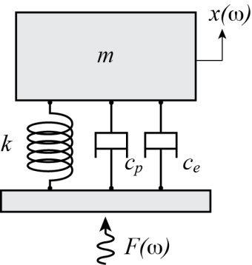

Figure 11. Schematic drawing of a damped, spring-mass system with a vibration source.

Thus, reducing the $k/m$ ratio requires an external mass which is proportional to the VeH’s elastic modulus. If that elastic modulus is high, a significantly large mass will be needed to lower the resonance, resulting in larger system dimensions. Therefore, to address the seeming contradictory requirement of low resonant frequency and device miniaturization, PμSL is exploited as a means to widen the design space via 3D microfabrication technology and to lower the elastic modulus using polymer-based structural materials. Within this work, we extend the design capabilities of this technology by tuning the postcure process to manipulate the polymer structure's material properties from values ranging from the green to the bulk state [62], which allows designers a fine tuning capability for the desired spring stiffness.

Lastly, if the system is tuned properly to operate near resonance at the vibration source frequency, then for optimal performance the following must be true [14]

|  |  |  |
| --- | --- | --- |
|  | $$P_{\left(ω=\sqrt{k/m}\right)}=fcn\left(\frac{1}{{\left(c_{p}+c_{e}\right)}^{2}}\right)\underset{→}{yields}P_{optimal}@ c_{p}=c_{e}$$ | (1) |

So without knowing a priori what the damping coefficients are, we tune the spring-mass system to operate near the naturally occurring vibration frequencies (sub- 100 Hz) and observe if any postcure times manipulate $c_{p}$ to approach near $c_{e}$.

## **3.2.1 Helical Spring Constant**

Taking advantage of the 3D fabrication capability in P*μ*SL and the tunable material properties, an array of polymeric helical coils were designed to be the same as in our previous study [14] so as to allow for comparison on the effect of the postcure process. The 3D CAD of the spring structure is shown in Figure 12(a) Coils are arranged in a symmetric two-by-two form. Below the spring structures, the flat substrate is fabricated using the same process. At the top of springs, a grid-like platform is formed to support the magnetic load mass needed for the electromagnetic VeH design. The complete structure is made of 170 layers, with each layer being 20 *μ*m thick, yielding a total structure height of 3.4 mm. The designed geometry of an individual helical coil is illustrated in Figure 12(b). The coil diameter *D*, width *b*, and thickness *t* are 1040 *μ*m, 400 *μ*m, and 160 *μ*m, respectively. A scanning electron microscope (SEM) image of the fabricated coil array is shown in Figure 12(c). The dimensions of the fabricated coil are measured as *D*=1010 *μ*m, *b*=372 *μ*m, and *t*=163.5 *μ*m. The dimensions are in good agreement with the design parameters, demonstrating the accuracy in rapid fabrication of complex 3D geometry using the P*μ*SL technique.

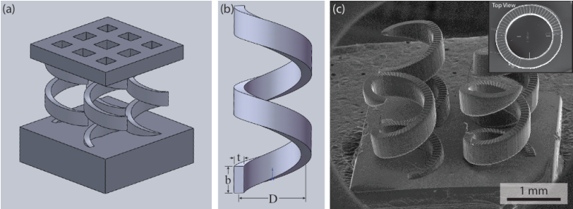

Figure 12. (a) A 3D CAD of the polymeric soft wpring structure. (b) Design geometry of an individual coil. (c) SEM image of coil array fabricated using PμSL method. Inset shows the top view of the individual coil

With the helical spring dimensions defined, we apply the following to determine the spring constant $k_{helix}$ for each rectangular cross-section helical coil within the structure

|  |  |  |
| --- | --- | --- |
|  | $$k_{helix}=\frac{K_{2}Ebt^{3}}{2\left(1+ν\right)nD^{3}}$$ | (2) |

where $n=2$ is the number of helical coil turns, $ν$ is Poisson’s ratio and assumed equal to 0.4, $E$ is the elastic modulus determined by the postcure time, and $K_{2}$ is the shape factor is approximated by the polynomial

|  |  |  |
| --- | --- | --- |
|  | $K_{2}=-0.00014{\left(\frac{b}{t}\right)}^{4}+0.00$ 42 ${\left(\frac{b}{t}\right)}^{3}-0.046{\left(\frac{b}{t}\right)}^{2}+0.21\left(\frac{b}{t}\right)+0.012$ | (3) |

The complete spring structure consists of $N$ =4 helical springs in parallel, which yields a structural spring constant ${ k=Nk}_{helix}$. A CAD model displaying the helix geometry, as well as the complete structure, is shown in Figure 12.

## **3.2.2 Acceptable Load Mass**

With the structural spring constant a function of the postcure time (elastic modulus), the lower bound for the resonant frequency of the structure is determined based on the the $k/m$ ratio, which is constrained by the maximum mass $m_{max}$ that can be applied under cyclical loading without exceeding its maximum stress $σ_{max}$ of the helical coil array. To calculate this lower bound, the combined stress, which is the combination of the torsional and transverse shear stresses, is used, which is defined as

|  |  |  |
| --- | --- | --- |
|  | $$m_{max} =0.4\frac{Nσ_{max}bt^{2}}{K_{w}K_{l}Dω^{2}x}$$ | (4) |

where the coefficient 0.4 is used when applied to cyclical loading cases, $σ_{max}$ is the maximum stress determined by the postcure time, $ω^{2}x$ is the vibration acceleration amplitude, $K_{w}$ is the Wahl factor, and $K_{1}$ is another shape factor (which the latter two are approximated by the polynomials)

|  |  |  |
| --- | --- | --- |
|  | $$K_{w}=\frac{4\left(\frac{D}{t}\right)-1}{4\left(\left(\frac{D}{t}\right)-1\right)}+\frac{0.615}{\left(\frac{D}{t}\right)}$$ | (5) |

|  |  |  |
| --- | --- | --- |
|  |  | (6) |

Thus, the acceptable load mass that can be applied to the spring structure (assuming the mass of the spring is negligible) must be below $m_{max}$, which is a function of both the postcure time (which effects $σ_{max}$) and the acceleration level of the input vibration source ($ω^{2}x$).

## **3.3 Tuning the mechanical properties with the PuSL system**

To reduce design complexity, the peak-to-peak (pk-pk) acceleration is assumed to be known and constant across all possible (sub- 100 Hz) resonant (vibration) frequencies. This simplifies $k$ and $m_{max}$ to functions of only the postcure time. For $σ_{max}$ values, which are with respect to each postcure time, approximations are made by performing a separate study using compression tests with the same photopolymer mixture (which yield stress-strain curves for a fixed strain rate), according to ASTM standards. Given that the chosen applied load mass is known to never violate the $m_{max}$ upper bound (for all selected spring postcure times), each resonant frequency can then be tuned to be below 100 Hz.

For the actual postcure process, the helical coils are placed at a distance of 5.0 inches from the quartz window with 1 to 3 minute exposure times. The UV dose applied is therefore expressed as the following: post-fabrication UV exposure [min @ 153mW/cm2] referring to the UVA exposure intensity at the location exposed.

## **3.4 VEH Experimental Characterization Setup**

The experimental setup is designed to simulate environmental vibration sources, see Figure 13. To represent the general waveform of the vibration, a control signal is selected and generated by a function generator (Agilent 33120A). The control signal is then amplified by a power amplifier (Bruel and Kjaer no. 2718) before entering into an electromagnetic shaker (LDS V203). The resulting shaker’s waveform and acceleration are monitored by a LabVIEW program using a uniaxial accelerometer (PCB Piezotronics no. 333B50) mounted to the shaker drive output. An aluminum stand is used to position the VeH device sufficiently away from the magnetic field of the shaker, so as to not to cause magnetic interference. The base of the VeH device is fixed to the top of the aluminum stand using adhesive. The device itself consists of three main components: the spring structure, a 1.184-gram magnetic load, and a 790-turn coil (48 AWG magnet wire) with a resistance of 590 Ω. The magnetic load is comprised of three layers: a 0.296-gram tungsten mass sandwiched between two magnetically opposing 0.444-gram NdFeB (N50) rare earth magnets. Each of the layers are fixed in place with epoxy and then attached to the top of the spring structure using epoxy again. The magnetic coil is positioned at the midlayer of the magnet such that the motion of the magnet is within the midpoints of the two magnets. The voltage output of the device is measured across a resistive load and recorded with LabVIEW.

Two separate vibration sweeps are performed to extract the electrical performance of the device as well as its parameter values. These sweeps represent the frequency response of a forced, harmonic vibration, with a sinusoidal input over a 40–110 Hz frequency sweep. The signal is controlled using a custom LabVIEW program with proportional gain feedback control to maintain a constant acceleration of 6.06 *±* 0*.*05m/s2, so as to decouple the test stand dynamics from the device dynamics. The voltage output across varying load resistances is then collected into the LabVIEW program at a sampling rate of 10 kHz for a duration of one second at each distinct frequency value. The peak-to-peak voltage of the largest signal within that 1-second time interval is logged for each corresponding frequency value. From these tests, the natural frequency, effective elastic modulus, damping coefficients, voltage output, and power output for our selected constant acceleration source are experimentally found.

Figure 13. (left) Experimental setup, (right) Neodymium-ion-boron rare earth magnet(s) on top of HDDA polymer 2x2 spring array structure (lower right: VeH with load mass, top right: with 1.184-gram load mass and inside 780 turn 48 awg magnet wire coil)

## **3.4.1 Setting up the constant acceleration loop and control theory**

This portion will be discussed in the full proposal.

## **3.5 Results and Discussion**

Using the setup described in the previous section, four structures were fabricated with a post cure of 60, 90, 120, and 180 seconds. The acceleration of the shaker was set to a constant 6.06±0.06 ms-2, a frequency sweep from 40 Hz to 110 Hz was performed to determine the resonant frequency of the VEH device, as well as yield the voltage and power performance when analyzed using varying resistive loads, see Figure 14 and Figure 15. From the plots, it is observed that the resonant frequency, the location of the peak voltage and power varies from 53.5 Hz to 80.5 Hz as the post cure time is increased from 1 minute to 3 minutes. More importantly it is also clear that the mechanical damping is reduced significantly as at lower post cure times. The mechanical damping values for each of these tests is shown in Annex A and compared to the damping for other structures throughout the literature. We found that as the post cure time was increased from 1 minute to 3 minutes the mechanical damping increased from 0.0595 to 0.0986 kgs-1 (Figure 16). This variation in mechanical damping has proven extremely useful for simultaneously tuning/reducing the resonant frequency and maximizing the power output. The Young’s modulus was experimentally determined to be 399, 445, 795 and 904MPa (Figure 17) with post cure times of 60, 90 120 and 180 seconds. The modulus was calculated assuming a Poisson’s ratio of 0.4 and using each of the measured values mentioned in Fabrication Process section. Also from the plots a maximum voltage outputs of 777.6, 773.1, 582.1, 477.0 mVwere observed when measuring across a 10.01 MΩ resistive load at 6.06±0.06 ms-2and a maximum power outputs of 120.4, 105.0, 82.4, 56.5 *μ*W when measuring across a 1113 Ω resistive load. Normalizing the results with respect to the G-level of the excitation’s acceleration, the maximum voltage output is 1258, 1251, 942, 772 mV and maximum power outputs of 195, 170, 133, 91 *μ*W/G. The mechanical damping of these structures was derived to be 0.0595, 0.0707, 0.0856, 0.*0986 kgs-1* (Figure 16). As a reminder all of this data refers to the 1, 1.5, 2, and 3 minute post cured structures.

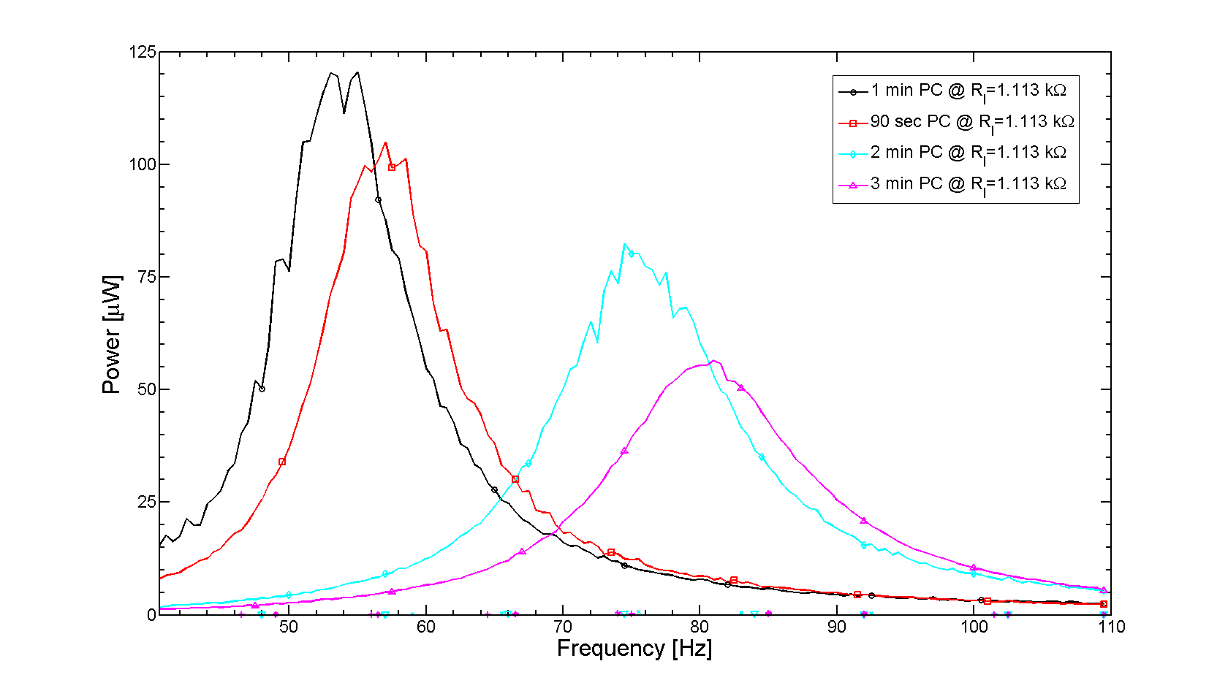 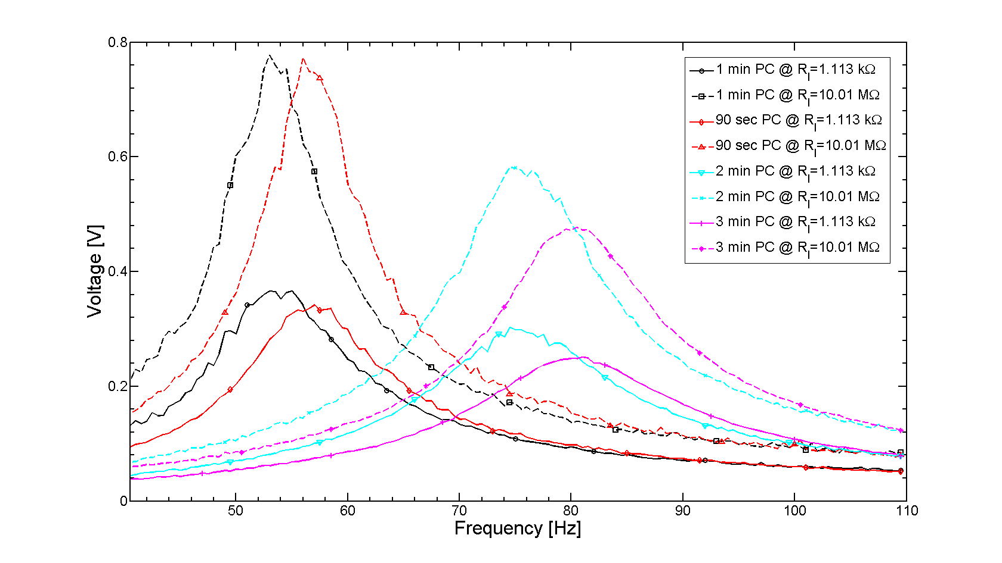

Figure 14 Power vs. frequency for 1-3 minutes of post-exposure. Resonant frequency shifts 53.5-80.5 Hz and power output increases from 55.4 to 119.6 μW (when excited at a constant acceleration of 6.06 ±0.06 ms-2) Figure 15. Voltage vs. frequency for 1-3 minutes of post-exposure, resonant frequency shifts 53.5-80.5 Hz and power output increases from 55.4 to 119.6 μW (when excited at a constant acceleration of 6.06±0.06 ms-2)

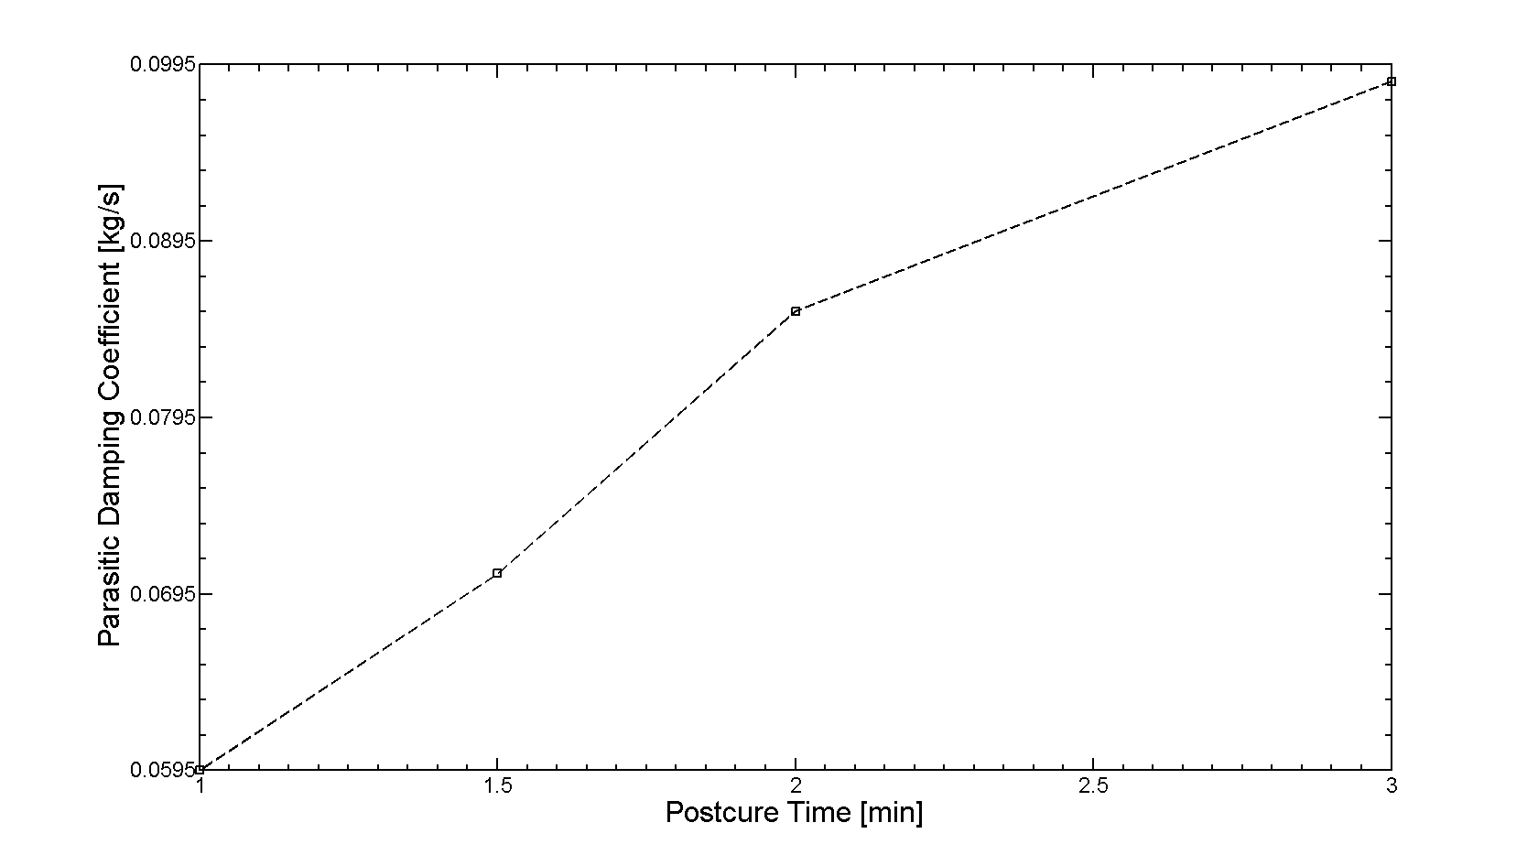 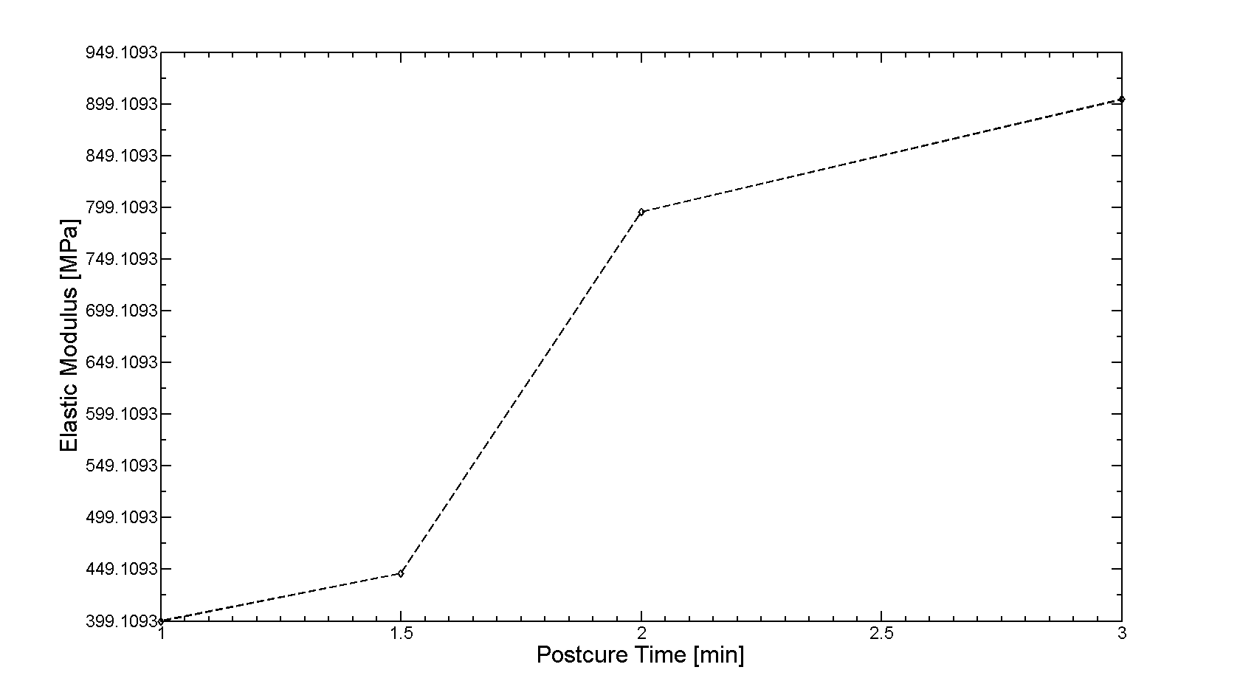

Figure 16. Parasitic damping coefficient [kg/s] vs. postcure time [min] for four spring structures cured at 1, 1.5, 2 and 3 minutes with a 1.184g load mass. Figure 17. Elastic Modulus [MPa] vs. Postcure Time[Min] for four spring structures cured at 1, 1.5, 2 and 3 minutes with a 1.184g load mass.

## **3.6 Conclusion**

To conclude, two comparisons of this spring design with other small-scale VEH structures in the literature is given, see Annex A and Annex B. Of notable distinction, it is observed that since the PuSL process utilizes polymeric material, this work has the lowest Young’s modulus (399MPa) and density (1.011 g/cm3) for a VEH spring structure to date. The spring structure also has the smallest “largest feature size” for a resonating structure in the sub-100 Hz range due to its 3D geometric design. The largest feature size is defined as the largest feature length (length, width, or thickness) of the resonating structure. Thus, the claim is that the PuSL fabrication method, along with the 3D helical design choice, yields the most compact VEH spring structure to date that is tuned to resonate at sub-100Hz. To justify this claim, the spring structure in this work is compared to the smallest “largest feature size” of a sub-100 Hz resonance VEH, which is described in Beeby et al. at 2.4 times this work’s value, or 8 mm [63]. Additionally, when slightly relaxing the sub-100 Hz resonance constraint and simply comparing with the smallest ‘largest feature size,’ the work described in Ching et al. is still larger than this work’s value with a 4 mm radius planar spring and with a resonant frequency that is 1.8 times higher at 110 Hz [64].

Additionally this work has shown a second method, in addition to the variation of the spring dimensions that can be tuned and optimized for vibration energy harvesters, the post-cure time. This work has demonstrated a reduction in the Young’s modulus of the material from 904 MPa to 399 MPa by reducing the post cure time of the structures from 3 minutes to 1 minute. The mechanical damping was simultaneously reduced from 0.0986 to 0.0595. The reduction in mechanical damping the reduction in mechanical damping improved the normalized power output from 91 uW/G at a 3 minute post cure to 195 uW/G at 1 minute post cure.

With the addition of a new magnetic coil described in the experimental setup section we have improved the power output of our same spring structure in our previous work [14], from 9.14uW/G to 195uW per G. Additionally our new structure has 4.2% less mass than our previous work.

# **chapter 4 Experimental fabrication & testing of topology optimized designs**

## **4.1 Background**

The energy harvester concept for which the structural optimization was performed is the same as in previous works in this thesis. The voltage is generated by the motion of a magnet in and out of a coil attached to circuitry for energy storage. The magnet’s motion is caused by environmental vibration in the vertical direction and can be maximized for the expected frequency spectrum by the design of the polymer structure, depicted as a spring in this figure. In this section, the design was optimized for vibrations of a single frequency $ω$.



Figure 18. Resonator Optimization Load Cases

The load cases as modeled in the optimization are shown below. The first is a vertical oscillating force distributed across the top of the structure, representing the environmental vibration energy to be harvested. The second is a perpendicular static force at the top, representing non-useful forces in the environment.

## **4.2 Topology Optimized Electromagnetic Energy Harvester Design**

The strategy that successfully produced results is to introduce a secondary, static load case in a different direction, for which the response is to be minimized. A similar strategy has been used to optimize static compliant mechanisms [65]. In this case, the secondary, perpendicular load case represents non-harvestable forces. The magnet and coil only collect energy from vertical vibration, so motion in response to perpendicular forces is undesirable.

As shown below, the first case is dynamically loaded in the y-direction at the desired frequency omega. The desired response output is the average y-displacement amplitude of the loaded surface. This corresponds to the displacement of the magnet and is proportional to the energy output. The second case is statically loaded in the perpendicular direction, and the governing equation is shown below. The output to be minimized is the x-displacement of the loaded point.



Figure 19. Resonator Optimization Load Cases

The objective function is as follows:

$$f_{obj}=w_{1}\frac{U_{y,0}}{U_{y}}+w_{2}\frac{U_{x}}{U_{x,0}}$$

The objective function is the sum of the reciprocal of the dynamic output $U_{y}$ (to be maximized) and the static output $U_{x}$ (to be minimized). The terms are normalized by the initial results $U_{y,0}$ and $U_{x,0}$. The weighting factors $w_{1}$ and $w_{2}$ were adjusted to produce structures that were more or less stiff. Because the top of the structure is loaded, the top 5% layer of the design space was excluded in the optimization. A volume fraction constraint of 30% was applied in all cases.

The values of the optimization variables are the solution to the following optimization problem:

$$\min_{}{f_{obj}}$$

$$s.t. F_{static}=K_{static}U_{static}$$

$$F_{dynamic}=S_{dynamic}U_{dynamic}$$

$$\sum_{i}^{N_{e}}{ρ_{i}}<V_{max}$$

$$ρ_{min}<ρ_{i}<1, i=1,…, N_{e}$$

## **4.2.2 Adjoint Sensitivity Calculation**

The sensitivity calculations are the same for SIMP and level set methods. The sensitivity of the volume constraint to any optimization variable (or pseudo-density) is constant for equal-sized elements. The sensitivity of the load displacements was calculated with the adjoint method. The adjoint load for the static force was $F_{static, adjoint}=2U_{static,out}$ and the adjoint load for the dynamic case was $F_{dynamic,adjoint}=2{U_{dynamic,out}}^{C}$. The element sensitivity of the dynamic load displacement is given by:

$$\frac{∂U_{static,out}}{∂ρ_{i}}=-U_{static,i}\frac{∂K_{i}}{∂ρ_{i}}U_{static,adj,i}$$

The sensitivity of the dynamic load displacement is given by:

$$\frac{∂U_{dyn,out}}{∂ρ_{i}}=-{w_{k}U}_{dyn,i}\frac{∂K_{i}}{∂ρ_{i}}U_{dyn,adj,i}-w_{m}U_{dyn,i}\frac{∂M_{i}}{∂ρ_{i}}U_{dyn,adj,i}$$

## **4.2.3 Optimization Flow Chart**

A flow chart for the SIMP and level set methods is shown below. Both methods use the same finite element analysis to calculate the dynamic and static response and compute the element-based sensitivities. The level set method has extra steps to convert the boundary-based representation of the design to element densities for this calculation. While the SIMP method uses the method of moving asymptotes (MMA) to update the design variables while taking into account the constraint functions, the level set method uses the Lagrangian to update the values of the level set function everywhere.

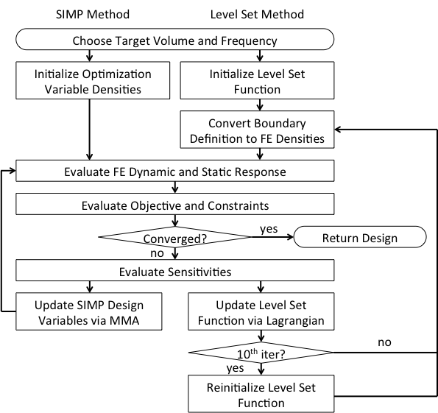

Figure 20. SIMP and Level Set Method Optimization Process

## **4.3 Optimization Results (Simp & Level Set Methods)**

Table 1. SIMP & Level Set Optimization Numerical Results

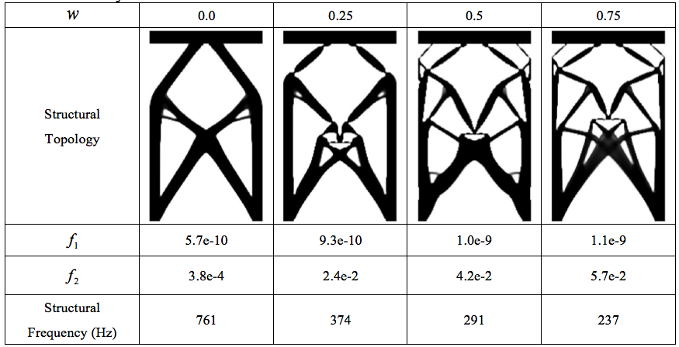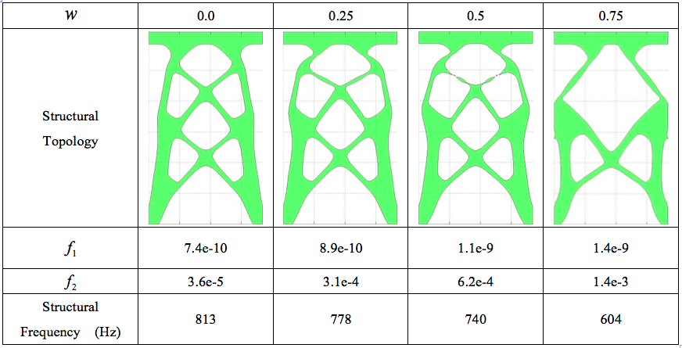

## **4.4 Fabrication**

The two fabricated resonator structures based on the optimal solutions from the density and the LSM methods respectively are shown in the figure below. Some minor differences are evident between the CAD designs and the fabricated structures. In particular, some of the smaller beams inside of the density based TO designs (left) were near the limit of the PuSL resolution. These beams are fabricated slightly thicker than designed to ensure structural integrity.

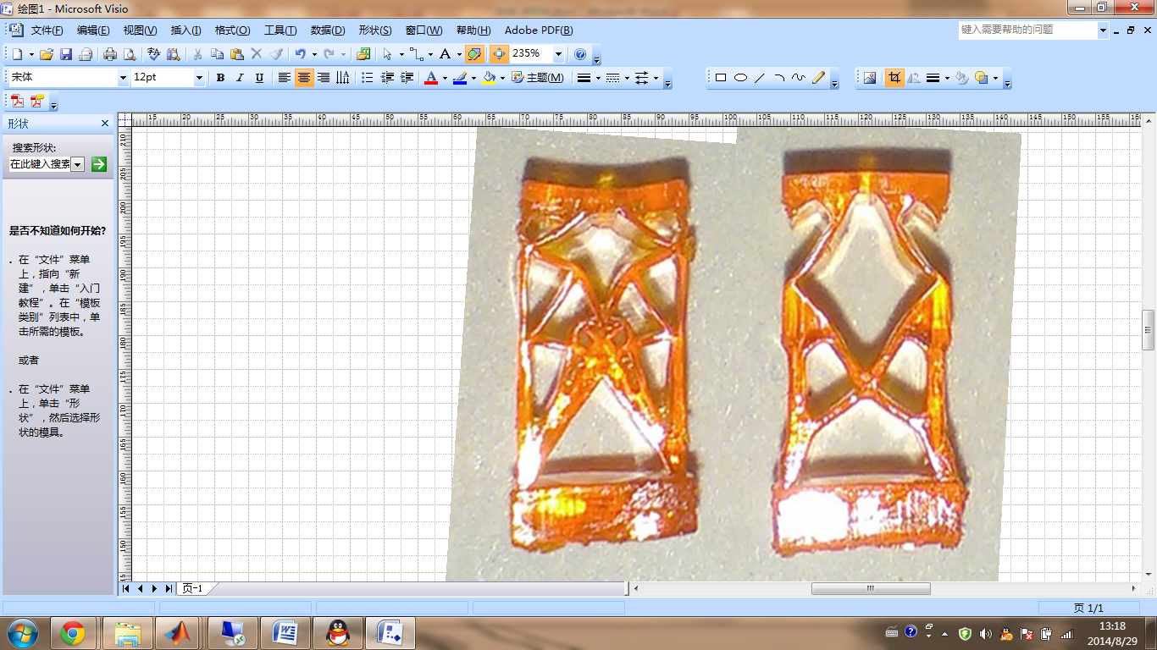

Figure 21. Fabricated resonators for (left) density based method =0.75, (right) level set method =0.75



The sketches in Figure 7 are then extruded to 3.69 mm in the third dimension and the thick base plates are included for ease of fabrication. The resonator structures are fabricated with the projection microstereolithography (PμSL) technique described earlier in this thesis.

## **4.5 Testing**

The experimental setup, shown in Figure 10, is designed to simulate environmental vibration sources. To represent the general waveform of the vibration, a control signal is selected and generated by a function generator (Agilent 33120A). The control signal is then amplified by a power amplifier (Bruel and Kjaer no. 2718) before entering into an electromagnetic shaker (LDS V203). The shaker’s waveform and acceleration are monitored by a LabVIEW program using a uniaxial accelerometer (PCB Piezotronics no. 333B50) and Force Sensor (PCB Piezotronics no. 201C01) mounted to the shaker drive output. The displacement of the electromagnetic system was monitored using the Keyence LK-G32 laser displacement sensor. An aluminum stand is used to position the device under testing (DUT) sufficiently away from the magnetic field of the shaker, so as to not to cause magnetic interference. The base of the DUT is fixed to the top of the aluminum stand with adhesive. The device itself consists of three main components: the resonator structure, a 1.143-gram magnetic load, and a 6mm inner diameter, 8mm outer diameter and 3mm height coil (48 AWG magnet wire) with a resistance of 590 Ω. The magnetic load is comprised of three layers: a 0.5-gram tungsten mass sandwiched between two 0.321-gram NdFeB (N50) rare earth magnets. The layers are fixed to each other and the top of the spring structure with epoxy. The magnetic coil is positioned such that the motion of the magnet is within the coil. Lastly, the voltage output of the device is measured across a resistive load and recorded with LabVIEW.

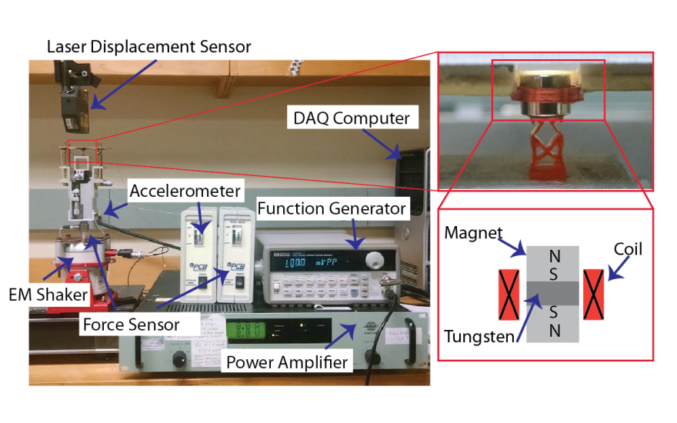

Figure 22. (left) Experimental Setup, (right) Neodymium-Ion-Boron Rare Earth Magnet(s) on top of the Projection Micro Stereo-Lithography fabricated HDDA polymer structure (lower right, VEH with load mass, top right: inside wire coil)



Figure 23. Experimental measurements of frequency dependent voltage output for density based design (=0.75) and level set design (=0.75) with different added masses



Separate vibration sweeps are performed to extract the electrical performance of the device. These sweeps represent a forced, harmonic vibration, with a sinusoidal input over a 45–550 Hz frequency sweep. The signal is controlled using a custom LabVIEW program with proportional gain feedback control to maintain a constant acceleration of 0.6 G, so as to decouple the test stand dynamics from the device dynamics. The voltage output across varying load resistances is then collected in the LabVIEW program at a sampling rate of 10 kHz. At each frequency value 20 wavelengths of data are collected, the first 10 wavelengths are ignored and peak to peak voltage values of the second 10 wavelengths are averaged and logged as the final value. To maintain a constant peak-to-peak acceleration, a similar process was used, if the acceleration was 0.6G +/- 5% then the voltage reading from the accelereometer was stored, if the acceleration was outside of that range, the input to the shaker system was adjusted according to a control theory prediction and subsequent tests were performed until the acceleration was in the desired range. After implementing control theory the system takes between one and six tests to reach the acceleration goal. From these tests, the natural frequency and power output for the vibration energy harvester are found experimentally.

The energy harvester prototypes containing the optimized designs showed clear resonances at 135.5 Hz and 171.5 Hz for the density based designs and level set designs respectively with . The structures were tested multiple times, at constant accelerations ranging from 0.2 G to 0.8G, which is representative for the vibration sources identified, for frequency sweeps from 45 Hz to 550 Hz. Figure 11 shows the voltage responses of the two structures designed by the density based TO optimization method (named D1 and D2) and two structures designed using the LSM optimization method (named LSM1 and LSM2) with and tested at constant accelerations. The density based optimized structure D1 with a 1.143g magnet has a peak at around 100 Hz, while the LSM optimized structure LSM1 with a 1.143g magnet has a major peak at around 510Hz. D2 and LSM2 have more added masses to prove that the peaks obtained are reliable.



The trend of the experiment data matches well that of the optimized results. From the simulation results in Table 1 and Table 2, we can see that density based optimized structure with has natural frequency 237Hz, and the LSM structure 604Hz, though the frequency of the excitation force is 100Hz. For the experiment data, the density based structure resonates at around 100Hz, and LSM around 500Hz. The trend of experiment data matches the trend of optimized results. The mismatch between the simulation data and the experiment data is attributed to differences in the material properties (Young's modulus and damping coefficients), physical models, and electrical damping etc. Especially for the material properties, many factors matters in the manufacturing process, such as the UV light intensity, exposure time, curing time, and volume fraction of different polymers. For the damping properties of the material, there are no accurate methods to measure them. How to accurately measure or predict the changed material properties after fabrication and integrate the information in the design stage would require further investigations.



## **4.4 Conclusion**

Here we explored the use of two popular topology optimization methods for the design of low-frequency mechanical resonators. An optimization formulation is proposed to overcome the challenges that traditional topology optimization methods face when maximizing frequency response, including degenerate, non-manufacturable optimal structures, and hinge formations. Its success is demonstrated systematically with the simulation, 3D micro-fabrication, and vibration testing of resultant designs.

The fabricated and tested resonators show that this optimization formulation, used in both the SIMP and Level Set methods, can produce manufacturable resonators with improved (i.e. lower resonant frequency) performance. The testing showed a reduction in the natural frequency from over 2500 Hz to 125 Hz for the Level Set Method and to 150 Hz for the SIMP method. Further improvements could be made by weighting the dynamic response more heavily in the optimization formulation, or using a 3D formulation.

Both SIMP and Level Set methods tended to produce thin, hinge-like areas. The SIMP method was found to benefit from the use of non-conforming finite elements to mitigate hinge formation. In both cases, post-processing was required to widen overly-thin regions.

Future extensions to this work include the addition of constraints and filters for manufacturability. Additionally, the nonlinear frequency-dependent dynamic behavior of the polymer material will be included in the finite element formulation.

# **CHAPTER 5: Metamaterials for Simultaneous vibration isolation and energy harvesting**

## **5. Material development for Piezoelectric Designs**

## **5.1 Background**

Metamaterials are artificial materials engineered to have exceptional mechanical[16, 17], optical[18, 19], thermal[20, 21] or electromagnetic[22, 23] properties not found in nature. They are usually made by conventional materials, e.g. metals and plastics, and arranged into periodic patterns in the space to achieve these exceptional properties. For instance, Fang et al. have demonstrated one-dimensional ultrasonic metamaterials through using an array of subwavelength Helmholtz resonators with carefully designed acoustic inductance and capacitance[17]. Near the resonant frequency of the Helmholtz resonators, these metamaterials displayed effective negative dynamic modulus[17], which sounds counterintuitive and has not been realized in nature. With the help of these unusual properties, e.g. effective negative dynamic modulus and density, many important applications, including negative refraction[24, 25], cloaking[26-28] and superlensing below the diffraction limit[29-31], could be achieved through these metamaterials. More interestingly, these unusually properties of metamaterials originate from their designed microstructures, not from the building materials. Thus, the shape, size, orientation and arrangement of internal microstructures determine the properties of metamaterials.

The design of mechanical metamaterials has attracted the attention of many in recent years. For example, Wang et al. demonstrated that the bandgap of acoustic metamaterials can be controlled and tuned through the buckling of microstructures[32]. Moreover, the buckling of microstructures is also found to be able to induce the auxetic behavior of 3D soft mechanical metamaterials, creating a new class of new materials “Bucklicrystals”[33]. Through direct lattice transformation, Bückmann et al. explored the mechanical cloaking behavior of 2D lattices[34]. They found that a 2D discrete lattice can be used to cloak a void with respect to static uniaxial compression, after the spatial coordinate transformation. All these works shed light on how microstructure design of mechanical metamaterials can be manipulated to enable a variety of applications.

In this Letter, we report a design of mechanical metamaterials for simultaneous vibration isolation and energy harvesting, through finite element analysis (FEA) and 3D printing-assisted experimental validation. Using a square periodic lattice as the primary structure, we attach extra cantilevers (auxiliary structure) to the primary, which can oscillate at their natural frequency. Due to the local resonant behavior of the auxiliary structure, a complete band gap can be created in the natural frequency range of the auxiliary. The suppression of the vibrations is achieved through the transfer of kinetic energy into the auxiliary in the band gap frequency range. By coating the piezoelectric thin film, polyvinylidene fluoride (PVDF), on the auxiliary cantilever, the kinetic energy can be further converted into electric energy for powering other devices. In this way, two distinct functions, vibration isolation and energy harvesting, are achieved simultaneously through the designed mechanical metamaterials, as byproducts of the same physical mechanism. This study reveals the energy harvesting mechanisms of microstructured mechanical metamaterials through a deep understanding of the interplay between phononic bandgaps and the mechanical-electrical coupling in the electroactive polymer materials.

## **5.2 Theory**

To demonstrate our concept, we use the standard unit cell of regular square lattice, as shown in Fig. 1a, as the primary structure. Then, additional cantilevers, denoted as the auxiliary structure, are attached to the primary (cf. Figs. 1b and c). The detailed dimensions of these unit cells are given in the Supplementary Material (SM) Fig. S1. The band structures of the original and modified square lattice are investigated through FEA. In this process, the homogenized mass matrix, $M$, and generalized stiffness matrix, $K$, are generated through standard finite element discretization. Then, the phononic characteristics of a periodic structure will be evaluated using a finite-element-based unit-cell technique based on Floquet-Bloch theory[66-68]. The equations of motion are given by $\left(K-ω^{2}M\right)q=0$, where $ω$ is the frequency and $q$ is a vector of generalized nodal degree of freedom (d.o.f.). After the d.o.f.s are partitioned and proper wave number dependent propagation conditions are imposed, the dynamics problem is recast as $\left[K_{r}\left(ξ_{1},ζ_{2}\right)-ω^{2}M_{r}\left(ξ_{1},ζ_{2}\right)\right]q_{r}=0$, where $K_{r}\left(ξ_{1},ζ_{2}\right)$ and $M_{r}\left(ξ_{1},ζ_{2}\right)$ are reduced matrices that depend on the two-dimensional wave number vector $ξ=\left(ξ_{1},ζ_{2}\right)$. Then, the solution of this eigenvalue problem is done by sweeping the wave vector along the contour of the irreducible Brillouin zone (cf. Fig. 1a) and solving for the corresponding $ω$. The result is coined as a band structure or band diagram and is a set of dispersion relation curves, which represent the propagation modes allowed in the structure and the corresponding frequency ranges. The existence of bandgaps is verified by isolating the frequency intervals in which no modes are allowed, where elastic waves are stopped from propagating as a result of wave interference. The detailed mathematical formulation for this problem has been given in our recent study on band structure of mechanical metamaterials[67].

## **5.3 Finite Element Analysis**

According to the above method, the band structures of the original and modified square lattices are obtained through FEA, as demonstrated in Fig. 1. As it has been discussed by Fleck ant co-workers[69], the original square periodic lattice does not have complete bandgap in the low frequency regime and other periodic lattices, e.g. honeycomb and triangular honeycomb, display bandgaps in the high frequency regime. These bandgaps are induced by the scattering of the longitudinal wave, due to the periodic variations of modulus and density in the space. Thus, the longitudinal wave length is on the same order of the unit cell size (mm), indicating that the corresponding band gap frequency will be on the order of kHz. However, the mechanical excitations and related vibration noises are characterized by low frequencies (about 100 Hz), which require the bandgaps in low frequency regime for filtering. To resolve this issue, modifications are made on these original periodic lattices to introduce additional bandgaps, as shown in Figs. 1b and c. The cantilevers are attached to the primary structure, forming extra microstructures. Due to the local resonant behaviors of these auxiliary structures, the bandgaps are created in the low frequency regime (cf. Figs. 1b and c). The similar idea has been applied to design sonic composite materials with spherical metal inclusions embedded into the epoxy matrix[70]. The surfaces of inclusions are coated by silicon rubber for local resonant to introduce complete bandgaps in the low frequency regime. Note that the location of the bandgaps can be easily changed by the design of the auxiliary structure, which will be explained in detail.

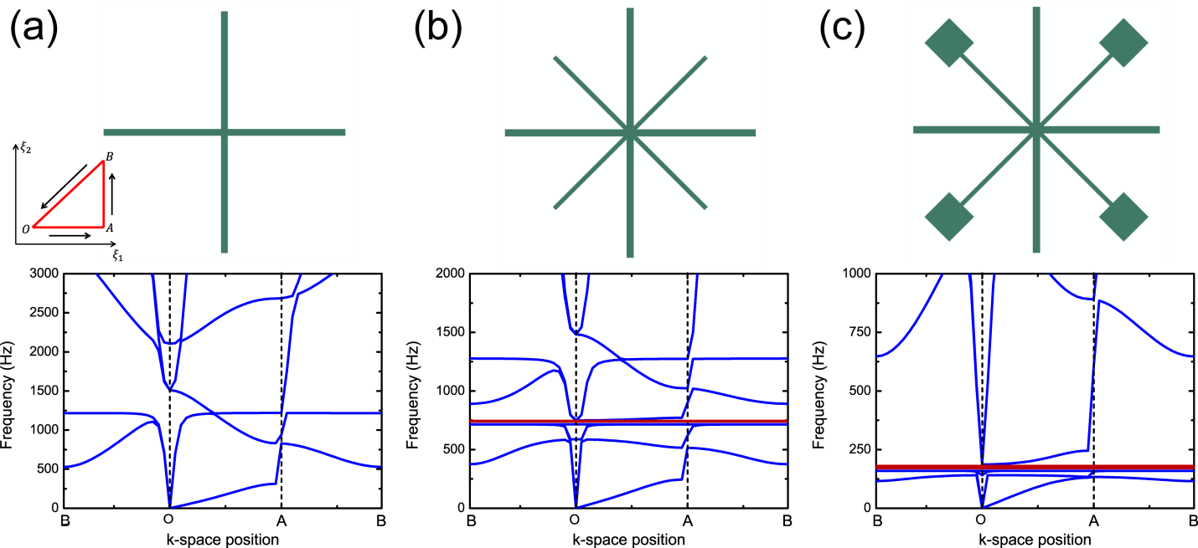

**FIG 1**. Topologies of unit cell and corresponding band structures: (a) original square lattice, (b) modified square lattice with cantilevers attached, and (c) modified square lattice with cantilevers and masses attached. The original square lattice and attached cantilevers are denoted as primary and auxiliary structures, respectively. The detailed dimension of these unit cells are given in SM Fig. S1. The irreducible Brillouin zone is given in the insert of (a). The bandgaps in (b) and (c) are 715-749 Hz and 146-171 Hz, represented by red blocks, respectively. The mechanical properties of the materials made for the unit cells are: Young’s modulus 1900 MPa, Poisson’s ratio 0.4 and density 1.099 g/cm3, given for acrylonitrile butadiene styrene plastic.

To further understand the band structures of original and modified square lattices, the mode shapes at critical frequencies are given in Fig. 2. For the original square lattice, the resonant of primary structure occurs at high frequency regime, as the fundamental resonance frequency of a pinned-pinned flexural lattice beam is given by $ω_{1}=π\sqrt{EI/ρL^{4}}/2$, where $E$ and $ρ$ are the Young’s modulus and density of the material, respectively. $L$ and $I$ denote the length and cross sectional inertia of the beam, respectively. Consequently, the lattice beam deformation displays the first pinned-pinned flexural mode at $ω_{1}$ (1613 Hz). Comparing the band structures between the original and modified square lattices, it immediately reveals that the bandgaps at low frequency regime arise from the additional cantilevers (auxiliary structure). The fundamental bending natural frequency of these clamp-free beams is given by _ENREF_22,[71] where $m$ is the end mass on the free end. Plugging in the corresponding material properties and geometric parameters of auxiliary, we can get $Ω_{1}=152$ Hz, which indeed falls into the bandgap range. Moreover, the deformations are mainly localized in the auxiliary at this frequency, featuring the first-mode-like deformed shape (cf. Figs. 2b and c). In short, the mechanical vibration energy has been localized and transferred into the kinetic energy of the auxiliary in the bandgap frequency range. Besides, the free ends of these cantilevers can be attached with masses to further reduce the bandgap frequency from 715 Hz to 146 Hz, with the similar deformation modes (see Figs. 1c and 2c). The reduced bandgap frequency has profound effect on our design, since the low frequency mechanical vibration (<300 Hz) is more abundant in nature.

From the energy harvesting point of view, the above deformation mode is ideal for a beam-like piezoelectric device. When the attached cantilevers display the first-mode-like bending deformation, the maximum stress should be observed at the root of the beam, which can enhance the performance of the piezoelectric device[72, 73]. Thus, we can design the modified square lattice structure with PVDF thin films coated on the surface of the auxiliary structure, as shown in Fig. 3a. The designed mechanical metamaterials is an assembly of 20×20 unit cells of the modified squared lattice. Here PVDF was selected for its ideal properties including low density (1.78 g/cm3) with high stretchability (10~20%), flexibility (1000 MPa) and excellent piezoelectric properties (mechano-electrical conversion, 14.4 V/N)[74]. Therefore, in the bandgap frequency range, the vibration energy has been trapped and transferred into the kinetic energy of the auxiliary structure, which can be further converted into electric energy through the piezoelectric response of coated PVDF films.

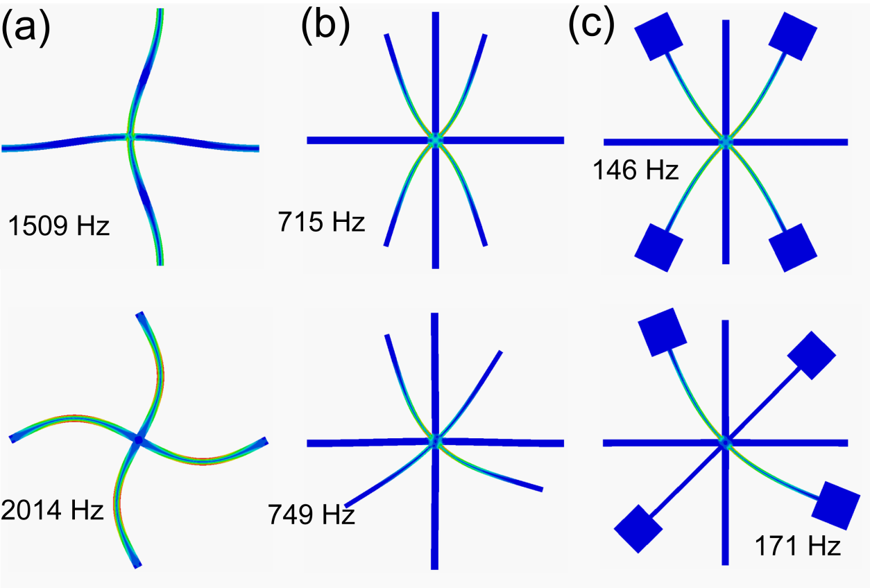

**FIG. 2** Representative mode shapes of different unit cells at O point in band structure analysis: (a) original square lattice, (b) modified square lattice with cantilevers attached, and (c) modified square lattice with cantilevers and masses attached.

## **5.4 Experimental Design**

As a proof-of-concept demonstration, the above mechanical metamaterial is fabricated using a Fortus 400mc fused deposition modeling machine (3D printing) with acrylonitrile butadiene styrene (ABS) plastic, as shown in Fig. 3b. This specific machine was selected because of its large 406 x 355 x 406 mm available build volume, relatively low cost, and +/- 0.127 mm resolution capabilities matched the requirements for the device we designed. After fabrication, measurements of each of the corresponding sections of the mechanical metamaterial were taken and compared with the original design. The smallest feature, the thickness of cantilevers (auxiliary), is about 0.63 mm, which is close to our targeted value and within the +/- 5% tolerance. Other parts of the design that had larger feature dimensions were all within a +/- 5% tolerance after fabrication.

The experimental setup, as given in SM Fig. S2, is designed to simulate environmental vibration sources, closely mimicking our conceptual design in FEA (Fig. 3a). To represent the general waveform of the vibration, a control signal is selected and generated by a function generator (Agilent 33120A). The control signal is then amplified by a power amplifier (Bruel and Kjaer no. 2718) before entering into an electromagnetic shaker (LDS V203). The resulting shaker’s waveform and force output are monitored by a LabVIEW program using an ICP force sensor (PCB Piezotronics 208C01) mounted to the shaker drive output. An aluminum fixture and clamps are used to position and fix the metamaterial under testing. To measure energy absorbed within the metamaterial, an uniaxial accelerometer (PCB Piezotronics no. 333B50) is mounted on the free end, The surfaces of cantilevers are manually attached with PVDF films (thickness 28 µm) to convert the localized kinetic energy into electric energy, as shown in Fig. 3b. The thin PVDF film was selected for its low rigidity to have minimal impact on the resonating behavior of the cantilever. Finally, the voltage output of the PVDF film is measured across a resistive load and recorded with LabVIEW.

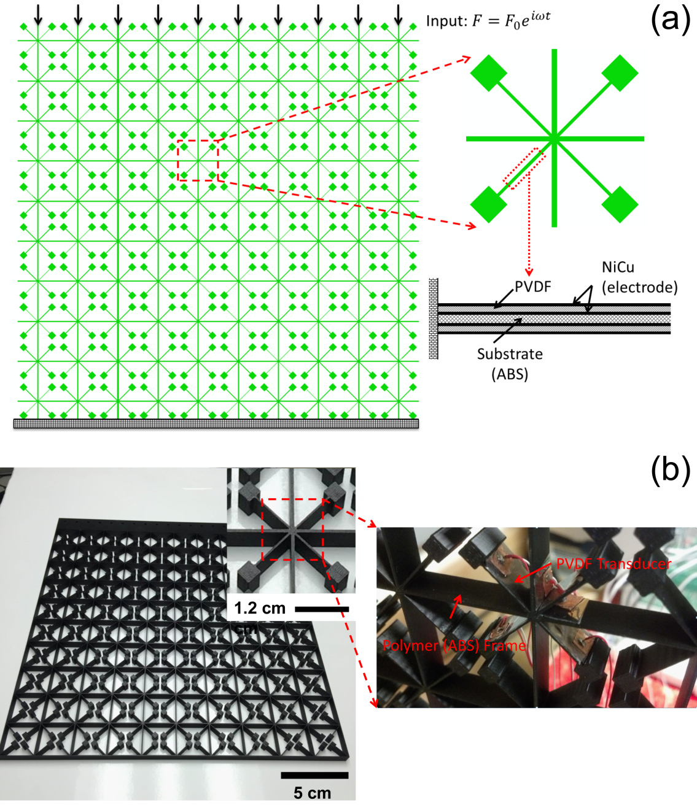

**FIG. 3** (a) Conceptual and (b) experimental design on mechanical metamaterials for simultaneous vibration isolation and energy harvesting. The mechanical metamaterial is an assembly of 10×10 unit cells. The surfaces of auxiliary structure (cantilevers) are coated with 28 µm thickness PVDF films to convert localized kinetic energy into electric energy. One end of the mechanical metamaterial is fixed in the experiments and the other end is excited with harmonic vibrations.

## **5.5 Results and Discussion**

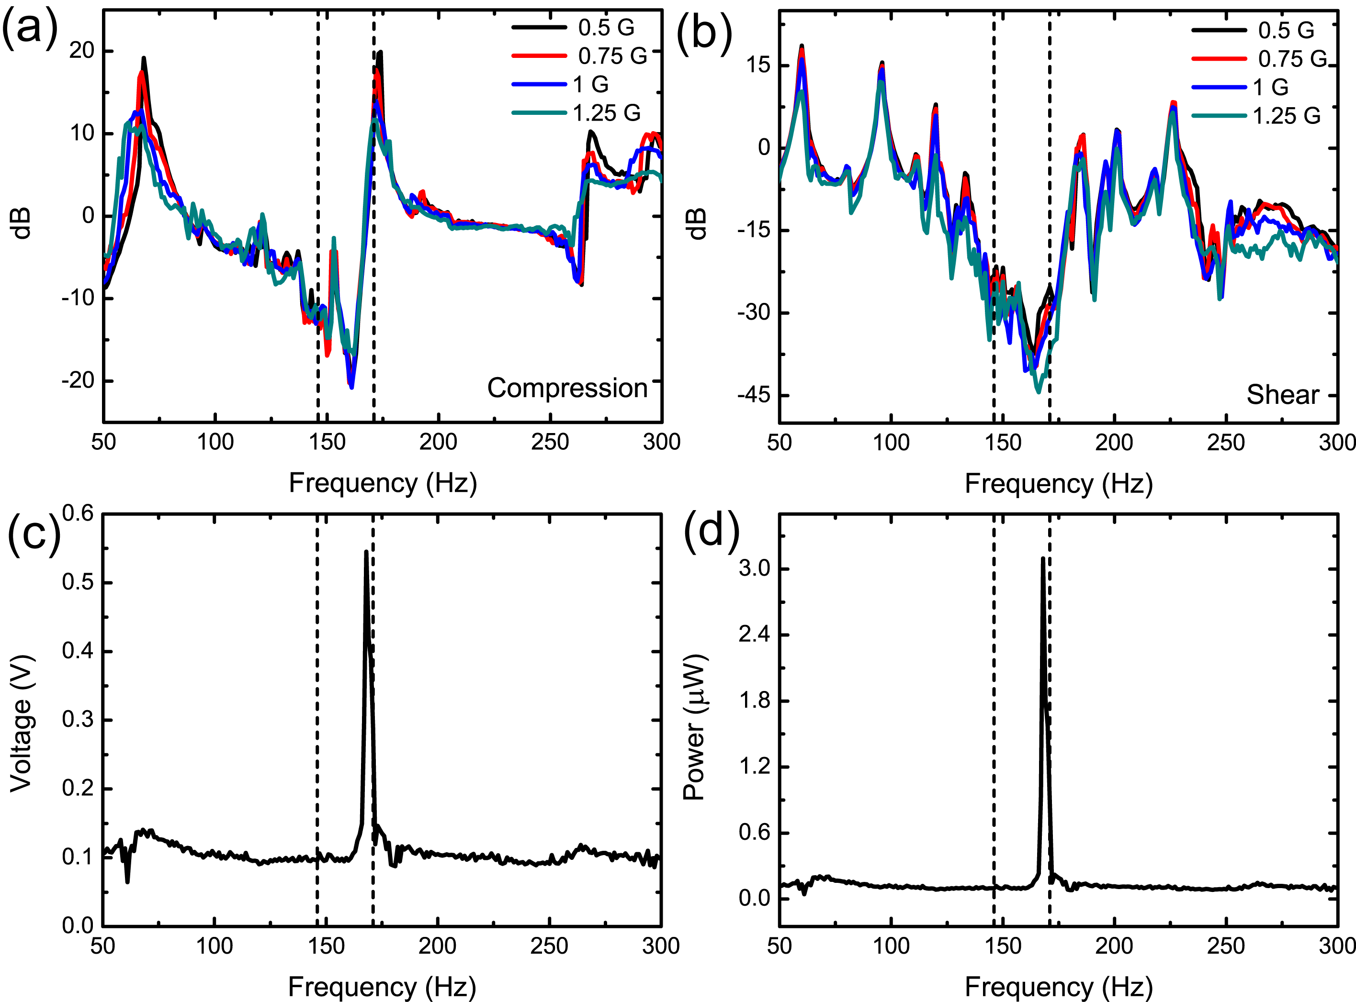**FIG 4**. Mechanical wave filtering capability of designed mechanical metamaterials: (a) compression (longitudinal wave) test and (b) shear (transverse wave) test. Within the bandgap range (indicated by dashed lines), the wave propagation has been stopped, indicating that the mechanical wave is trapped and localized within the mechanical metamaterials. Energy harvesting capability of designed mechanical metamaterials with transverse wave input: (c) voltage and (d) power output of attached PVDF films. The maximum outputs of voltage and power are found within the bandgap frequency. The power is measured across a 634k Ohm resistor.

Separate vibration sweeps are performed to study the capability of vibration isolation for the designed mechanical metamaterials. These sweeps represent the frequency response of a forced, harmonic vibration, with a sinusoidal input over a 50-300 Hz frequency sweep. The signal is controlled using a custom LabVIEW program with proportional gain feedback control to maintain a constant input force of 1N, 2N, 3N or 4N, so as to decouple the test stand dynamics from the structure dynamics. The difference between the input force and output acceleration across the device is measured and displayed in Figs. 4a and b. Within the bandgap frequency range, the vibration energy has been greatly absorbed and trapped within the metamaterial. In the meantime, the kinetic energy has been localized on the extra cantilevers (auxiliary structure), as we have observed in the FEA (results not shown here). Note that the square lattice is anisotropic materials[69] and both the compression (longitudinal wave) and shear (transvers wave) loadings are tested. The vibration isolation has been conformed to be independent on the wave direction, indicating a complete bandgap is formed in this frequency range.

The voltage output across the PVDF film is then collected into the LabVIEW program at a sampling rate of 10 kHz over the course of 10 wavelengths at the target frequency and averaged to obtain the final peak to peak result graphed. To generate a clear measurable signal from the PVDF film, up to 9 N of input force was applied to the system. From these tests, the natural frequency and power output for the vibration energy harvester are found experimentally, as displayed in Figs. 4c and d. Within the bandgap frequency range (146-171 Hz), the peaks of voltage and power output have been observed. The maximum voltage of 0.58 V was measured across a 634kOhm load and had a corresponding power of 0.53 µW, respectively. Here we should emphasize that the voltage and power outputs rely on tunable device properties including the tip mass, the beam dimensions and the thickness of the PVDF films. In the present study, we chose the thinnest available 28 µm thick PVDF films, so they would have a negligible effect on the cantilever’s natural frequency, enabling us to easily study the pure bandgap performance. To further increase the voltage and power output per beam on this device, a larger tip mass, a thicker piezoelectric film, and thinner/longer cantilever beams within each unit cell could be implemented.

In recent years, the need for multifunctional electromechanical structures and material systems with the capability to harvest energy from low frequency mechanical vibration (<300 Hz) has grown significantly in response to the proliferation of portable electronic devices, wireless sensors and micro-electro-mechanical systems, and the related demand for sustainable and reliable power sources[7, 75, 76]. The extremely low duty cycle of these systems pushes the power source requirement into the µW range[77]. Therefore, the current study provides a viable alternative to harvest ambient energy for self-powered systems, eliminating the needs for replacing batteries and creating low-maintenance, autonomous systems. Moreover, the energy generation mechanism involved in our concept exploits internal deformation states. Devices based on this idea minimize the risk of damaging the piezoelectric materials as the result of shocks or friction forces, as the active microstructure is embedded in the system and therefore shielded from the external environment. The increased robustness is expected to have a significant impact on the lifespan of the systems and the possibility to exploit the device for applications in harsh environments.

## **5.7 Conclusion**

In summary, we demonstrate a design of mechanical metamaterial for simultaneous vibration energy isolation and energy harvesting through numerical simulations (FEA) and 3D printing-assisted experimental study. The original square lattice (primary structure) has been modified by adding extra cantilevers (auxiliary structure) with surface coated PVDF films. A complete bandgap has been created due to the local resonance of auxiliary in the low frequency regime. Thus, the vibration energy has been trapped and transferred into the kinetic energy of auxiliary in the bandgap frequency, which is further converted into electric energy through the piezoelectric effect of PVDF films. The proposed mechanical metamaterials are particularly useful for advanced aerospace and mechanical engineering applications due to their multifunctional capabilities for mechanical wave filtering and energy harvesting, as well as reduced weight.

# **CHAPTER 6: PROPOSED RESEARCH Material development of bio-compatible and piezoeletric resins & new pusl printer design.**

## **6. Material development for Piezoelectric Designs**

## **6.1 Background**

In addition to developing bio-compatible materials for bio-medical implants and drug delivery, our group is interested in developing piezoelectric material to enable new types of multi-functional devices from micro-actuators and vibration warning systems to micro piezoelectric energy harvesters capable of powering wireless sensor nodes.

To enable the construction of these types of devices with additive manufacturing new types of piezoelectric resins and conductive resins must be developed. This next section focuses on the development of a new piezoelectric resin for projection micro setereolithography systems. This specific resin will be tested and developed on our exiting 3D printer and will be simultaneously used in the new inverted 3D projection system that we have constructed. In preliminary designs 30% PVDF by volume is mixed with 67.8% HDDA, 2% Irgacure 819 and 0.2% Sudan I to create this piezoelectric resin, however initial designs have proven difficult to pole and test, our group is currently exploring a number of solvents including (dimethyl acetamide, dimethyl formamide, and dimethyl sulfoxide) to dissolve PVDF material in HDDA this will reduce the viscosity of the material and enable a consistent mixture of materials. After extensive testing, we have demonstrated a viable piezoelectric material with Diethyl Fumarate.

## **6.2 Introduction to the need for piezoelectric materials**

Piezoelectricity, also called the piezoelectric effect, is the ability of certain materials to generate an AC (alternating current) voltage when subjected to a mechanical stress or vibration, or to vibrate when subjected to an AC voltage, or both. (1)

Piezoelectric materials are important because their properties enable a broad range of unique and useful devices.  One category of examples are piezoelectric transducers, such as intrusion detectors and alarms.  Piezoelectric devices are also employed at AF (audio frequencies) as pickups, microphones, earphones, beepers, and buzzers. In wireless applications, piezoelectricity makes it possible to use crystals and ceramics as oscillators that generated predictable and stable signals at RF (radio frequencies) (1).

Today the vast majority of piezoelectric films are rolled (18) or spin coated (16,17) onto a planar surface.  Although these coatings (especially rolling) are low cost and high volume, they limit a designer’s ability to use piezoelectric materials in new ways.  To simplify the production and prototyping of devices with piezoelectric and conductive components a our group has been pursuing new multi-functional materials for stereolithography printing technologies.

Stereolithographic printing technologies cure liquid resin with a UV laser or a projected UV pattern.  Examples of commercial companies selling these printers include EnvisionTec(19), which sells micro stereolithography and projection stereolithography printers; Stratasys (20), which sells ink-jet printers based on a UV curable resin; and two new low cost entrants:  Formlabs (21), selling $3000 micro stereolithography printers and MakeX, selling a $2000 projection stereolithography printer. A last and very exciting company Carbon3D is developing a printer based on projection techniques and CLIP technology and is able to print designs 25-100 times faster than all of the previously mentioned competing technologies. As the new low cost options begin to proliferate, the demand for multi-functional resin materials will continue to increase.  The piezoelectric material we are describing in this work could be modified easily to function on any of these existing commercial printing technologies.

To address the gap in functional materials available, a number of groups have been exploring the possibility of additive manufacturing of piezoelectric materials. Notably Sun et. al (2,3) developed a piezoceramic able to 3D print detailed designs out of a piezoelectric material. However, the material was very brittle, required a post process step of baking at hundreds of degrees C which caused large internal stresses and would deform designs, addressing this issue was what inspired the development of our polymer PVDF based piezoelectric material.

In addition to piezoelectric materials other groups have developed conductive stereolithography materials.  In 2006, Sandoval et al. functionalized a stereolithography resin by integrating carbon nanotubes, enabling conductive properties of the material.  In 2014, a conductive transparent material using a polymer ionic liquid was developed and printed in high resolution on a projection micro stereolithography machine (23).In addition to conductive materials, Polymer Supermagnetic (13), magnette/thermoplastic material (14), Magnetic Nano-Composite Resins (10) have been developed.

The material we have developed contains PVDF, a piezoelectric polymer which possesses 10 times the piezoelectric properties of a similarly sized quartz crystal (24).  Although PVDF was initially the obvious choice to mix into projection resins, past researchers have had extreme difficulty integrating PVDF into a functional piezoelectric resin. (26) After running our own experiments we found this difficulty was due to the extremely high viscosity of PVDF when mixed with most solvents, dealing with a quickly separating suspension and solvent evaporation problems.  We have addressed these issues by identifying the a ‘gold standard’ solvent DEF (Diethyl Fumarate).  This solvent has an extremely low evaporation rate, an extremely low viscosity, completely dissolves PVDF in HDDA, along with Sudan I and Irgacure 819.  This solvent also holds the PVDF in suspension for up over 48 hours, (figure 8) enabling a large number of prints before the material needs to be re-mixed (sensors were printed mixing the resin every 2 hours).  By using this solvent in concentrations of 15-25% by mass we have been able to successfully print 15-25% by mass PVDF concentration imbed in 30-40% HDDA with 20-30% DEF. Not only can we print at resolutions approaching 7um with layer depths of 20um (Figure 9), this material maintains strong piezoelectric properties and we have measured g33 over 100 V*m/N*10^-3.

The rest of the paper is organized as follows, a theory section focusing on how piezoelectric materials (specifically PVDF) works, and how temperature can impact the PVDF polling results.  It is followed by an experimental fabrication section where the custom 3D printer we are using in our lab is explained in detail as well as the fabrication of each individual sensor.  The next section are the experimental results, including g33 measurements of sensors with different concentrations of PVDF, poled at various temperatures, and the impacts of temperature and PVDF concentration on the material’s viscosity and printability. Those graphs are followed by a time-lapse of the suspension separation and a section demonstrating the high resolution capabilities with this material through a print of St. Basil’s Cathedral.  Lastly, the information is summarized in the conclusion where future methods to improve piezoelectric coefficients are also discussed.

## **6.3 Piezoelectric Material Theory**

## **6.3.1 PVDF Theory**

PVDF is a highly non-reactive thermoplastic fluoropolymer and is produced when vinylidene difluoride is polymerized. As a thermoplastic it becomes pliable or moldable above a specific temperature and solidifies upon cooling.  As a fluoropolymer, PVDF contains multiple strong carbon-fluoride bonds and is characterized with high resistance to solids, acids and bases. This resistance makes PVDF difficult to dissolve into a liquid form without a strong solvent.

A piezoelectric material generates a spurt of charges when stressed.  Stress causes a change in the distribution of charges in the film. When surface charges change, electrodes next to each surface gain or lose electrons in order to restore neutrality of charges in the sensor film. When a mechanical force acts on the PVDF film, the voltage produced is directly proportional to how much and how rapidly the film is deformed. The greater the deformation of the film, the higher the voltage will be. (27)

Piezoelectric polymer films are also pyroelectric. As PVDF film absorbs thermal energy (as in a motion detector), it will expand (B) and contract in response to the thermal gradient developed. This redistributes electrical charges in the film, which generates a voltage. (27)

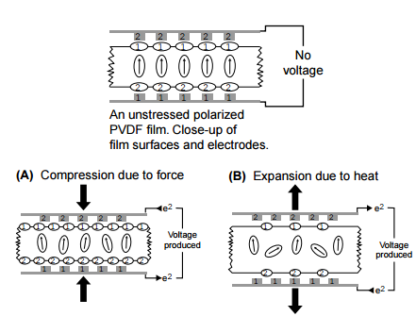

Figure . Image description of the piezoelectric effect and pyroelectric effect for PVDF polymer films. (27)

## **6.3.2 Temperature vs. Polling PVDF Theory**

Kaura et al [27] have studied the piezoelectric constants of PVDF as a function of the poling temperature (20–120 C), stretching ratio (2–5×) and poling field (0.1–0.8MVcm−1). The piezoelectric constant is calculated from

d31 = (Q/A)(tw/F)                                                                               Equation 1.

where *Q* is the induced charge, *A* is the electrode area, *t* is the thickness, *w* the width of the sample, and *F* is the applied force.

Similarly, Huan et al (28) studied the impact of the poling temperature and the poling field on the piezoelectricity of PVDF. It is reported that d33 of PVDF is proportional to temperature if the poling temperature is below 65°C. If the temperature is higher than 65°C,  d33 of PVDF will decrease due to reduced effective poling field and lower transformation ratio of alpha phase to beta phase.

## **6.3.2 Mechanical Strain vs. Polling PVDF Theory**

It is known that dipole moment is directly involved in the piezoelectric effect. (30) Enhanced piezoelectric effects will be observed when the mechanical stresses imparted to the material are stresses which directly affect the dipole moment. This effect  occurs because stress applied along the polymer chain can deform the polymer fragment from an alpha crystalline form into a crystalline form that resembles the beta crystalline configuration. Because the piezoelectric effect in polymers is primarily caused by these longitudinal deformations, it is reasonable to consider that the best response from polymeric materials will not arise from compression but rather from direct uniaxial tension or direct longitudinal deformation. By attempting further strain along the covalent bond direction through direct uniaxial tension, higher dipole moments may be expected.

## **6.4 Experimental Fabrication**

## **6.4.1 Experimental Fabrication**

Projection microstereolithography (PμSL) builds microstructures from a photo-curable piezoelectric resin/ink (V-Ink) in a layer-by-layer fashion directly from a 3D CAD design. Each layer is cured in a single exposure by using a liquid crystal display (LCD) panel as a dynamic mask for the UV light. This allows for a drastic reduction in fabrication time compared with conventional 3D printing process, which fabricates 3D structures in a point-by-point scanning fashion.

     The entire process flow is shown below. Prior to sensor fabrication, a photo-curable V-Ink was formulated as described in the section below. The CAD structure is sliced into a series of cross sections, which are then converted into bitmap images. This slicing is done using a MATLAB code developed specifically for this system. The UV absorber and light intensity concentration is tuned to obtain a curing depth of 20 microns, determining the necessary slicing layer thickness.

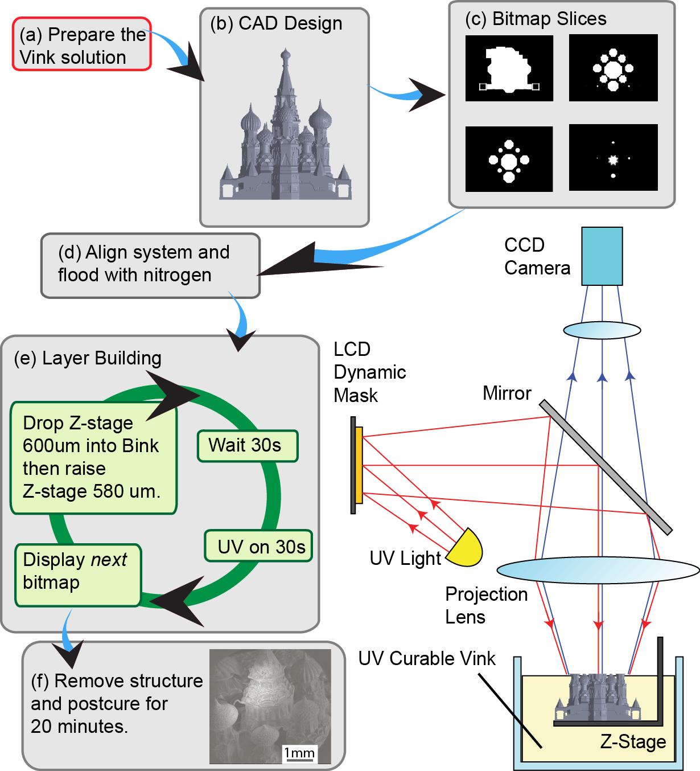

Figure . PuSL System Flow Diagram.

       The silicon wafer is then aligned with the top of the V-Ink layer, and the 160 liter PuSL chamber is filled with nitrogen gas. This reduces the concentration of oxygen within the chamber and ensures optimal solidification and resolution of the photo-curable V-Ink. Afterwards, the layer building process begins. The first sliced bitmap image is displayed on the dynamic mask (in this case, a 1400 × 1050 pixel array), and the wafer drops by 20 microns. The system then waits 30 seconds for the V-Ink to settle. The UV lamp is turned on for 20 seconds, reflects off a beam splitting mirror, passes through a reduction lens and finally projects onto the surface of the V-ink in high resolution, with each pixel corresponding to 7.1 × 7.1 μm2 repeats for each bitmap layer in the fabrication.

## **6.4.2 Fabrication of V-Ink Sensors**

Each piezoelectric film tested in this study was fabricated using our lab’s custom projection microstereolithography machine.  The material contains 16-25% PVDF, 20-25% DEF, 50-60% HDDA, 2.2% Irgacure 819 and 0.12% Sudan I.  This range of compositions enabled a curing depths in the range of 20-50um with 30 seconds of UV exposure (at this power intensity).

After the device was fabricated, it was placed in a DEF solvent bath and cleaned for 2 minutes.  Once cleaned, the structure was placed in a UV oven (36 Watt) 10-20 minutes to further solidify each design.  Conductive aluminum layers were then attached to each side of the sample using silver paste and copper tape was used to attach wire leads.

To poll each sample, we used a high voltage power supply (Stanford Research Systems, Model PS310/1250V-25W) and provided 3MV/m to 12MV/m electric field. The results of our polling are discussed in the following section.

## **6.5 Experimental**

## **6.5.1 Experimental Design**

Figure 3 depicts the sensor design, dimensions and experimental setup that was used to collect the piezoelctric stress coefficient (g33) of various materials that we 3D printed in our lab.

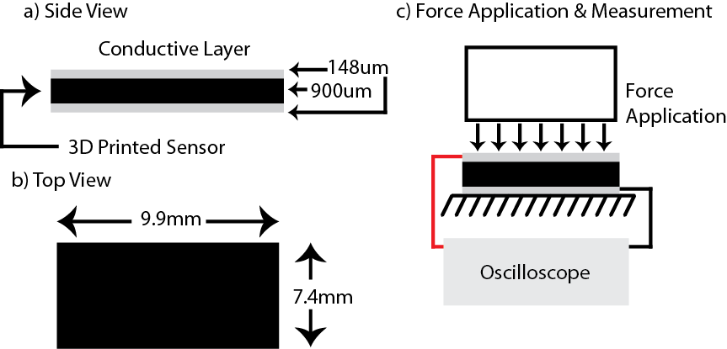

Figure . Sensor & Experimental Design.  a) depicts a side view of the fabricated sensor including the one example 900um thick sample with 148um thick conductive layer  b) represents a top view of the fabricated sensor and c) depicts the force application and data collection setup.

## **6.5.2 Varying PVDF Material Concentration**

In this section we explore how various concentrations of PVDF impact the 3d printed piezoelectric material properties. 9.9mmX7.4mmX0.9mm samples containing various concentration of PVDF are fabricated by PuSL printer. Each sample is made at room temperature and polled for 40 minutes. Constant force is applied on sample by force sensor and output voltage is measured by oscilloscope. The results are shown in Figure 4.

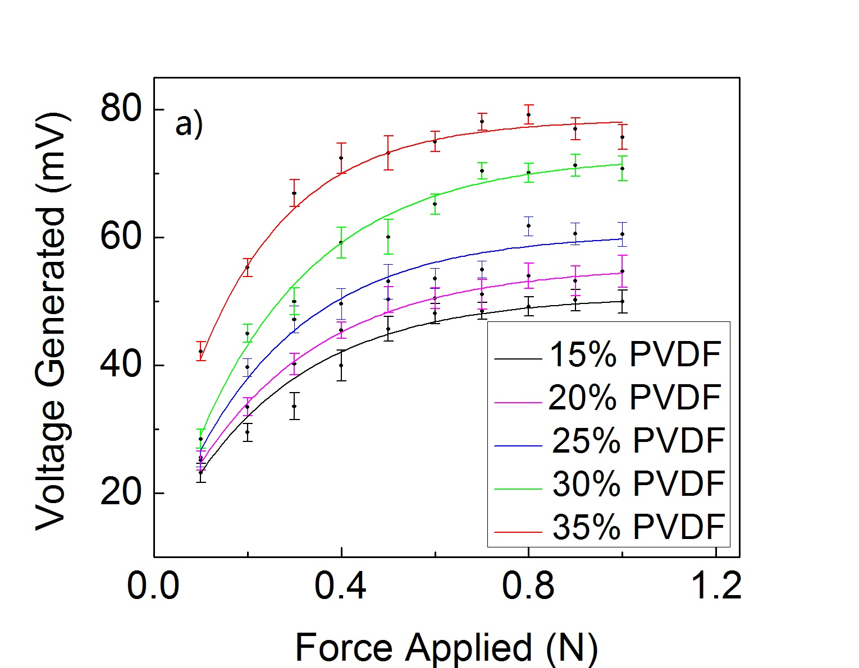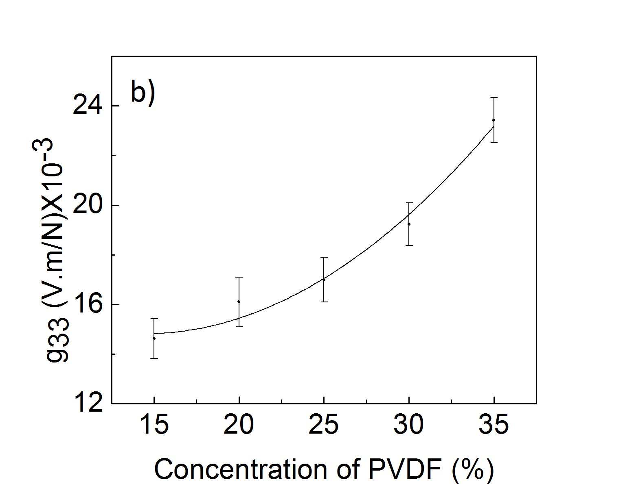

Figure . Voltage output versus Force for 15 to 35% PVDF concentration materials(figure a), and measured g33 for 15 to 35% PVDF (figure b)

Here we demonstrate as the percentage of PVDF increases from 20 to 35 wt.% the voltage generated increases by 75%.Correspondingly, the absolute value of g33 , as shown in Figure 4,b, also increase by 75%, when concentration of PVDF increase from 15% to 35wt.%. The concentration of PVDF has a significant effect on the g33 value of the samples, because PVDF is the only piezoelectric material in resin. In order to fabricate samples with high piezoelectric properties, the centration of PVDF should reach a relative high value. However, when concentration of PVDF is beyond 35wt.%, the viscosity of resin will increase dramatically, which will disable the focusing process of printing.

## **6.5.3 Varying the Poling Electric Field**

Poling temperature can have a large impact on the piezoelectric properties of PVDF. To test the printed film we applied  various strength electric fields passing through our device.  We found that, in fact, increasing the poling electric field  does have a significant impact on the g33 of the device. As shown in Figure 5.  Increasing the poling electric field  to 12 MV/m from 3MV/m increased the g33 of a single film design by 500%. We found that under 12 MV/m electric field, g33 of the 30% PVDF film reached it expected maximum value, 30% of pure PVDF.

Figure 28,a represents varying voltage output of samples under  the poling electric field from 3MV/m to 12 MV/m. We were able to generate different electric fields by changing thickness of the sample. In order to get a high electric field, the sample needs to be designed thin. While the voltage output is proportional to thickness if force applied on sample is constant. So in Figure 5, even though sample polled under 12MV/m can reach the highest g33, it does not generate the highest voltage due to small thickness. While the sample polled under 4MV, which generate more voltage not only has a relatively high g33, but also has a large thickness. We found that , in order to get high output voltage, we should take both electric field and thickness into consideration.

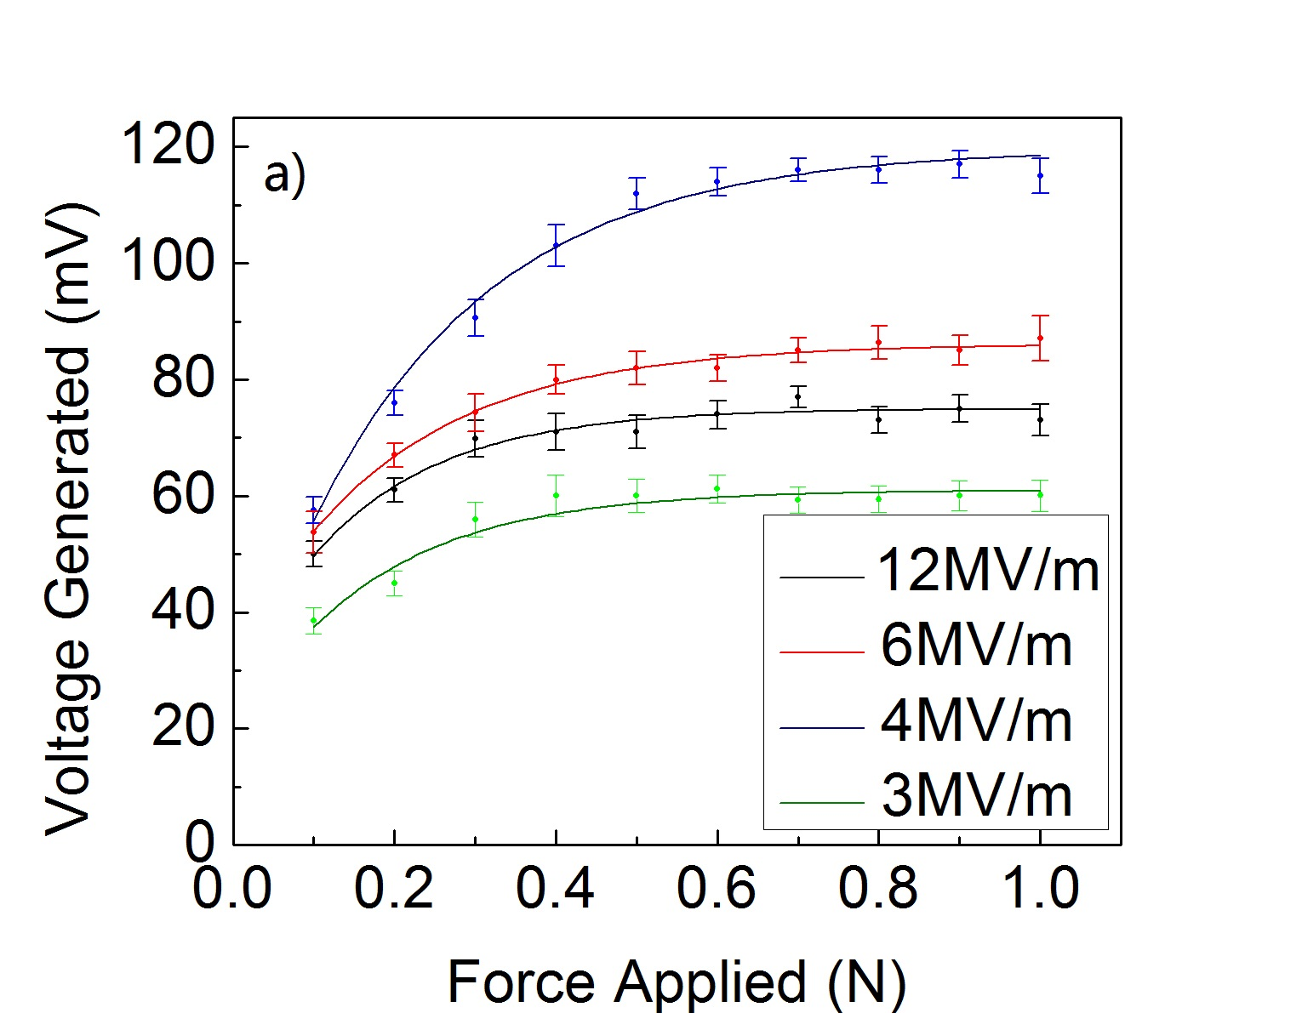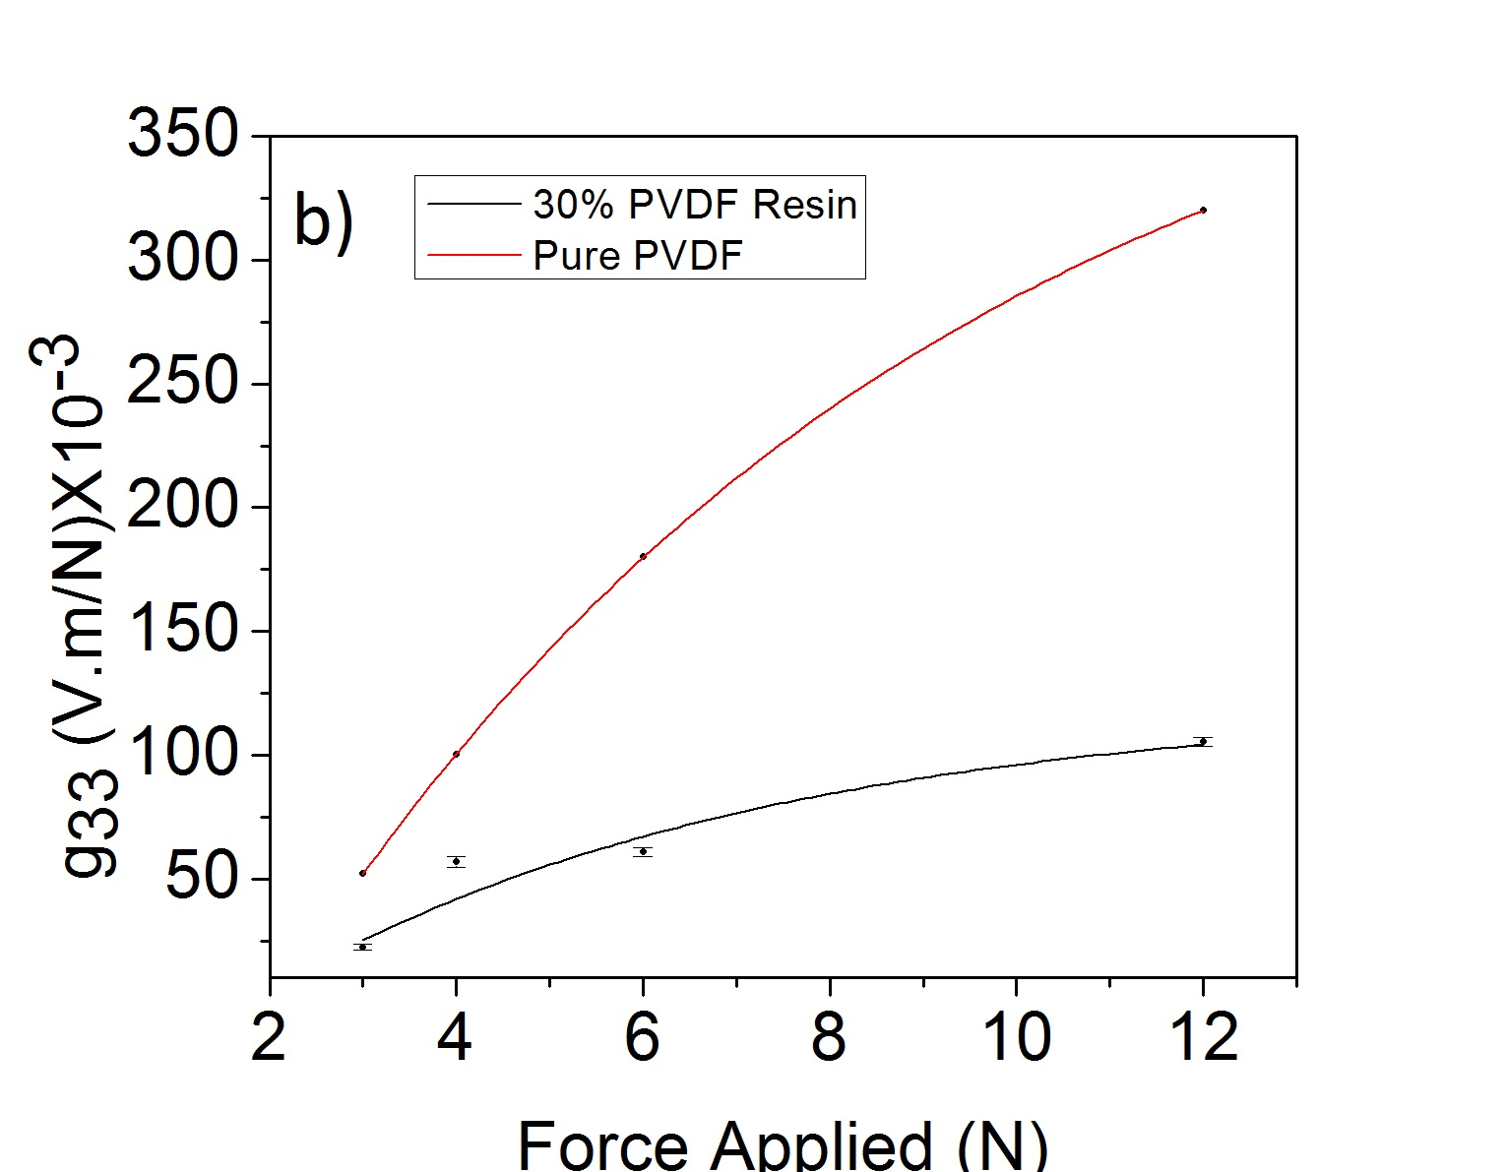

Figure . Force Applied N for materials subjected to various polling voltages (figure a) and Measured g33 vs. Polling Electric Field Voltages for 30% PVDF and for Pure PVDF(figure b).

## **6.5.4 Viscosity vs. % Concentration of PVDF**

As a plan for future work, we wanted to determine the maximum amount of PVDF that could be printed with on our PuSL printer.  The maximum percent PVDF used in a given print is viscosity limited.  When the viscosity of the liquid V-Ink gets too high, the resin will no longer settle flat on the fabrication platform, without settling flat the V-Ink thickness can be so large than the curing depth.

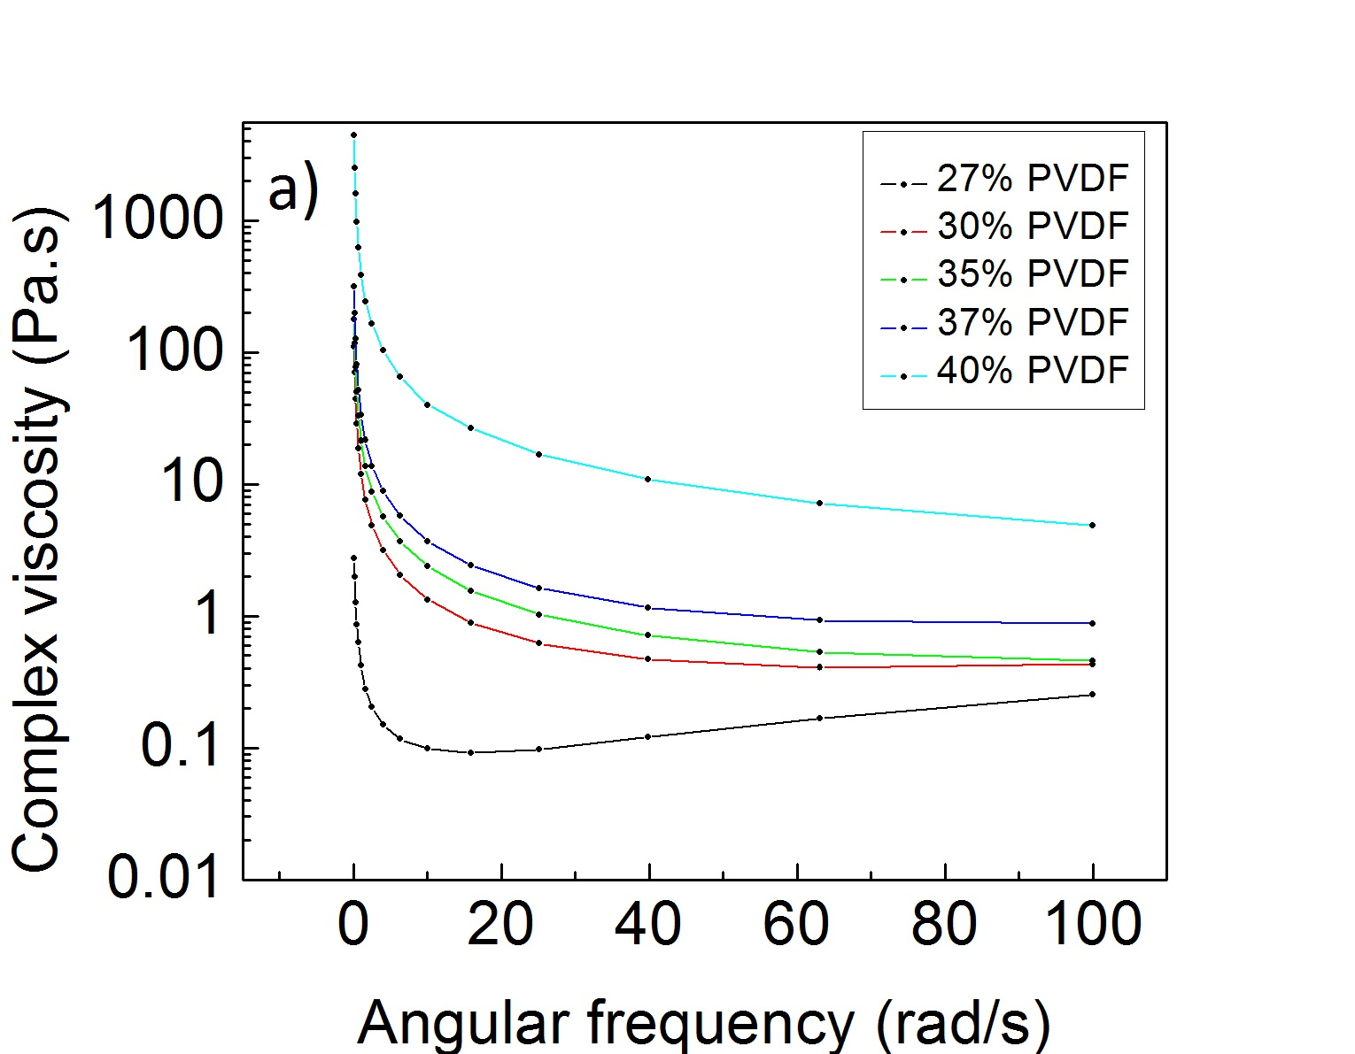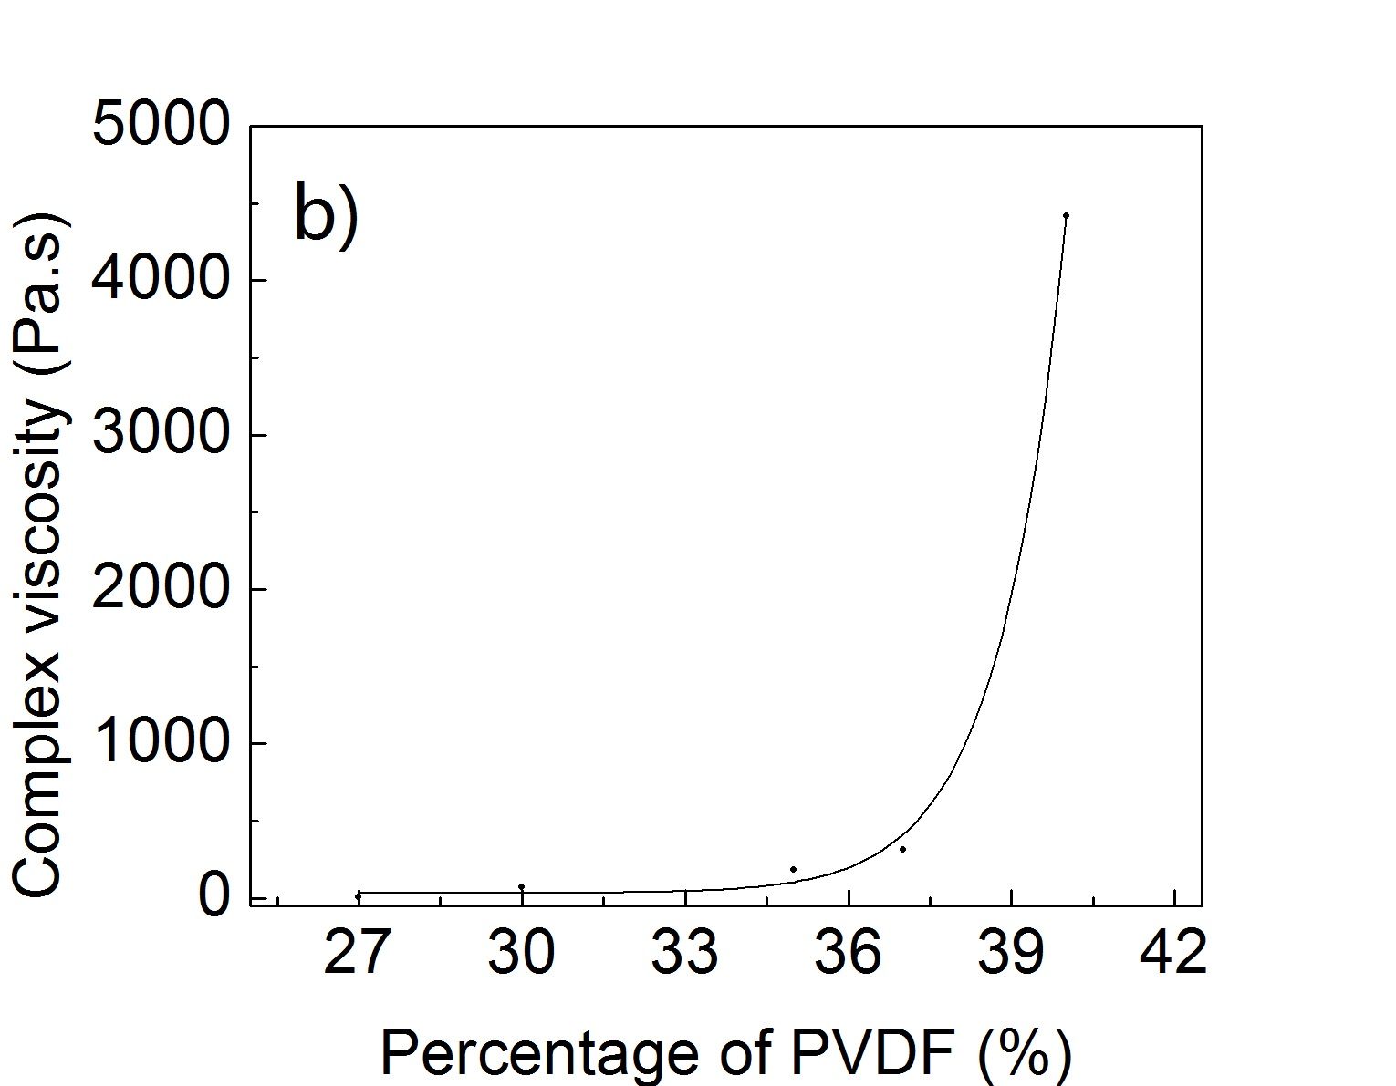

Figure . Complex viscosity for materials subjected to various angular frequency (figure a) and complex viscosity for various percentage of PVDF (figure b)

The graph of Viscosity vs. Temperature and PVDF % demonstrates the viscosities of the materials we have been printing with on our projection system.  A viscosity below 100 Pa.s is required for successful printing on our projection microstereolithography machine.  This information informed our initial tests such that a maximum concentration of 35% PVDF was used at room temperature.  As shown in Figure 29, we also found that the viscosity of resin will increase dramatically when concentration of PVDF goes beyond 37%. The tenfold increase in viscosity measured when PVDF concentration reached 40% PVDF disabled the PuSL printer’s ability to focus and caused a total fabrication failure.

## **6.5.5 Experimental Verification of Suspension**

To verify that this material was a suspension and not a solution we tested the viscosity of this material over time and measured the quantity of viscosity change between tests. The data in Figure 30 demonstrates that the rheology machine not only measures the viscosity, but also quickly separates the suspension.

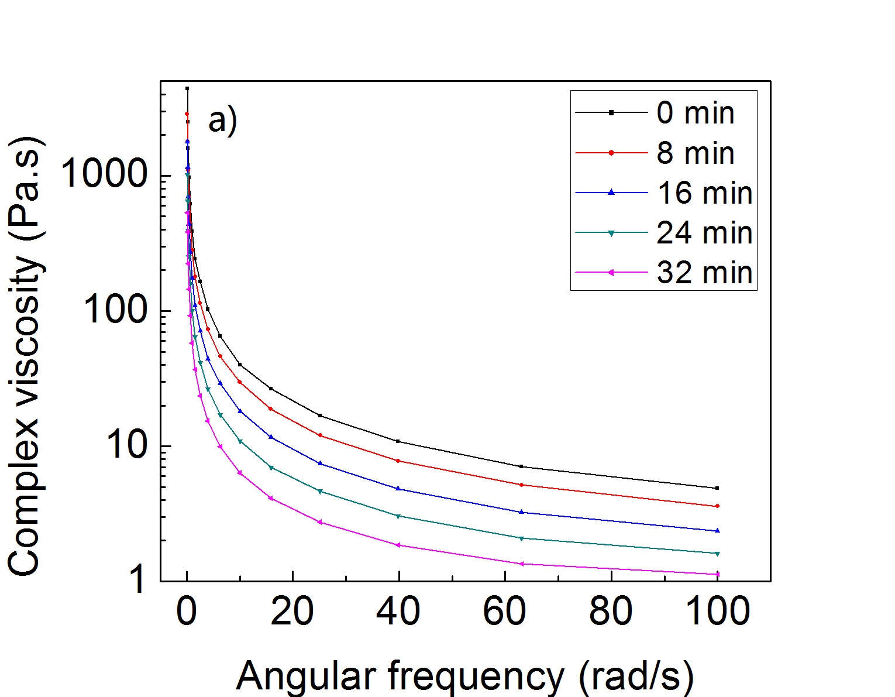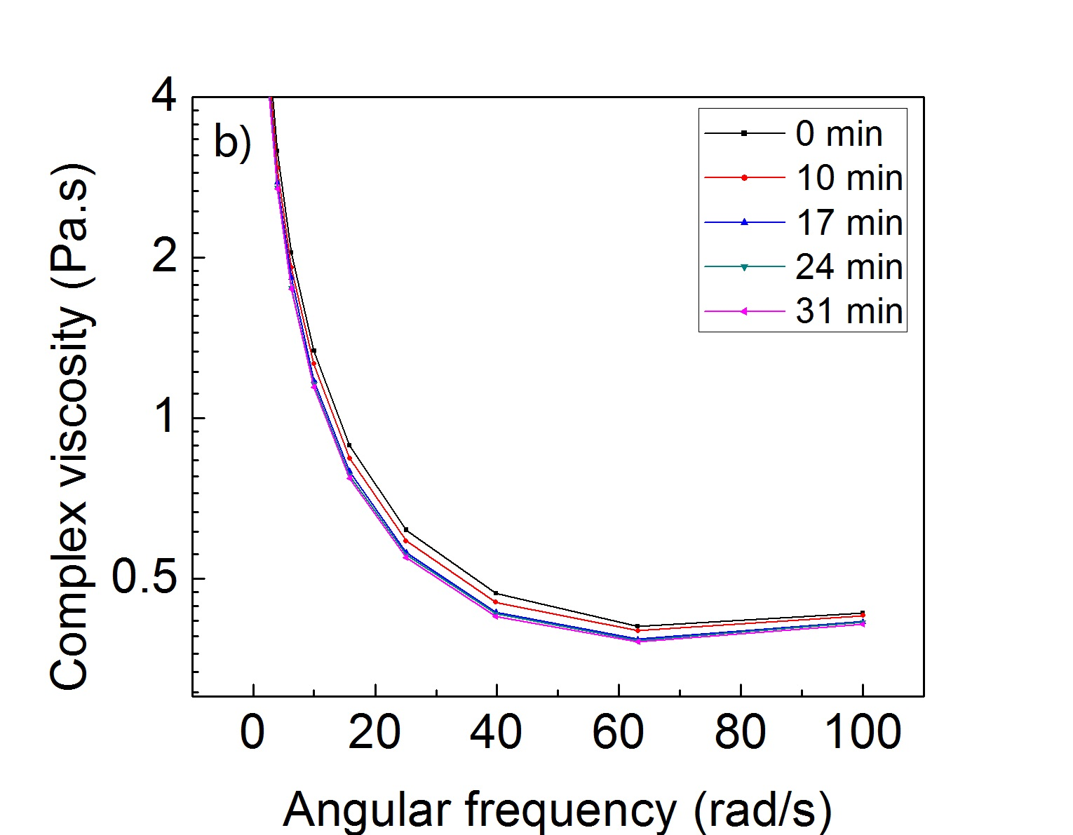

Figure . Complex viscosity for 40% PVDF over 32 minutes (figure a) and  Complex viscosity for 30% PVDF over 31 minutes (figure b)

Under four tests the material separated gradually and was measured as less viscous. Each test was performed under identical conditions. 40% PVDF, 50um separation gap, and at room temperature. A similar test was performed on 30% PVDF resin. The data shown in Figure 7 demonstrates the similar separation trend of materials. One reason for this behavior is the close matching between the densities of HDDA (1.01g/cm^3)(9), DEF, and PVDF (1.78g/cm^3 - Google). After separation, mixing the resin for 5 minutes re-creates the suspension and enables consistent properties.

To further demonstrate the suspension properties of this material, a time-lapse video of the material through a transparent beaker was collected using a Nikon 5000 DSLR camera. The goal of this test was to determine the amount of time required for the suspension to separate.  The entire time-lapse video is included in the supplemental materials and a series of six images between up to six hours after the time of mixture is displayed in Figure 8.

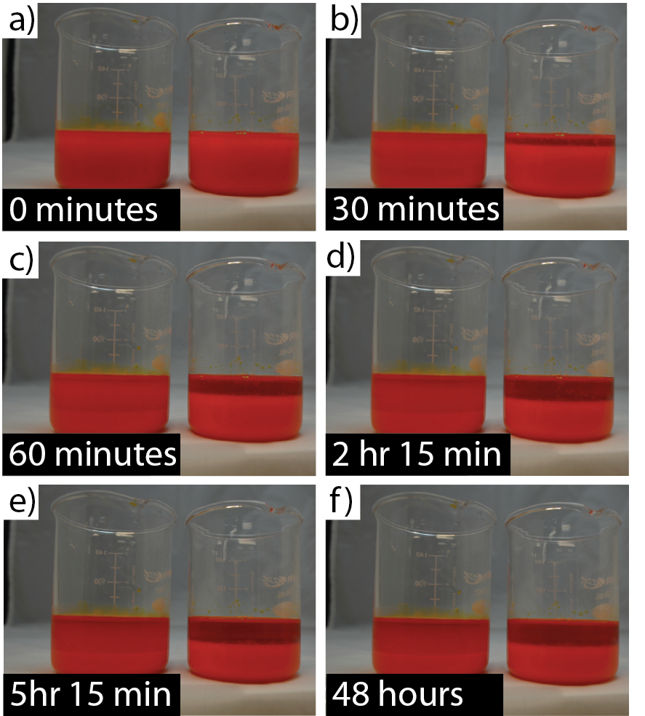

Figure . Optical Images of 60ml beaker mixtures of material.  Left beaker contains 15% PVDF V-Ink and the right beaker contains 15% PVDF V-Ink with 8 grams of added surfactant.  Even after 7 hours and 15 minutes, PVDF particles in the left beaker are still dispersed throughout the material.  Significant ‘settling’ of the material can be noticed by 60 minutes after the V-ink material is mixedremains quite stable between 2 and 7 hours when compared with the material with added surfactant (right).

This time lapse demonstrates that a significant portion of the V-Ink material separates after the first hour.  Between hours 1 and 7, the material remains highly stable with clear quantities of PVDF particles suspended in the resin.  The added surfactant added in the right beaker accelerates the separation and a clear difference can be noted between the transparency of the right and left beakers.  We can also be confident that PVDF particles still remain suspended in the material even after long time durations based on our fabrication outcome for St. Basil’s Cathedral (Figure 9.)  SEM Images of the top of the towers (Figure 9 c,d, and e) clearly show PVDF particles suspended within the material.  The complete St. Basil’s Cathedral print took over 10 hours and the material remained un-mixed during that period of time.

## **6.5.6 Experimental Demonstration of High Resolution: St. Basil’s Cathedral**

To Demonstrate High Resolution Capabilities with this new V-Ink material.  St. Basil’s Cathedral (Figure 32) was fabricated with 7um pixel resolution.  Figure 9,a shows an optical microscopy image, focused on the central tower with six of the adjacent towers clearly in view.  One unique feature of St. Basil’s Cathedral are the various surface finishes of each tower and in both the optical and SEM images even these small details can clearly be identified.   Figure 9,b demonstrates a top-down image of St. Basil’s Cathedral.  Figures 9 c,d, and e show the layer resolution of this printing technology at 50um and 10um magnification.  The integrated PVDF particles suspended uniformly throughout this material can clearly be seen.

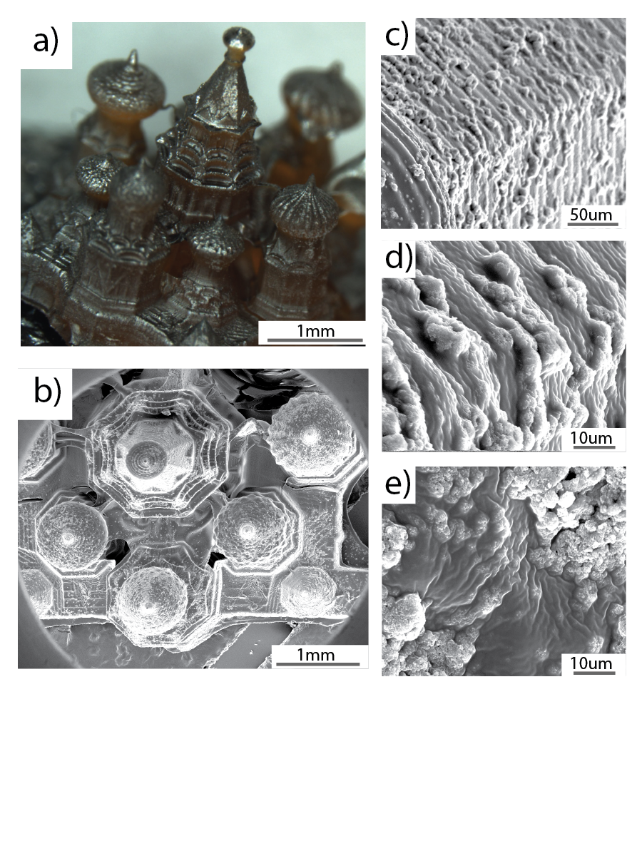

Figure . Scanning Electron Microscopy Images of St. Basil’s Cathedral.

## **6.6 Recommended Next Steps in Piezoelectric Material Development**

Additional work will be done to further increase the piezoelectric properties such as heating 30-50wt.% concentration PVDF material. Heating reduces the effective viscosity within the fabrication range, thus enabling successful printing.  Additional printing with this material will be performed on a CLIP (continuous liquid interface production) printer that we are constructing and this new printer will be compatible with higher viscosity materials. Pairing those two advancements will enable faster printing and a significant increase of piezoelectric properties. To further increase the effective piezoelectric properties of PVDF polymers, a mechanical to electrical enhancer such as carbon nanotubes will be added to resin.The addition of CNTs has been shown in the literature to stiffen the polymer matrix, increasing the mechanical response of the piezoelectric material when the polymer chains are strained.

## **6.7 Summary of New Piezoelectric 3D Printable Polymer Results**

A new piezoelectric material (V-Ink) consisting of PVDF, HDDA, Irgacure 819 and Sudan I and DEF has been optimized for compatibility with projection stereolithography additive manufacturing techniques. This new material enables a PuSL printer to fabricate structures with high resolution. The piezo-electric properties (g33) of the printed structures are explored. The results demonstrate that piezoelectric properties of V-ink depend on PVDF concentration and polling electric field magnitude. In addition, we found that the viscosity of resin will affect the quality of printed structures. PVDF concentration above 35wt.% leads to a  dramatic increase in the viscosity, which will disable the PuSL printer to fabricate structures with high resolution. The suspension nature of this material was verified through viscosity testing over time. We also found that the V-ink is a suspension which will separate after about 15 hours without mixing. Five minutes of mixing of the resin will re-create the suspension and enable consistent properties.

# **CHAPTER 7: Material development of bio-compatible resins & STENT DEVICES**

## **7.1 Novelty and Utility of B-ink Stent Designs**

This invention disclosure reports a method for rapid fabrication of endovascular stents using a biomaterial ink (BInkTM) via 3D printing or additive manufacturing processes with micrometer accuracy. The method includes preparation and optimization of the BInk to be suitable for the 3D printing process, digital representation of stent design using Computer-aid design (CAD) modeling, optimize the stent mechanical properties using numerical simulation, fabrication processing parameters for device prototype and scalable manufacturing. BInk can be photopolymerized by ultraviolet or visible light at various wavelengths. Different stent structures such as sinusoidal formed wire, helical wrap or laser fused strut can be customized with patient-specific features in the CAD model and subsequently fabricated using the 3D printing system with high fidelity. By optimizing the stent geometry, polydiolcitrate solution composition, initiator concentration, and curing conditions, the mechanical properties of printed stents can be tailored to closely match with blood vessel or a bare metal stent. The kink-resist stent design can be obtained by incorporating the stent strut exhibiting near-zero or negative Poisson’s ratio. Finally, the use of biodegradable materials allows for the encapsulation and slow release of drugs from the bulk of the stent rather than a coating that is applied to the stent struts.

## **7.2 Background**

Percutaneous coronary intervention (PCI) is a commonly performed procedure in cardiovascular medicine [35]. Since the implantation of the first bare metal stent (BMS) was reported in 1986 [36], coronary artery stenting quickly established its role in angioplasty [37]. Although stenting improved the outcome of balloon angioplasty, in-stent restenosis due to neointimal hyperplasia remains a challenging problem in the treatment of vascular occlusions [38]. Stents that elute drugs such as paclitaxel or sirolimus have shown some improvement regarding the inhibition of neointimal hyperplasia and a number of second-generation drug-eluting stents (DES) have received CE Mark for clinical use in Europe, or approved by the US Food and Drug Administration [39-41]. However, DES have a relatively higher late-stent thrombosis rate than BMS [42]. Biodegradable stents (BDS), both metallic and polymeric, offer a promising alternative to conventional BMS and DES in providing temporary drug release for vessel patency, resisting late stent thrombosis due to uncovered struts, and potential reduction in the usage of antiplatelet drugs [38, 43]. Moreover, disappearance of BDS over time allows for eventual recurrence of natural vasomotion.

Among natural and synthetic biodegradable polymers, chitosan [44], poly(4-hydroxybutyrate) (PHB) [45], poly(-caprolactone) (PCL) [46], poly(L-lactide) (PLLA) and poly(D,L-lactide) (PDLLA) [47], [48] and its copolymers or composites [49, 50] have been extensively investigated for use in resorbable devices. In particular, a polylactide stent (Igaki Tamai or BVS) has been shown to degrade into metabolites such as lactic acid, CO2 and H2O in two years and to date appear to be safe when used in human coronary arteries [47]. Relative to a BMS, the self-expandable PLLA stents require 8 min for full-expansion in an aqueous environment due to the viscoelastic behavior of polymer 37oC [51], which increases the risk of ischemia and myocardial infarction. Late shrinkage after degradation also remains a concern. It’s important to note that as with metal stents, there are manufacturing challenges for strut design, processing, and fabrication.

Over the last decades, rapid prototyping techniques such as stereolithography, selective laser sintering, fused deposition modeling and others have been developed for high precision manufacturing of customized biomedical devices, greatly expanding in biomedical research and tissue engineering for a broad range of functional and structural materials such as hydrogels, polymers and ceramics [52, 53]. Melgoza et.al. optimized the continuous tool path planning strategies for open sourced and commercial fused deposition machines (FDM), making a customized tracheal stent rapidly and affordably [54]. In comparison to selective laser sintering and solid ground curing, stereolithography offered the best surface finish in the process of customized tracheobronchial stents, while selective ground curing had the best repeatability of length [55]. Unlike the above large-size stents, Park et.al. was able to extrude a bioabsorbable drug-coated stent with a 300um strut diameter using PCL polymer and a rapid prototyping technique [56]. These stents showed to be effective in reducing neointimal hyperplasia, inflammation and thrombosis formation. Sun et. al. disclosed a 3D micro-jetting free molding technique to fabricate slide or snap fastener biodegradable stents with polydioxanone (PDO) [57]. Different from extrusion techniques in 3D printing, projection microstereolithography (PµSL) offers a high precision and high resolution processing method with a digital micromirror device (DMDTM, Texas Instruments) as a dynamic mask [58, 59]. Using a photo-curable polymer, complex 3D microstructures can be created. The Ameer lab has developed a series of citrate-based polymers with a wide range of properties such as controllable elasticity, biodegradability, shape-memory and antioxidant properties [60, 61]. After methacrylation with glycidyl methacrylate, this polymer can be printed via projection stereolithography under the appropriate solvent and additive conditions. Here we show the feasibility to 3D print complex strut structures in a micron scale with the biodegradable polymer.

## **7.3 Methods**

## **7.3.1 Polymer Synthesis and characterization**

The synthesis of methacrylated poly(1,12-dodecanediol citrate) was described in an application patent of Northwestern University (Application Serial No. 62/118,049). Briefly, citric acid (76.8 g; Sigma) and 1,12-dodecanediol (40.4 g; Sigma) were added to a flask and heated to 165°C under nitrogen atmosphere. After melting, the reaction was continued for an additional 30 minutes at 140°C. The viscous poly(1, 12-dodecanediol citrate) (PDC) pre-polymer is dissolved in 100-150 ml ethanol and purified by precipitation in 1000 mL of deionized water (Millipore water purification system), then freeze-dried for at least 72 hours. Subsequently, 22g PDC was added to 180mL tetrahydrofuran (Sigma) for dissolution, then 816 mg of imidazole (Sigma) and 17.04 g of glycidyl methacrylate (Sigma) was added and heated to 60°C for 6 hours then placed on a rotary evaporator for 30 minutes at 60°C. After methacrylation, mPDC was purified using 900 mL of deionized water twice, then centrifuged in 50 mL vials for 5 minutes at 3500 rpm followed by freeze drying for 24 hours. The purified mPDC polymer was characterized using a Bruker Ag500 NMR spectrometer at ambient temperature, using DMSO-d6 as solvent, and tetramethylsilane (TMS) as the internal reference.

## **7.3.2 Biomaterial ink formulation and rheological characterization**

The viscous mPDC polymer was diluted with different chemicals such as ethyl acetate (Anhydrous, 99.8%; Sigma), 1-butanol (ACS reagent, >99.4%; Sigma), Diethyl adipate (ReagentPlus®, 99%; Aldrich), 1,6-hexanediol diacrylate (Technical grade, 80%; Aldrich) and Diethyl fumarate (98%; Aldrich), 0.1-5wt% amounts of initiators such as Irgacure 819, 2-hydroxy-2-methylpropiophone (Homp) and Camphorquinone were formulated into mPDC solution for curing at different wavelengths. Compatibly, 4-ethyl-N,N-dimethylaminobenzoate was used as a coinitiator to accelerate the reaction, a number of dyes such as Yellow 5 and Sudan 1 served as a free radical quencher or UV absorber. The UV/Vis absorption spectra of different initiators were recorded in an Aligent Cary 100 spectrophotometer. Rheological measurement of mPDC solution in ethyl acetate was carried out on a TA instruments DHR rheometer with a 20mm 4o cone peltier plate geometry and solvent trap cover to minimize sample evaporation. A flow ramp experiment was performed for 0.1 to 142.665 rad/s at 25oC and 37oC to determine the dynamic viscosities of pure mPDC and mPDC solution with 5wt%, 10wt% and 15wt% ethyl acetate. Viscosity changes as a function of shear rate were assessed via rheometry.

## **7.3.3 Projection microstereolithography printer design and fabrication**

Projection microstereolithography (PμSL) builds microstructures from a photo-curable biomaterial ink (BInk) in a layer-by-layer fashion directly from a 3D CAD design. Each layer is cured in a single exposure by using a liquid crystal display (LCD) panel as a dynamic mask for the UV light. This allows for a drastic reduction in fabrication time compared with conventional 3D printing process, which fabricates 3D structures in a point-by-point scanning fashion.

The entire process flow is shown below. Prior to stent fabrication, a photo-curable BInk was formulated as described in the section below. The CAD structure is sliced into a series bitmap images using a MATLAB code developed specifically for this system. The UV absorber and light intensity concentration is tuned to obtain a curing depth of 20 microns, determining the necessary slicing layer thickness.

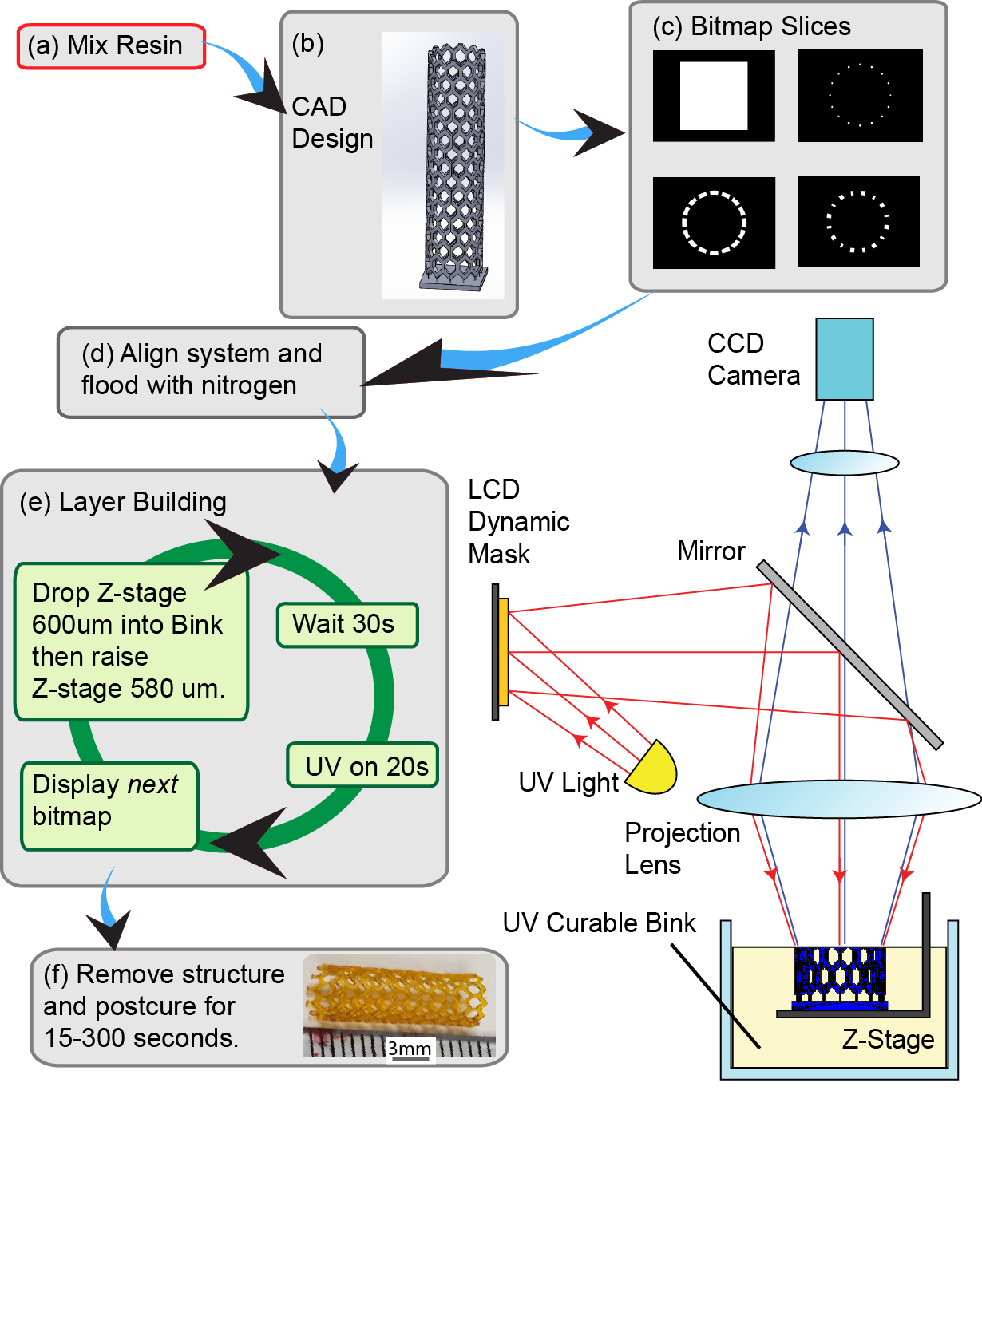

Figure . Schematic of PuSL System and process flow

The silicon wafer is then aligned with the top of the BInk layer, and the 160 liter PuSL chamber is filled with nitrogen gas. This reduces the concentration of oxygen within the chamber and ensures optimal solidification and resolution of the photo-curable BInk. Afterwards, the layer building process begins. The first sliced bitmap image is displayed on the dynamic mask (in this case, a 1400 × 1050 pixel array), and the wafer drops by 20 microns. The system then waits for 30 seconds for the BInk to settle. The UV lamp is turned on for 20 seconds, reflects off a beam splitting mirror, passes through a reduction lens and finally projects onto the surface of the bink in high resolution, with each pixel corresponding to 7.1 × 7.1 μm2 repeats for each bitmap layer in the fabrication. The micro-structure is then removed from the PμSL machine, cleaned with isopropyl alcohol (IPA) , dried under a low flow rate nitrogen gun. At this point, the BInk within the structure has not completely solidified. To finish the curing process and bring the BInk to its final state, the structure is further exposed to UV for post-curing.

## **7.3.4 Stent Design**

Stent design with various microstructures was accomplished using the SolidWorksTM CAD software (Waltham, MA). Sinusoidal formed wire, helix wrap and meshed tube was created and printed along the circumference layer-by-layer with length x outer diameter x thickness. Various parameters such as 300um, 350um, 400um and 500um in thickness or 9.0mm, 16mm and 21mm in length were investigated. Typically, a stent pattern was chosen to be a triangular truss structure along the circumference with each new row connected via vertical supporting rods, as shown in Figure 3a. Each new row was shifted to allow the lowest point of the upper row to be in line with the highest point of the bottom row. These points were then connected by vertical beams that gives the appearance of hexagonal holes across the face of the cylinder. To avoid misalignment and a floating point at the low point of the top row, it was necessary for vertical support rods to be placed at low and high point section for fabrication.

The rods with smaller cross section can simply act as removable support structure that can be removed after fabrication was completed, outer diameter of stent is given a set value of 5.20mm. Stent strut thickness was set to 350um, the individual “true support” stent rod diameter is also set at 350um and a height of 550um tall. The “removable support” material rods were set to a value of 100um with a height of 300um. Further support rods of 150um diameter and 300um tall were placed at the bottom of the stent to allow easy removal from the base. The entire stent was built on a square base of 5.5mm x 5.5mm by 500um tall. This overall design was initially chosen in order to verify the capability of the PuSL system to manufacture such structures as stents. Optimization to this design and other design changes can be performed.

## **7.3.5 Morphological assessment of the stents**

Samples of printed stents were observed in high vacuum mode (<10-4Torr) with 10kV operation voltage by utilizing FEI Quanta environmental scanning electron microscopy (ESEM) without polish and coating.

## **7.3.6 Mechanical Testing**

Mechanical compressive tests of mPDC stents were conducted according to ASTM D2412-11 by parallel-plate loading on an Instron 5544 mechanical tester equipped with 500 N load cell at a rate of 100 mm/min (Instron, Canton, MA). Briefly, radial compression testing was performed by compressing mPDC stents a total of 2 mm corresponding to 33% to 50% displacement depending on stent outer diameter. A three-point bend test apparatus (a cylindrical actuator in the middle of two cylindrical end-supports at a distance of 20 mm) was used for flexibility testing, which was performed according to ASTM F2606-08 on a MTS Sintech 20/G Universal Testing Machine with 210 N load cell at a crosshead rate of 10 mm/min (Sinotech, Portland, OR). The maximum bending angle was set at 48°.

## **7.3.7 Numerical Simulation**

Numerical simulation for three-point bending and parallel-plate compression of stents were performed utilizing the SolidWorksTM (Waltham, MA) and ANSYS workbench (Cecil Township, PA) softwares. Three thicknesses of 300um, 350um, and 400um and length of 21mm of stents were examined for both the parallel-plate compression and three-point bending simulations. To simulate 3-point bending, the stent was fixed on one side and two regions near the edges while forces were added along half the length of the stent, the displacement field was analyzed. In the parallel-plate compression, the forces were applied in a slim region along the length of stent.

## **7.4 Results and Discussion**

## **7.4.1 Polymer synthesis and characterization**

Citric acid is a multifunctional monomer in Kerb’s cycle that is easily reacted with various diols to form a crosslink elastomer in the absence of exogenous catalysts [60]. Under a controllable condition and procedure, the synthesized PDDC prepolymer was uncrosslinked and could be dissolved in several solvents such as ethanol, acetone, dioxane, etc [78]. In basic conditions, glycidyl methacrylate was used in an epoxide ring-opening reaction to attack the unreacted carboxylic groups of citric acid using imidazole as a catalyst. Methacrylate was successfully introduced to the PDDC backbone. A novel mPDC polymer was obtained as determined by 1H NMR spectrum with evidence of proton peaks for citrate residues (1) and methacrylate residues (5 and 6) in Figure 34. The multiple peaks at 2.79 ppm were assigned to the protons in -CH2- from citric acid, and the peak at 1.84 ppm was assigned to –CH3 in methacrylate unit. The molar composition of mPDC calculated the signal intensities of both protons was approximately 1:1 of citric acid/methacrylate. mPDC polymer can immediately form a solid by photopolymerization after mixing with a photoinitiator as shown in Figure 34.



Figure . Chemical structure and proton nuclear magnetic resonance spectrum of methacrylated poly(1,12-dodecanediol citrate) polymer (left); schematic showing the reaction due to exposure to UV (right).

## **7.4.2 Biomaterial ink formulation and rheological characterization**

mPDC polymer can be easily dispersed and formulated in different chemicals such as ethanol, acetone, dioxane, ethyl acetate, 1-butanol, Diethyl adipate, 1,6-hexanediol diacrylate and Diethyl fumarate, etc. mPDC viscosities do not change significantly in a shear rate from 1 to 150 1/s, at 15.5±0.4 Pa.s as shown in Figure 2c. Evan adding different amounts of ethyl acetate, the mPDC solution is still flowing stable, the viscosities remarkably decrease over shear rate with the increasing ethyl acetate, from 8.0±0.5 Pa.s in 5wt% to 1.50±0.04 Pa.s in 15wt%. However, all the viscosities of the polymer and solution decrease over temperature, heating can increase the flowability of both polymer and solution.



Figure . (a) UV/Vis absorption spectra of Irgacure 819, Camphorqinone and 2-hydroxy-2-methylpropiophone (Homp) in ethanol; (b) UV/Vis absorption spectra of Camphorqinone at different concentrations; (c) Dynamic viscosities of mPDC polymer solutions with different amount of ethyl acetate; (d) Compression strength of in-situ mPDC stents of different thicknesses, the stent is 21.8 mm x 5.0 mm (length x outer diameter).

It has been observed in the experiments that all the initiators, coinitiators and free radical quenchers are easily dissolved in the mPDC solution forming a homogenous solution and quickly forming a solid upon exposure to light. Figure 35a showed the UV/Vis absorption of different initiators such as Irgacure 819, Camphorqinone and 2-hydroxy-2-methylpropiophone separately in 370 nm, 470 nm and 340 nm, with the concentration dependence. After cured with Camphorqinone at 470 nm, the mPDC stent in 0.5 mm thickness showed complete compliance with BMS in compressive strength in Figure 35d, compressive modulus of mPDC stent in 0.75 mm increased to 10.64±3.6 MPa. Similarly, to increase the resolution of projection microstereolithography printing, 2.2wt% Irgacure 819 was used as the photoinitiator and 0.18-0.22wt% Sudan 1 as the UV absorber after a series of optimization. Irgacure 819 can easily bind both HDDA and mPDC independently at a molecular level, while Sudan I absorbs UV light at 405nm provided by the printer to control the curing depth.

## **7.4.3 Projection microstereolithgoraphy printer design and fabrication**

Projection microstereolithography printer design was based on digital micromirror device (DMD, Texas Instrument) as a dynamic mask at 1400 x 1050 pixels that is the core of this technique to use a spatial light modulator. The modulated light was transferred through a reduction lens (CoastalOpt 60mm UV-VIS-NIR lens, JENOPTIK Optical System Inc) to the surface of biomaterial ink with the reduced feature sizes, each pixel in the dynamic mask is focused down from original dimensions (object size) of 10 um x 10 um to an image size of 7.1 um x 7.1 um, the magnification is approximately 1.4. The biomaterial ink can be cured at a 2D pattern in a single exposure and stacked in a series of closely spaced horizontal planes programmed by a 3D CAD model (Supplemental MATLAB codes). In the projection microstereolithography printer, the intensity of UV light is controlled by the current input into the system with 0.4A at 405 nm, the measured intensity is 0.03 mW. Typically, the curing time for HDDA stent is 12 seconds per layer and 20 seconds per layer for mPDC stent. With this bottom-to-top fabrication, the bink enables printing the stents with high resolution of 7um pixel in a curing depth of 20um. The cured bink has strong enough mechanical properties to enable 350-400um struts over a 21mm stent design height, as shown in Figure 36c-d and Figure 37, each layer is 20um in depth with precise edges.

## **7.4.4 Morphological Assessment of the Stents**

In this process of bottom-to-top microfabrication, various microstructures in the stents were also showed in Figure 36c-d and Figure 37. Sinusoidal wire and fiber mesh were stacked in circular and rectangular layers with 20um height. In Figure 36, SEM images showed sinusoidal stent was interconnected with bridges in 0.55mm as designed as vertical support rods. It has been demonstrated that projection microstereolithography can print the stents with various microstructures.



Figure . (a) Sketch and gross image of typical repeating stent element and full 3D CAD Design of the stent; (b & c) Scanning electron microscopy images of a printed mPDC stent showing the 20um layers.



Figure . (a & c) low and high magnification of SEM images of a mesh mPDC-HDDA stent., CAD design shown in the top right corner; (b & d) low and high magnification of SEM images of sinusoidal an mPDC-HDDA stent. CAD design shown in the top right corner.

## **7.4.5 Mechanical Testing**

Parallel-plate compression and 3-point bending experiments were performed to determine the mechanical properties of stents. Unlike in-situ mPDC tubes, the mechanical properties of printed stent are significantly affected by stent design and its microstructure. mPDC significantly change HDDA compression strength and make it more flexible to match Nitinol BMS, as shown in Figure 39b. By compressing 2 mm from 5.5 mm in outer diameter, no complete rupture was found so that this closed microstructure might resist the mechanical fracture of stent.

## **7.4.6 Numerical simulation of the stent design**

To accomplish the simulation for three-point bending, on one half of the stent circumference, two regions near the edges of the stent were fixed, while forces were added along half the length of the stent on the opposite side of the fixed area. A typical displacement field from a 400um thick stent is presented in Figure 38d. From an applied force of 0.5N onto the 400um stent, the resulting maximum displacement of 7.945mm was observed where forces were applied. The displacement on the opposite end of the stent was 3.783mm. For all three stent thicknesses, the maximum displacement was plotted against the force applied to the stent (Figure 38c). For increasing stent thickness, the necessary applied force to displace the stent increases. The primary properties analyzed in these simulations were the range of forces that these stents are predicted to be usable. The stent was considered “unusable” when the point of maximum displacement is within 1mm from the point on the opposite side of the circumference of the stent. This was determined from the following equation:

$\left(D_{d}+d_{2}\right)- d_{1}$;

where *D*d is the outside diameter or the stent, *d*2 is the displacement of the point opposite the point of maximum displacement, *d*1 is the maximum displacement value. With increasing thickness (m), the Applied Force necessary to make the stent unusable increased (Figure 5d). These Applied Force values for the 300um, 350um, and 400um thick stents were 0.18N, 0.325N, and 0.555N, respectively.

|  |
| --- |
|  |
|  |

Figure . (a) Schematic view of 3-point bending experiment with a gap of 16 mm and compressive displacement of 3.2 mm for stent with 5 mm outer diameter; (b) compressive displacement and resilience of Nitinol ( 21.8 mm x 5.0 mm x 0.2 mm) and mPDC stent (21.8 mm x 5.0 mm x 0.5 mm, (length x outer diameter x thickness)); (c) Simulated maximum force-displacement curves for different thickness stents and force-thickness curve at onset of kinking in 3-point bending simulation; (d) Simulated loading and displacement field for 350um stent in 3-point bending simulation.

Next, the parallel-plate compression was simulated on the three stent designs. With increasing force, there is nonlinear contact between the plates and the new deformed surface of cylinder. The parallel-plate compression analysis was done for this study by having a slim region along the length of the cylinder be fixed. Particular faces on the cylinder’s opposite side were subjected to equal forces. As with three-point bending, the range of forces that the stents were “usable” were analyzed (Figure 39a) and the Maximum Usable Applied Force was plotted in relation to stent thickness (Figure 39b). As expected, with increasing stent thickness, the necessary force to cause deformation of the stent walls. The numerical results and the experimental results differed by approximately a factor of 10. A scaling factor of 10 was used in order to compare the experimental results and the numerical results. Figures 6a and 6c represent Applied Forces multiplied by the scaling factor.

|  |
| --- |
|  |

Figure . (a) Scaled Applied Force vs. Maximum Displacement profile of stents with 300um, 350um and 400um in thickness. (b) Compressive strength of Nitinol BMS (21.8 mm x 5.0 mm x 0.2 mm), HDDA and mPDC printed stents with 9.1 mm x 5.5 mm in length x outer diameter, the thickness of printed stent is 500um;. (c) Scaled Maximum Usable Applied Force vs. Stent Thickness curve. (d) Typical Displacement distribution for Parallel-Plate Compression simulation of stent with 400um in thickness.

With the scaling, the numerical simulation is directly comparable to the experimental tests. The “HDDA” stent used for the experimental tests was a design that was 400um in thickness for both the stent walls and all supporting rods. This slightly differs from the design that is numerically evaluated. The design that is being evaluated numerically has some support structures of (100um). At 2mm compression, the HDDA stent needed approximately 4N of force. At 2mm of compression, the 400um design needed approximately 3N of force. This difference could possibly be attributed to the inclusion of smaller 100um support rods. The 300um stent best approximates the Nitinol BMS stent. In both cases, approximately 1N of force is necessary to compress the structure 2mm.

## **7.5 Conclusion**

A biodegradable biomaterial ink (BInkTM) was formulated with biodegradable methacrylated poly(diol citrate)s and enables rapid fabrication of endovascular stents via projection microstereolithography technique. The stents with various microstructures could be printed in a resolution of 20um using CAD modeling. mPDC stent showed a compliant compressive strength and flexibility with bare metal stent, numerical simulation showed the experimental results differed by approximately a factor of 10, the 300um stent best approximates the Nitinol BMS stent.

## **7.6 Claims**

A method to produce a 3D printed stent using polydiolcitrates and microstereolithography

A biomaterial inc with the following formulations:

1. Polydiolcitrate (Jian include polydiolcitrates that you believe will work) + solvent+ initiator+ drug. Successful printing with DEF concentrations of 45%-65%. Potentially lower concentrations of DEF are possible if the material is heated, which causes a reduction in material viscosity.

## **7.7 B-Ink Viscosity Testing**

Once we had settled that DEF would be the most appropriate solvent due to its’ low evaporation rate we needed to determine the minimum quantity of DEF we could add into the material and still yield a successful print. The quickest way to determine this information is viscosity testing since the major limiting factor for printing on a projection stereolithography machine is material viscosity.

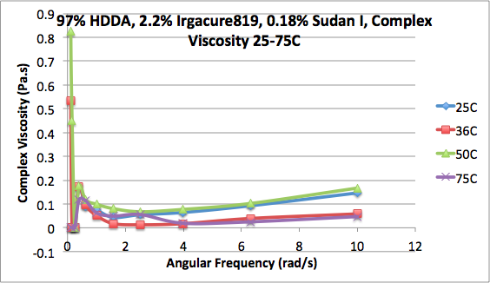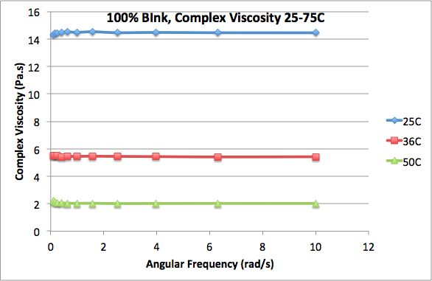

Figure . (left) Pure B-Ink prior to adding solvent, UV absorber, or photoinitiator at various temperatures and (right) various potential 3D printing materials

To gain a bench-mark for comparison, we first ran viscosity measurements on our main HDDA based 3D printing material which we have used for a number of years. Those measurements are displayed in Figure 40 (left). We saw that under temperature variation from 25C to 75C the complex viscosity was between 0.2 and 0.05 Pa.s at an angular frequency of 10 rad/s. Heating our HDDA material had the potential to reduce the viscosity by nearly a factor of four. We followed this with a test of nearly pure B-ink prior to the addition of solvent, photoinitiator or UV absorber. From this test we found the viscosity to be well over an order of magnitude higher than the HDDA based material.

After running viscosity tests on the pure B-ink solution and our pure HDDA solution it was clear that a significant portion of the material would need to be solvent for a successful print. The complex viscosity of pure B-Ink was measured to be over 14 Pa.s while the complex viscosity of the 3D printable polymer we most commonly use was measured to be 0.2 Pa.s.

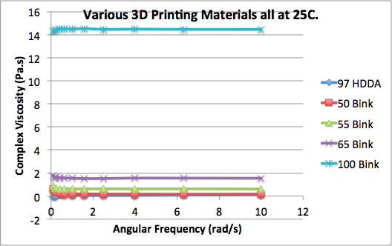 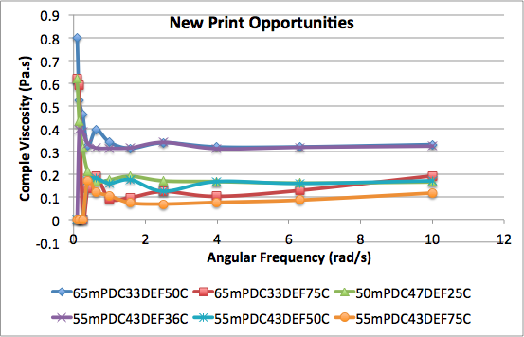

## **7.8 New Design inspired by commercially available stents.**

After demonstrating that we could successfully fabricate stents out of a bio-degradable material I reached out to cardio-thorasic surgeon Dr. Chris Malaisrie who works at Northwestern Medical Hospital. Dr. Malaisrie connected us with Dr. Scott Resinick, a vascular surgeon also at Northwestern Medical Hospital.

Dr. Resinick was very impressed by the stents we had already created and recommended that we focus on the gaining more compressibility and bendability by modifying the design. In my meeting with Dr. Resinick, he provided our group with different commercial vascular stent designs, and taught me in detail how each stent type could be delivered. Dr. Resinick explained the major differences between the stainless steel balloon expandable stents and the self-expanding nitanol stents and mentioned that his preference was for the self-expanding nitanol stents for peripheral vascular applications. The reason for this preference was that the balloon expandable stainless steel stings would often ‘kink’ under the large amount of pressure typically exerted on the human thigh. If the stent bent too much it could lead to another complete blockage. Balloon expandable stents are great for cardio-thorasic applications where the artery or vein being treated is protected by your rib cage, but these stents are not preferable for peripheral stenting in other more exposed areas of the body. Dr. Resinick also mentioned an important ‘need’ in the medical community was a 3mm stent for the upper calf. He mentioned that a 3mm stent was temporarily available to the medical community for a few months, but was taken off the market due to complications. Dr. Resinick believed there were important applications for the 3mm stent and that if a new 3mm stent could be clinically approved, it would be frequently used by vascular surgeons.

Based on these conversations, this inspired us to develop designs for two new stent sizes, 3mm and 4mm in diameter. The new design is depicted in Figure 41 and is vaguely similar to a commercial Cypher nitanol design.

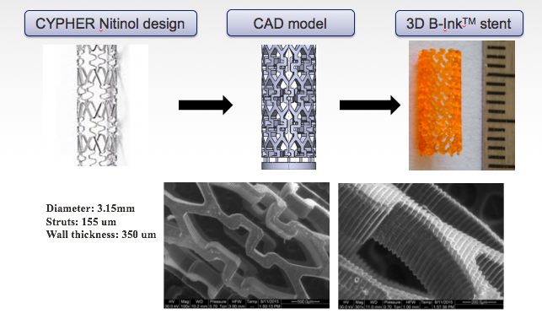

Figure New stent design inspired by commercial designs.

## **7.9 Preliminary Stent Compression Testing**

After successfully demonstrating that we could print a variety of stent designs, our goal was to design a stent that matched the mechanical properties of a commercial self-expanding Nitanol stent. We chose this as our goal because the Nitanol stent is both strong enough to hold a blood vessel open for a long period of time and compliant enough that it can be compressed down to fit on a catheter. Figure X (left) represents initial compression tests under both wet and dry conditions on a 3mm diameter, 12mm long stent of various wall thickness. We found in this first set of tests that we could obtain 60% of the nitanol stent's compression strength under dry testing, however when we moved into wet testing to match the environment of an implanted stent, we found a nearly 10 times reduction in the radial compression load that these stents could withstand. To solve this problem, I thought back to work I had previously done on vibration energy harvesting springs. In that work with Tim Reissman, we exposed the stent to high intensity UV light in the cleanroom and were able to increase the mechanical Young's Modulus of spring designs from 200MPa when cured by the low intensity UV oven in the lab to 1000 MPa under a maximum cure in the high intensity UV oven, nearly an order of magnitude higher. As is clear this same technique worked for the stent designs.

Figure . Mechanical Compression Testing of 3mm stents (left) with a low energy post cure and (right) under a high intensity (100x) post-cure.

## **7.9 Preliminary Stent Compression Testing**

To test if the stents compressed they were sheathed inside a pipette tip, compressed down to half of the original stent diameter and given time to expand back to their original shape. This test demonstrates the potential for these stents to be sheathed onto a catheter and delivered inside the human body. Further tests to load these devices directly onto a catheter are on-going.

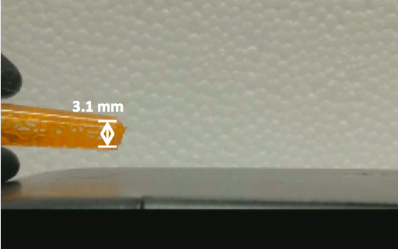 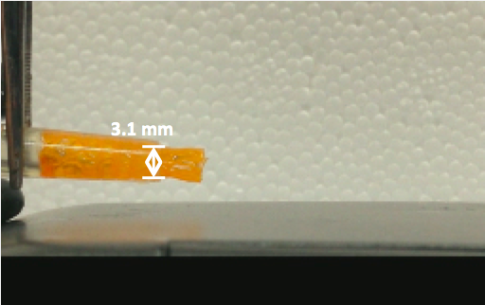 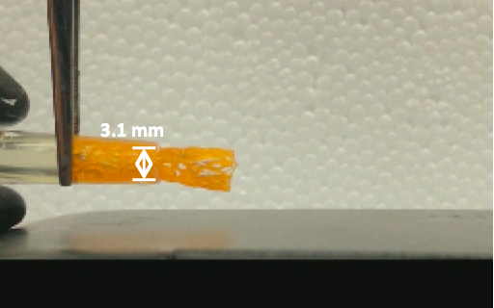

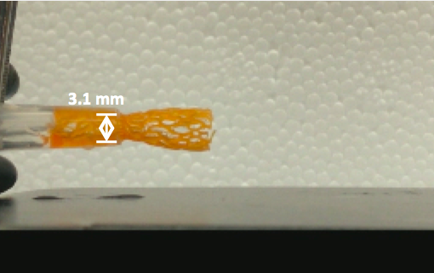 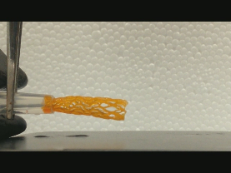 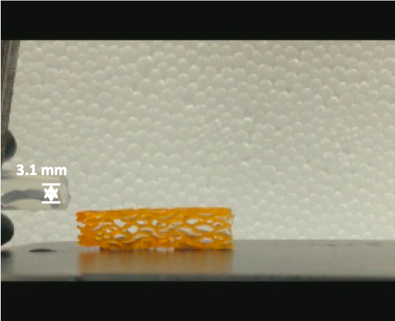

Figure Preliminary Stent Sheathing and Delivery Testing.

# **CHAPTER 8: new pusl printer design**

## **8.1 Design and Construction of a New Inverted Projection Stereo-lithography system.**

To further advance the field of rapid prototyping and design for micro-manufactured parts, we have designed and constructed a new rapid prototyping system for Northwestern’s rapid prototyping lab. With recent advances in inverted platform printing technologies, throughput for projection stereolithography machines this new printer will be able to manufacture parts 25-100 times faster, with drastic reductions to wasted material, power consumption, and improvement to the surface finish and material properties of completed parts. The final CAD design for this system is displayed in Figure 44 below.

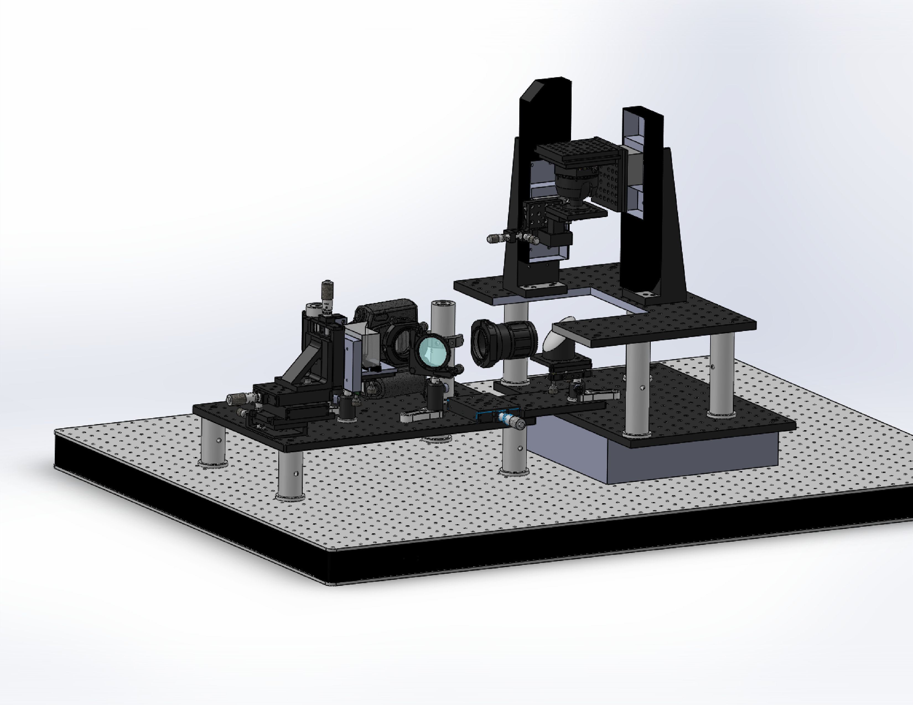

Figure CAD of new projection System Design Side View

## **8.2 Similarities and Differences between the ‘New’ and ‘Existing’ PuSL Systems.**

**Major Differences**

1. **The 'curing' wavelength:**  The 'old' system uses a 405nm 1.5 Watt max UV LED array, the new system uses a 365nm 40Watt max UV LED array and is compatible with multiple light sources.  The dynamic mask on the projector we used in our old system would get 'burned' / destroyed if we used 365 nm light (or 405nm light with higher intensity).  However in the past 5 years a number of interesting materials have been developed that are compatible with 365nm light and we would like to take advantage of those materials.

2. **The 'dynamic mask'**:  The dynamic mask is a 1400 x 1050 LCD (liquid crystal display) chip that controls the image that is projected into the resin bath.  For the new system we are using a DMD mirror array.  This DMD mirror array is compatible with 365nm light and also allows for higher power intensity of UV light to be project across it.  Higher power reduces curing time (increasing speed), but it also limits resolution by adding a 'blurring' effect.  This is the same across any stereolithography machine, the tradeoff between resolution and speed.

3. **x-y automated stages:** The 'old' PuSL machine has a very small 'print' area, only ~1cm x 1cm x 2cm.  (x, y, z).  With the new printer, we added a x-y automated stage that can move at 10cm x 10cm.  This enables both the printing of 'large' designs and it will allow 'mass production' of approximately 75-100 or of the same 1cm x 1cm designs.

4. **x-y automated stages (enabling 'stepping')**:  'Stepping' is a method that is used to enhance the resolution of a projection stereolithography printer.  With stepping you can move the x-y automated stages a fraction of the pixel size to enhance the resolution of the printed design.  For example if you wanted to print a circle, but each pixel is a square, you could 'step' the x-y automated stage in small increments to form a smooth outside perimeter of your circle.  Commonly half steps are taken at the boundary of objects to double the print resolution.  This does have an impact on the speed of the printer and should only be done when design resolution below 7um is more critical than print speed.

5. **Automated z-stage attached to the resin bath**:  Currently in the 'old' projection printer the z-stage attached to the resin bath is a mechanical micrometer.  This z-stage has to be mechanically moved into focus by the user prior to each print and lowered after each print to remove the printed structure.  The problem with this process is that the 'optimal' focus is determined by the eye of the user and can vary slightly from print to print - this can have an impact on the resolution and mechanical properties of the resulting design.  With an automated stage, software can be used to locate the ideal focal location.

6. **Resolution:** The resolution of our 'old' projection printer is 7.1um x 7.1um x 20um.  For a number of reasons, we have designed the new printer to maintain the same base projection resolution. There are a few key reasons why we made this decision. The main reason and limiting factor is because the size of micro-mirrors on the dynamic mask have not reduced in size or increased in quantity over the past six year.s This resolution is difficult to improve upon for a projection stereolithography printer because there is an inherent trade-off between magnification, fabrication area and the diffraction limit. As the resolution is improved with greater magnification, the print fabrication area decreases, which is not always desirable. One way to increase both resolution and print area simultaneously is to use a higher resolution dynamic mask. The mask we are using in the new printer contains 1950x1050 10umx10um pixels compared with our previous LCD mask which contained 1400x1050 pixels. Another major upgrade coming soon for projection stereolithography technologies are 4K chips with 4000x2000 pixels a four times increase in resolution when compared with high definition. For the new printer, the mirrors and optics will be controlled by an automated x-y stage to enable a variety of resolution prints based on the user's requirements.  The printer will both be able to print at a higher resolution we estimate 2um x 2um x 5um but with a very small 'projection' area.  We will also be able to use the software to change the location of the lenses, enabling a larger projection area, with 40um x 40um x 80um pixel resolution to print larger designs more quickly.

**Similarities**

**1. Nitrogen Flood / Oxygen Reduction**: For both printers the actual print occurs in an environment where the oxygen concentration at the fabrication plane is controlled. In ‘old’ projection printer Nitrogen is used to vacate oxygen within the fabrication area, Oxygen inhibits the reaction.  We have purchased an oxygen sensor that is able to monitor the oxygen concentration in the resin bath.  Our tests have found that after 20 minutes the oxygen concentration reduces from 20% to less than 2%.  Unfortunately the noise level for our oxygen sensor is about 1% so we cannot determine the exact level of oxygen concentration at the time of fabrication. The new PuSL printer will not require a Nitrogen environment, the oxygen flow to the fabrication is controlled by a semi-permeable Teflon AF2400 membrane that acts as the transparent base of the resin bath. Three different thin films 47um, 66um and 82um can all be used to vary the ‘dead zone’ thickness, or thickness where oxygen inhibits the reaction.

2. **Cleaning procedure:**To clean these designs, they are dipped in an isopropyl alcohol bath for about 30 seconds, then blown dry using nitrogen.  This procedure is repeated 2-3 times until all excess liquid resin is removed.  The 3D printed designs are then left to sit for up to 24 hours and then post-cured in a UV oven for 5-10 minutes.  Occasionally when in a rush to test new designs after the IPA bath and nitrogen dry they are directly post-cured, but this does have an impact on the mechanical / material properties of the designs.  When let sit for 24 hours the 3D printed designs 'drain' uncured liquid monomer from inside the 3D printed design and it is soaked up by filter paper.

## **8.3 Component Selection for the new PuSL System**

In this section I review the selection of major components of the Continuous Liquid Interface Production (CLIP) method. The goal of this section is to enable a future reader who desires to be able to build one of these printers for themselves. I review the reasoning behind the selection of various components and I will talk briefly if I believe there are other, more affordable products on the market and where the best places for ‘cost cutting’ are.

## **8.3.1 Selecting the Dynamic Mask**

The dynamic mask was purchased from Vialux. This specific dynamic mask was selected because of its ability to reflect 365 nm, high intensity UV light. Each mirror is also optimized to be 10um x 10um enabling resolution down to 7.5umx7.5um with a 1.5x magnification UV lens. I expect that the majority of the cost of this product is related to the fact that it is low volume and not actually related to the specific components. Given that there are a number of other commercial projection based printers on the market, I recommend researching the suppliers of Carbon3D and EnvisionTec to determine if a lower cost solution exists for future builds.

## **8.3.2 Selecting the UV Lens**

The UV macro lens (105mm f/4.5 lens) was purchased from Jenoptik Optical Systems, Inc. This lens has a transmission of over 90% for 365nm UV light and a controllable aperture from 4.5 to 32. This lens cost approximately $5000 and is one of the key cost drivers for a projection stereolithography system. Sourcing a low cost UV compatible macro lens will be key for developing a future low cost system.

## **8.3.3 Selecting the Motorized Stages**

Five axes motorized stages were purchased from Aerotech. The X-Y axes base stage enables 100mm by 100 mm motion with 100nm precision. The large plane of motion (100mm x 100mm) is important because it enables the production of designs that are larger than the projection area. This motion also enables the user to produce multiple copies of the same design over the same fabrication plane. However, after building this printer, if a future printer designer interested in keeping costs low, I highly recommend reducing the complexity down to a single automated Z-axis stage. A second automated ‘scraping’ stage could be added to remove the design from the top platform after the design is fabricated – this would enable the autonomous production of hundreds or thousands of similar designs without human interaction with the printer. Our group is working to develop the first CLIP printer with stepping and the first CLIP printer with an automated system to remove parts after fabrication.

## **8.3.4 Selecting the Oxygen Permeable Transparent Thin Film**

The oxygen permissible transparent thin films AF2400 were purchased from Biogeneral (<http://biogeneral.com/>) located at 9925 Mesa Rim Road San Diego CA. I wanted to provide the specifics for this product, because the Teflon AF 2400 film is a critical piece of the design. This film is rigid, transparent and oxygen permeable which makes it the perfect candidate for the bottom of a resin bath. Biogeneral currently sells three different thicknesses of this film, an 88um thick film, a 66um thick film and a new 47um thick film. The rest of the resin bath that housed these films was printed on a Makerbot Replicator 2 3D fused deposition-modeling (FDM) printer. To seal those baths, they were coated in one layer of fast drying polyurethane purchased from Home Depot. The Makerbot Replicator was used for simplicity and the ability to quickly modify designs for alignment. I strongly recommend other, more precise methods for the final production resin bath.

## **8.3.5 Selecting UV Mirror**

The UV mirror was purchased from Thorlabs. This UV mirror is placed just after the focusing lens and just before the liquid resin bath in the printer setup. The specific UV mirror we chose was the BBE2-E02 -2’’ Broadband Dielectric Elliptical Mirror 400-750 nm. That mirror was chosen because the original plan of the printer was to make it compatible with multiple UV LED light sources over a broad range. However, it may end out being more beneficial to switch to the The BB2-E01-O2’’ Broadband Dielectric Mirror to more optimally reflect 365nm UV light. The reflectance curves for both UV mirrors are displayed in Figure 45.



Figure . Broadband reflection specrum for the BB2-E01-02’’ Broadband Dielectric Mirror.

To verify the true reflection percentage using our specific 365 nm light source, a test was run with the UV source placed 10 cm from the detector. A second test was performed where the light reflected off the UV mirror, again 10cm from the detector. From this test we confirmed that the reflection of 365nm UV was nearly 100% +/- 5% error related to the rough placement of the detector.

## **8.3.5 Selecting a Beamsplitter**

Transmission and reflection curves for BP208 pellicle beamsplitter selected for our build are displayed in Figure 46. The beamsplitter is required to give the user a view of the focused pattern on the fabrication plane. This allows the user to ensure that the printer is focused correctly before beginning a new print. Once the machine is properly aligned, imaging should not be required prior to each print, but for the first alignment, proper imaging is critical.

 

Figure . BP208 Pellicle Beamsplitter reflection and transmission curves.

## **8.3.6 UV Collimating Parabolic Mirror.**

The MPD508762-90-F01 – 02’’ 90 degree off-axis parabolic mirror, UV Aluminum, RFL = 6’’ was purchased from Thorlabs. An image of that mirror and the reflectance vs. wavelength for the F01 coating is displayed in Figure 47. The F01 enhanced aluminum coating was selected to enable over 90% reflectance using a 365nm UV source. The focal distance of 102 mm enables a collimated UV light when the UV source is placed 102 mm away from the parabolic mirror.

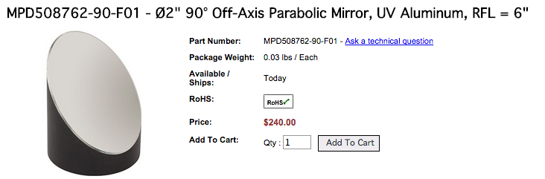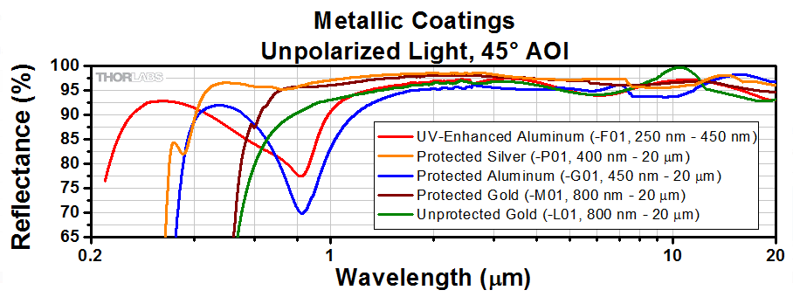

Figure . MPD508762-90-F01 off-axis parabolic mirror

## **8.3.7 Optimizing UV LED Power with a parallel combining lens.**

Preliminary results (as displayed later in this report) indicated that the UV intensity at the focal plane was lower than is required for proper CLIP printing with the low cost UV LED Dr. Sun identified and purchased off an unknown Amazon vendor. To address this issue a dramatically more poweful UV LED, optimized for UV ink curing at long distances and collimating lens optics were identified and purchased from Clearstone Technologies

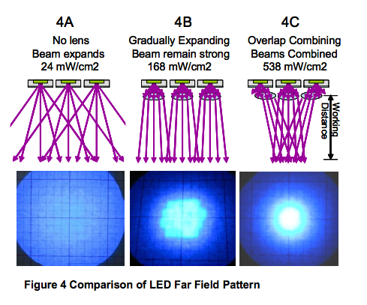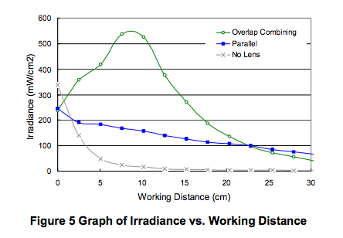

From Clearstone Technologies, we ordered the following components:

    1. JL3-365E-18  LED head, 5 cm diameter emission area, metal case, 6.0 W light power.  Emission wavelength peak 365 nm +/- 5 nm.   $3250  
    2. CF2000Rev 2.0  $1,650  
    3. JLFB-PRL-18 Lens Array  Lens array for 365 nm or 385 nm with parallel pattern.   JL3-xxxE-18 LED heads.  $450  
    4. JLHB-OC-18 Lens Array  Lens array for 365 nm or 385 nm with overlap combine pattern.   JL3-xxxE-18 LED heads.  $450 (Free)   
**Total Cost: $5800**

This component is not only higher intensity, it can also be programmatically controlled throughout the printing process, enabling high intensity (higher print speed) through areas of the print that require less resolution and lower intensity (paired with slower speed) in areas that require the highest resolution.

The reason I knew more UV intensity must be required at the focal plane was based on a thorough review of the CLIP science magazine article by Tumbleston. After reviewing the requirements of the CLIP Printing process, it was clear that additional UV intensity would be required for truly fast printing. In the figure below the minimum photon flux was 1x1015 Photons/cm2 (500uW/cm2) with a maximum photon flux of 12x1015 photons/cm2 (6000 uW/cm2). The UV lamp was turned on for 12 seconds in each test. Using only the previously purchased UV LED, the highest UV intensity obtainable at the focal plane (500mm from the UV LED source) was 30-50uW/cm2, less than ten times the required minimum amount. This lens and collimating optics were ordered in the first week of Dec. with not enough time to fully install and test them before the completion of this document.

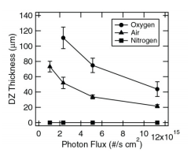

Figure . The dead zone is formed by oxygen permeation through the Teflon AF2400 window. Dead zone thickness vs. incident photon flux is shown in the graph above. This is critically important because if the photon flux is not high enough (>500uW/cm^2) then the dead zone thickness will be too large and it will not be possible to cure any material through the membrane. For the full details please review the reference.

## **8.4 Software for the New PuSL System.**

In addition to designing and building the new PuSL system for our lab. I wrote the software that controls each of the motorized stages, the UV light source and the dynamic mask using LabVIEW. Screenshots of the code are included in the appendix.

## **8.4.1 LabVIEW Software Graphical User Interface. Focusing/Alignment**

The graphical user interface can be broken down into two sections, the ‘Focusing’ interface and the ‘Fabrication’ Interface. To toggle between the different displays click on the button to enable that specific section as shown in Figure 49.

 

Figure . In this figure ‘Focusing/Alignment’ is enabled, the button is highlighted green and the ‘Fabrication’ section is disabled.

Within the ‘Focusing / Alignment’ section, the user has the ability to project either a ‘square’ pattern or a ‘Focusing Image’ pattern, these two options are displayed in the figure below. They can toggle between these two choices by flipping the switch.

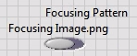 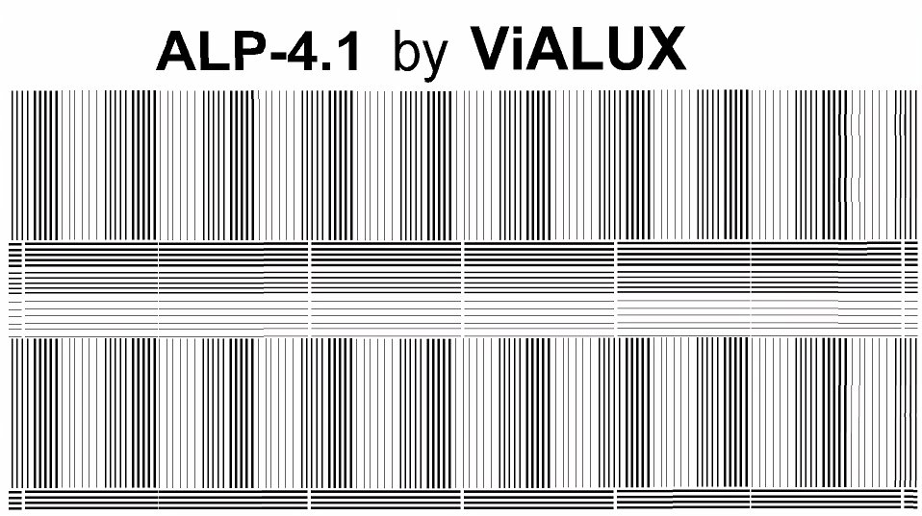

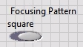 

Figure . Toggle switches and their corresponding projected patterns on the dynamic mask. Black areas in the attached .jpg will be projected.

If the user wants to generate a new image for this printer, that image must be formatted as a 2 bit .png image. The easiest way to do this (using Paint) is under the ‘properties’ tab to set the ‘Colors’ to be ‘Black and white’. That will reduce the image to a 2 bit black and white only image. If you want to modify the code to add a new image, double click on the focusing pattern button in the GUI. That will send you directly into the code so you can modify which image is input into the program.

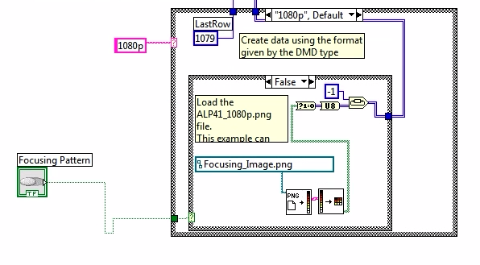

Figure . Code for the ‘focusing image’ input.

If you would like to add a new image as the focusing image, simply type the name of your new image file in place of ‘Focusing_Image.png’ (shown in Figure 51) and make sure that the image is located in labVIEWs working directory. In this case that working directory is C:\Users\SUN_3D_1\Dropbox\PuSL Splicing\PuSL new System Control\AerotechExampleVIproject

In addition to controlling what image is projected during the focusing / alignment process, the user can decide if they want to have the UV light turned on or not. The user can control whether the UV light is on or not using the button displayed in Figure 52. This button must be pressed before the labVIEW program is run. When aligning the base platform you will want to have the UV light on, but when aligning the liquid resin bath, you will want to have the light off to avoid exposure of your material.

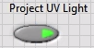

Figure . Pressed Button enabling the UV light during Focusing/Alignment.

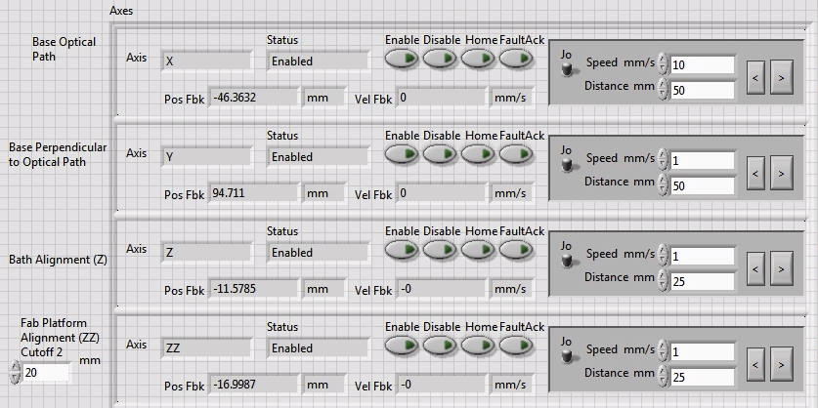

Figure . Alignment and Focusing Controls for various motorized stages.

Fab Platform Alignment (ZZ) Cutoff is an optional input for the user to set a distance where the fabrication platform will stop and turn around. I found that this was an important feature to have after accidentally bursting through one of the thin Teflon AF2400 films in the resin bath. This feature protects the printer from a certain amount of user error.

The complete software for ‘Fabrication’ is displayed in Figure X Below. In this software the user can select the type of ‘focusing pattern’ image they would like to display before running the program. There are now four selections, Focusing Image as shown earlier in this section, an all white image, and two images that have a white background with small black squares. Additional images can be easily added.

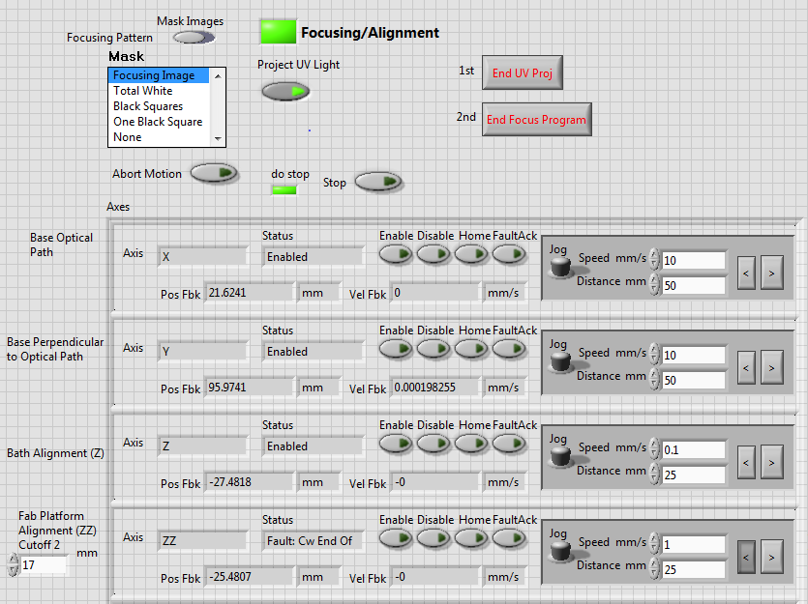

Figure . Focusing Code for new CLIP Based PuSL Printer

## **8.4.2 LabVIEW Software Graphical User Interface. Fabrication**

The software for fabrication was developed on the same platform that we used for our ‘old’ PuSL system. To enable the ‘fabrication’ software, the button nest to ‘Fabrication’ in the top left of the screen must be highlighted. The only other requirement for the fabrication section is to upload the file that you would like to print under the file path section.

To make this software more convenient for users, I added a few additional controls to the graphical user interface. Each of these features can be enabled by highlighting the button next to that feature. The first feature is the ‘Custom Final Layer’, with that feature enabled, the fabrication program will end on the layer specified in the text box (in this case after the first 20 layers are printed). The second feature enables an override of the UV exposure time per layer. With that feature enabled, the program will ignore the UV exposure time set in the control text file and instead it will be the UV exposure set in the GUI. The third feature is the layer thickness override and it works in the same way.

Another critical control for CLIP based projection stereolithography printing is speed control for the platform. The default speed is set to 0.0833 mm/s, this speed was recommended for the highest resolution prints by (reference Carbon3D science paper here).

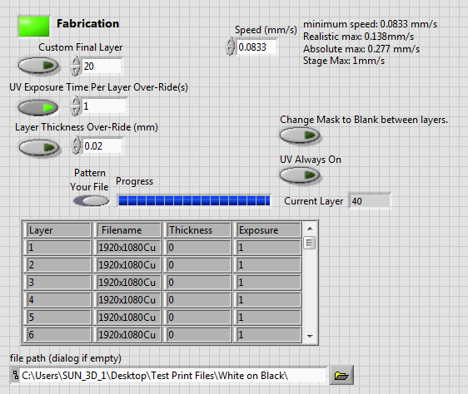

Figure . New 'Fabrication' Software for the new CLIP Based PuSL System. Software is written using LabVIEW.

## **8.5 Alignment Process.**

The first step of the alignment process is to ensure that your light gate, dynamic mask and UV Macro Lens are properly aligned. Any laser could be used to do this paired with two optical crosshair reticles or any other preferred alignment method. Once the laser beam, reflected off the dynamic mask passes through the center of the UV lens, the aligner can work on the collimated light.

To ensure that the UV light from the source is properly collimated the distance from the UV light source to the parabolic mirror and from the parabolic mirror to the dynamic mask must be equal to the focal length of the parabolic mirror. The specific parabolic mirror that we are using in this setup has a focal length of 102mm, just long enough to fit behind the light gate, but not too long which would cause a more significant drop in UV intensity. A schematic of this setup is shown in the figures below.

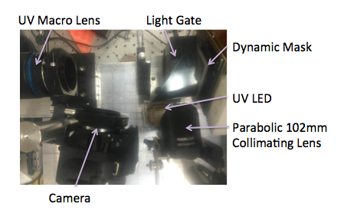

Figure . Image of major components in CLIP PuSL systems and their respective alignments.

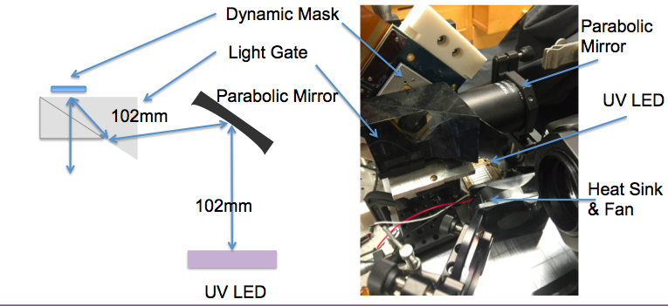

Figure . Schematic of UV LED collimated by a parabolic mirror. To collimate the source both the UV LED and dynamic mask are placed at the focal length of the parabolic mirror.

After aligning the optical path and collimating the UV source the final relative positions of the macro lens and dynamic mask should be set. In our particular setup as shown in the image below, we selected an image distance of 180 mm. The image distance of 180mm enabled a magnification of -0.71, creating a focal plane 252mm away. This image distance was selected to enable a resolution of 7.1 microns per pixel which is approximately the same resolution as our ‘old’ PuSL printer. After selecting the image distance, two cameras should be set up, one approximately at the 252 mm focal plane, and a second one that captures the reflected image off the focal plane, back through the UV macro lens, and off a beam-splitter as shown in the figure below. It is critical to work with two cameras simultaneously.

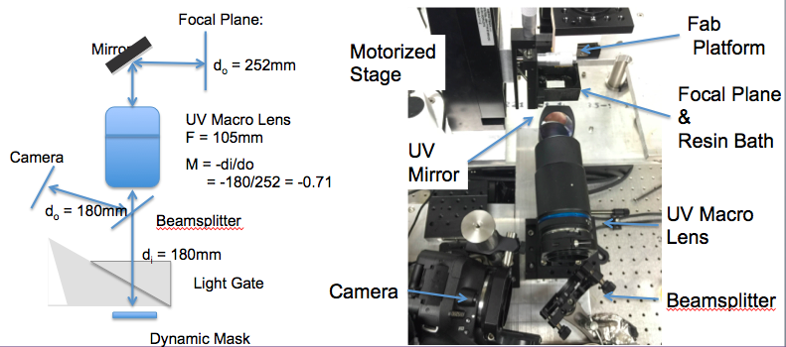

Figure . Schematic of New CLIP PuSL Printer Optical Alignment

First, align the camera at the main focal plane. An image of the DMD camera that we used, the focused image we obtained on it are displayed in the figure below. Another interesting fact is that we actually 3D printed the adaptor that connects to this camera on a Makerbot 3D printer. Make sure to twist the tilt of the UV mirror’s optical post such that the reflected beam still stays aligned along the same path, this will be critical when trying to align the second camera and to ensure that the beam reflects back through the center of the UV macro lens.

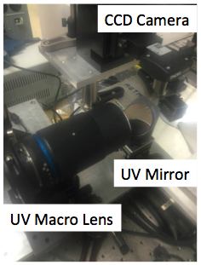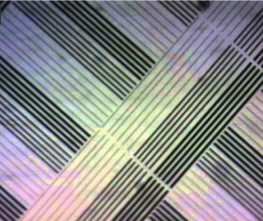

Figure . Camera installed at focal plane (left) and captured image (right).

After aligning the CCD at the focal plane, install the beamsplitter and the second camera approximately the same distance as the distance from the dynamic mask to the macro lens. You may need a second person to help with this installation. While one person is adjusting the camera to be just in the right place, the second can closely look at the image that camera creates on the computer to determine if the camera is in the ideal focal position. If you are not seeing any image at all, it is likely that the source is not aligned properly – try manipulating the UV mirror and using a sheet of paper to capture the image reflected off the beamsplitter. It can also help to place a large reflective surface over the CCD camera (like a silicon wafer) to ensure that you are reflecting all incoming light back towards the lens. The ideal images captured by this second camera are displayed in the image below.

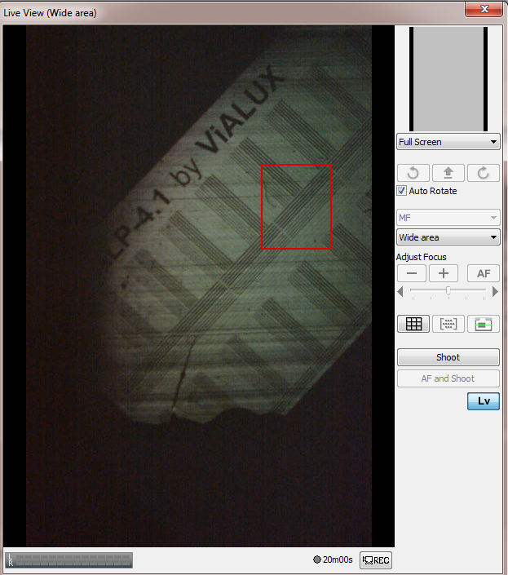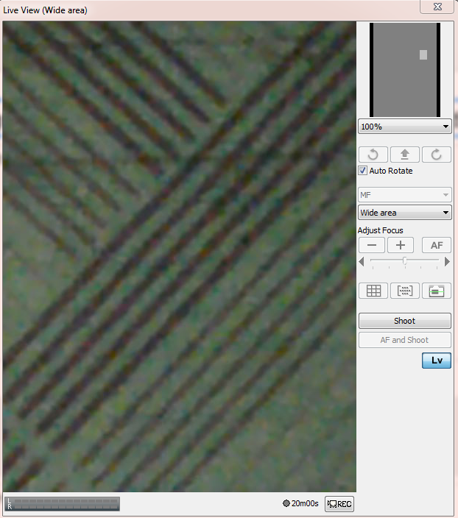 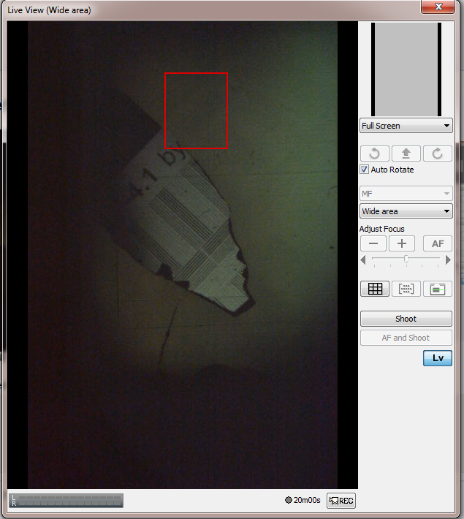

Figure . Images of 'Focusing Image' reflected off the CCD camera and off a shard of silicon wafer.

Once the second camera is aligned, the first camera can be removed and the UV Intensity meter should be installed. The goal of this next portion is to maximize the UV intensity at the focal point through fine-tuning the UV collimation. Once focused on the UV intensity meter, the projection image should also be switched from ‘Focusing Image’ to ‘White’ to ensure a consistent reading. Try adjusting the tilt of the UV Parabolic mirror until you obtain a maximum UV reading and simultaneously see a clear reflected image reflected off the UV sensor. The adaptor necessary to hold the UV intensity meter is displayed in the figure below. Each of the 3D printable adaptors are stored in the Google Drive/Northewstern/New 3D Printer Design folder.

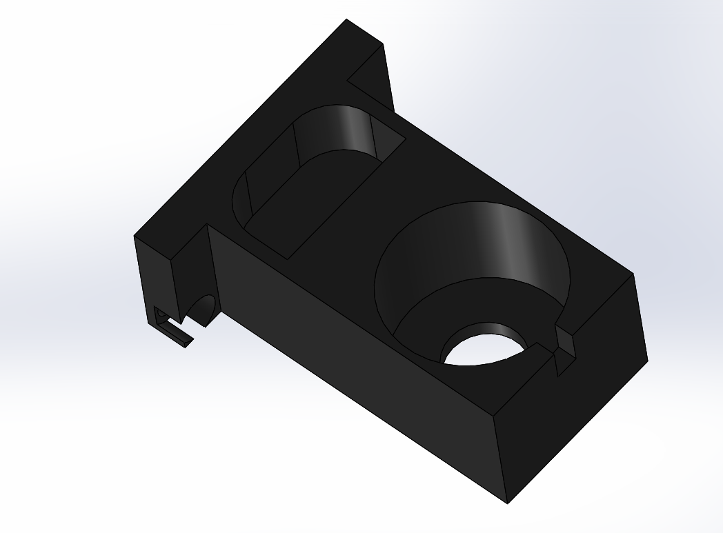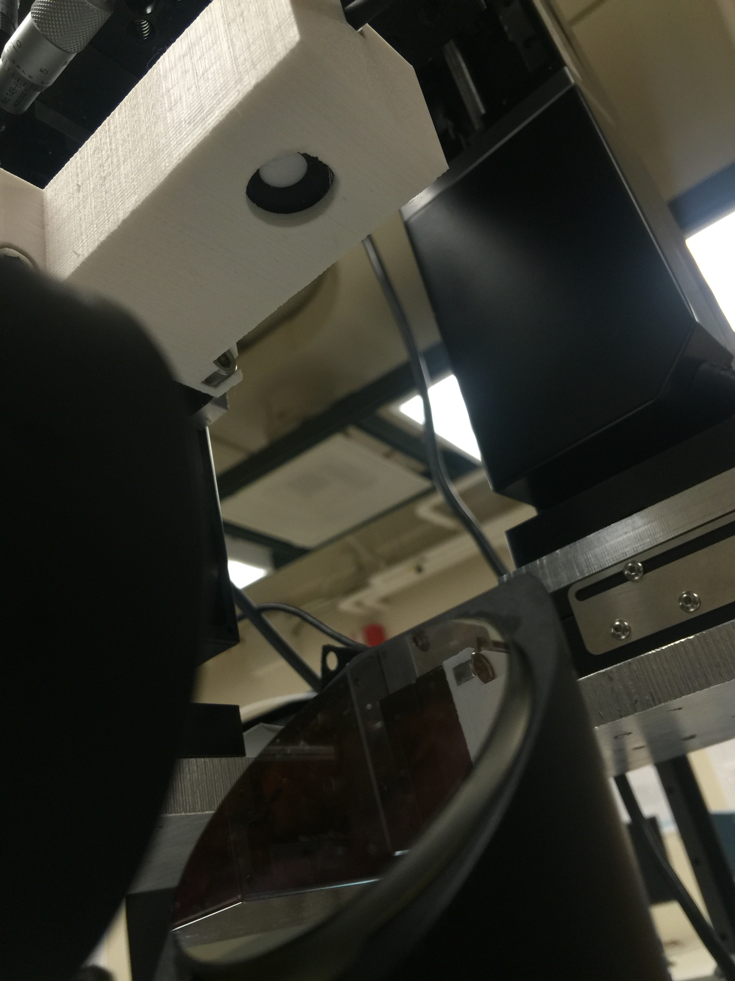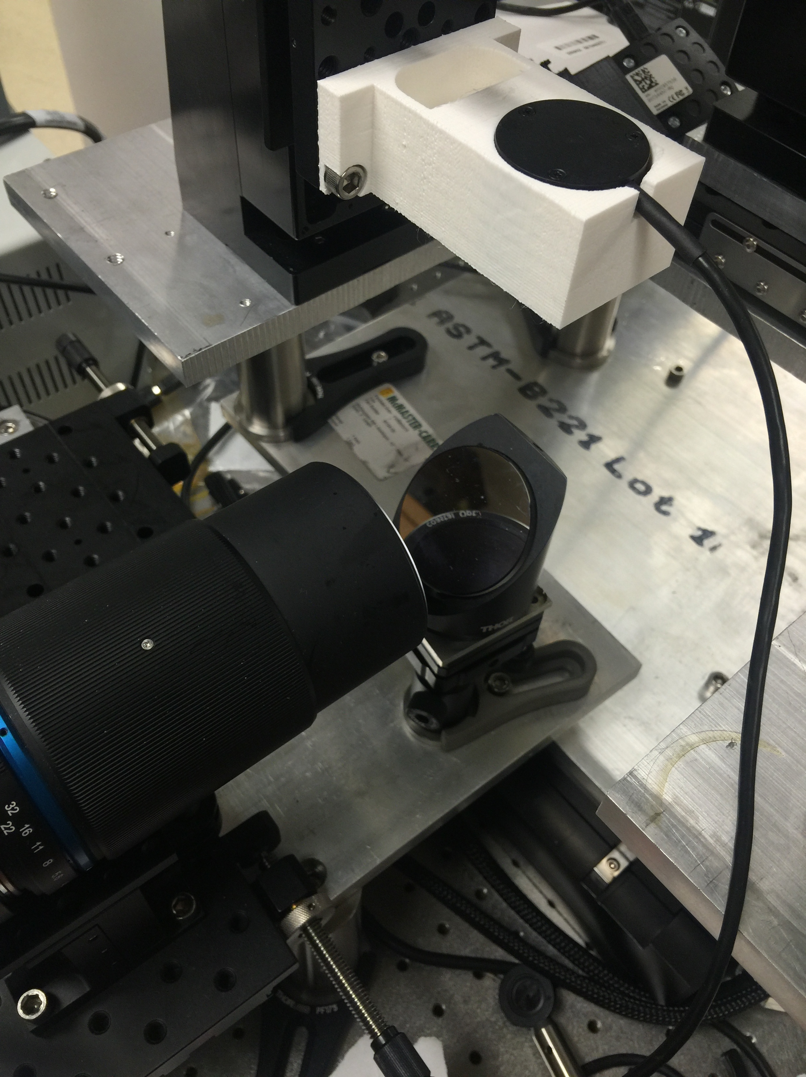

Figure . UV intensity meter installed (show a picture of it installed) UV intensity meter 3D printed adapter. Also include a few sample measurements.

Once the UV intensity is maximized, you are ready to begin calibration printing. The first calibration print recommended is a dynamic 40 second print to determine the curing depth. This test print creates a series of boxes, the first box displays for 40 seconds, the second 39 seconds, etc. all the way down to the last box which only appears for one second. After performing this test, and measuring the thickness of each of the cured boxes on top of the silicon glass slide, the user will have a good idea how much UV exposure they should use for their particular material to get a desired curing depth. To run this test, I designed a 3D printed adapter that can hold four different glass slides at once. If you need to print out another copy of this part, make sure you coat it in polyurethane to seal the part to liquid. An image of the 3D designed part is shown in the image below.

A number of system intensity measurements are taken below. With two new power supplies provided by Dr. Alan Sahakian we were able to increase the UV intensity up to 60uW/cm^2. However, the UV LED quickly over-heated at that high of intensity. A much better heat sink needed to be constructed to divert some of the heat. The heat-sink was constructed out of the heat sink from an old motherboard, silver paste to connect the UV LED to the heat sink and also to connect the heat sink to the aluminum breadboard. Additionally a fan was set up behind the heat sink. This heat sink requires further improvement for running the UV LED at high voltages (35+V), but works well for 32-35V with 1A inputs.

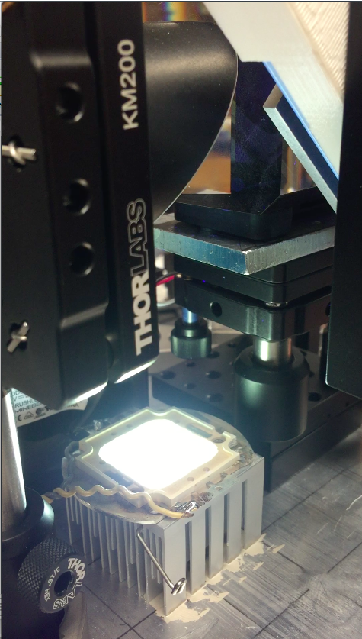

Figure . UV LED with heat sink. (right) UV LED Intensity tests at the focal plane. To successfully print with through the Teflon AF2400 film, at least 500uW/cm^2 is required.

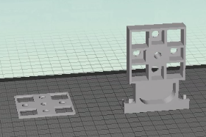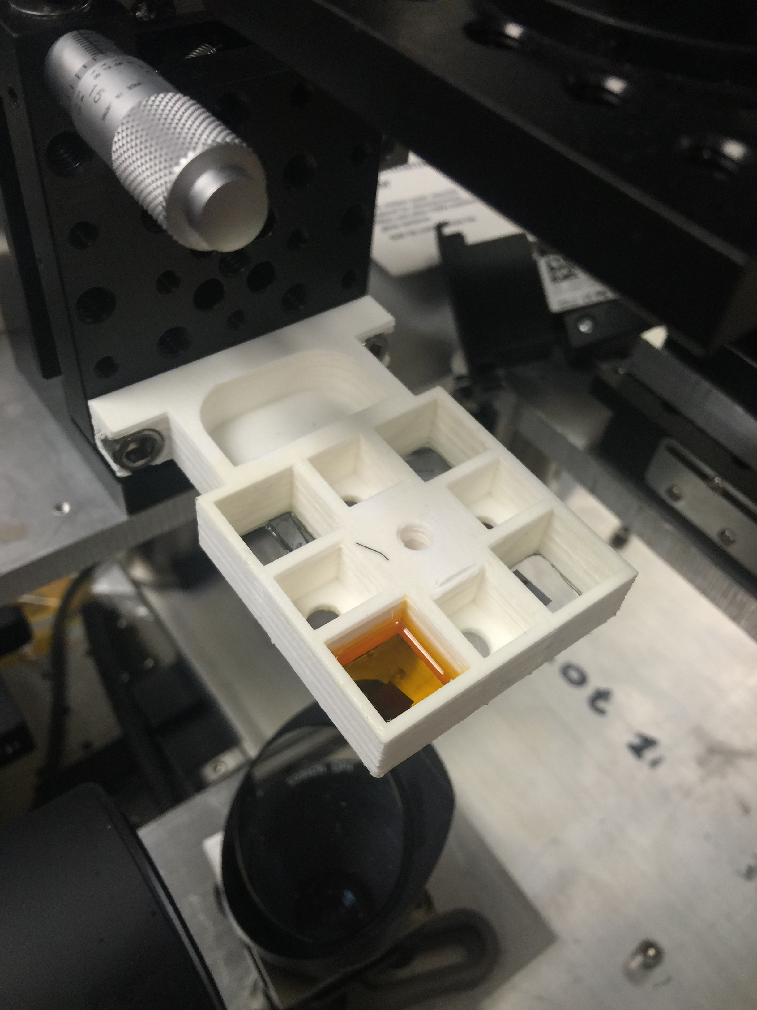

Figure . 3D designed and printed glass slides resin bath (left). At right is an image of the installed bath.

To align the focal plane on the surface of the glass slides, put a small shard of silicon wafer just on top of the glass slide and move the X-Y Stage until the focusing pattern is on top of that small silicon shard. The user should be able to easily focus on the small shard of silicon wafer, that silicon wafer can then be removed if necessary, or it can be left on the glass slide. After focused on the correct plane, the UV intensity should be turned off and the resin should be introduced. After the resin is introduced the necessary fabrication test can be run.

After running a series of tests to verify the curing depth for your given collimation, LED current/voltage, and material you are ready to print material through the Teflon AF2400 thin film. The first step is to align the resin bath as shown in the figure below. Once the resin bath is aligned, create a small elevated platform using cover slides that is elevated 200um above the Teflon AF2400 film. This will allow you to measure the deadzone of your specific Teflon AF2400 thin film. Similar tests are performed in the supplementary materials of J. Tumbleston et. Al. recent science magazine publication ‘Continuous liquid interface production of 3D objects’.

After quantifying the deadzone thickness, the system is ready for printing structures. Ensure that the system is aligned with the top of the deadzone to ensure maximum resolution. The first step is to align the fabrication platform, use the ball and joint socket to ensure that the fabrication platform is as level as possible. It helps a lot to attach an actual level to the base of the platform to get an accurate position. Avoid manipulation of the 45 degree UV mirror since that was already tuned to the proper focusing position. Ensure a clear image can be seen on the camera that captures the reflection off the platform.

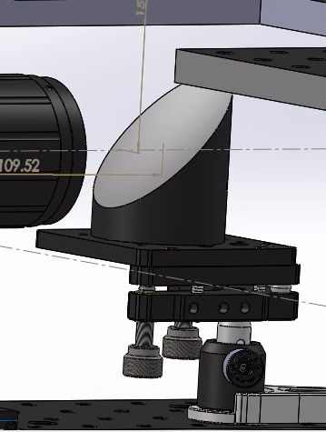 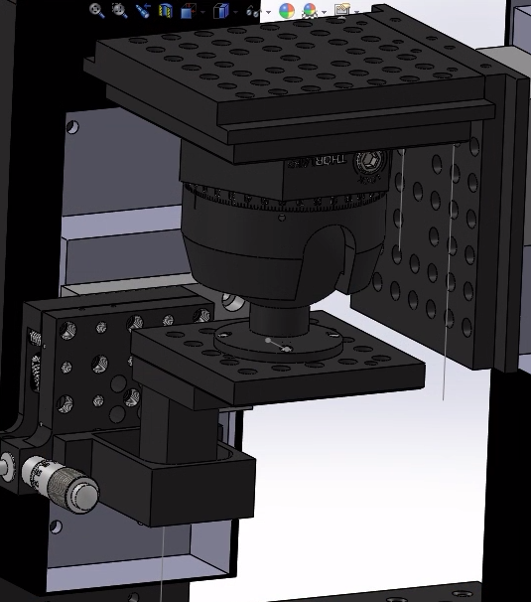 

Figure . 45 degree UV Mirror (left) and rotational ball joint (middle) for inverted platform. The image at right demonstrates focusing on the liquid resin bath with a shard of silicon on top of the Teflon AF2400 thin film.

Once the platform is aligned, raise the platform so it is out of the way and align the resin liquid resin bath through the Teflon AF2400 thick film. It is critical to place a shard of silicon wafer on top of the Teflon AF2400 to do the alignment since the Teflon AF2400 film does not reflect the light very well. Once the bath is aligned, you are ready to begin printing.

To begin the printing process, add the material you would like to print with into the liquid resin bath. Set the ‘speed’ that you would like your print to happen at (recommended 0.008mm/s is recommended for now, load the file you want to print and press run. Congratulations! You have learned everything you need to know to build, align or update your own CLIP based projection stereolithography system.

## **8.6 Summary of the Expected Impact of CLIP Technology**

We expect this completed printer to have a dramatic impact on both the quality and quantity of devices created in the Northwestern labs. This new printer has been designed so that it is significantly easier to use than previous technologies (no alignment is necessary for the general user) and 50 to 100 times faster and it works with a broader range of materials. What this dramatic improvement to speed will mean is that instead of a single user reserving the 3D printer for a week to print five to ten copies of a single device to test, many users will be able to user this printer many times every single day. This will open up a broad range of collaborations that were not possible with the previous 3d PuSL printer. This new printer will also enable a significantly faster development cycle for designed products.

The types of materials that are possible with this new printer include any photo-curable liquid material. These materials can range widely in optical properties from transparent to opaque in a large variety of colors. Additionally the mechanical properties can vary from rigid to rubber-like. A number of groups are also working on bio-compatible, bio-resorbable, high temperature resistant, piezoelectric and conductive photo-curable materials.

The types of devices that we expect to be created on this new printer include microfluidics, cell-scaffolds, human implants including splints and stents, optics including intra-ocular lenses and contact lens molds. Additionally our group is interested in developing piezoelectric 3D printed sensors, energy harvesters and micro-robotics.

A fascinating next potential step for this printer is the inclusion of a 6-degree of freedom robotic arm as the extracting method from the liquid resin bath. This robotic arm would enable dramatic design flexibility not possible with the existing method. The robotic arm could also enable dipping the structure into multiple different materials throughout the printing process enabling rapid construction of multi-material prints with micro-scale resolution.

## **8.7 Recommended Additions to the PuSL System.**

## **8.7.1. Pitch/Yaw Control Behind Dynamic Mask**

A critical adjustment to the printer will be the addition of pitch/yaw control behind the dynamic mask. Pitch/Yaw control will enable the user to tune the tilt of the dynamic mask, which will enable a more uniform projection pattern onto the fabrication platform.

## **8.7.2. A new Heat-Sink**

The current heat sink does not sufficiently draw heat away from the UV LED. The heat sink needs to be dramatically improved for high intensity operation.

## **8.7.3. A Physically Smaller Light Gate, Optimized for 365nm UV.**

The current light gate for the system was purchased off Ebay for $30 and we lack the proper documentation for it. Although it did ‘work’ Significant loss occurs through the light gate and it is also very large. The size of the light gate prevents the user from using a shorter focal distance UV collimating lens / parabolic collimating mirror.

## **8.7.4. An Upgraded Circuit Board from Vialux that is compatible with 8-bit grey-scale images. Potentially even a 4k dynamic mask if that becomes available.**

This is a lower-priority long-term upgrade to the system. Improving the resolution from 1920-1080 to 4k increases the pixel density by a factor of four, this would lead to a dramatic improvement in design resolution. Grey-scale images would enable variation of pixel intensity throughout a given print, currently that is not possible with our existing system. A programmable power supply could also provided tunable intensity.

## **8.7.5. Collimating Lenses (50mm, 60mm, 70mm, 80mm).**

The UV Collimation of this system needs to be re-designed and may require a multi-lens system. The simplest solution is to use a single lens where the focal distance of that lens is equidistant from the UV LED and the dynamic mask, due to space constraints the shortest focal length lens we will be able to use is in the 50mm – 80mm range. That minimum length needs to be identified once the smaller, optimized light gate is purchased.

# **references:**

1. Zhang, X., *Dynamic mask projection stereo micro lithography*, 2006, Google Patents.

2. Marin, I., et al., *Wireless Sensor Networks: A Survey on Ultra-Low Power-Aware Design.* Proceedings of World Academy of Science, Engineering and Technology, Vol 8, 2005. **8**: p. 44-49.

3. Chao, L., C.Y. Tsui, and W.H. Ki, *A batteryless vibration-based energy harvesting system for ultra low power ubiquitous applications.* 2007 Ieee International Symposium on Circuits and Systems, Vols 1-11, 2007: p. 1349-1352.

4. Yeager, D., et al., *A 9 mu A, Addressable Gen2 Sensor Tag for Biosignal Acquisition.* Ieee Journal of Solid-State Circuits, 2010. **45**(10): p. 2198-2209.

5. Yahya, B. and J. Ben-Othman, *Towards a classification of energy aware MAC protocols for wireless sensor networks.* Wireless Communications & Mobile Computing, 2009. **9**(12): p. 1572-1607.

6. Arnold, D.P., *Review of microscale magnetic power generation.* Ieee Transactions on Magnetics, 2007. **43**(11): p. 3940-3951.

7. Beeby, S.P., M.J. Tudor, and N.M. White, *Energy harvesting vibration sources for microsystems applications.* Measurement Science & Technology, 2006. **17**(12): p. R175-R195.

8. Umeda, M., K. Nakamura, and S. Ueha, *Analysis of the transformation of mechanical impact energy to electric energy using piezoelectric vibrator.* Japanese Journal of Applied Physics Part 1-Regular Papers Short Notes & Review Papers, 1996. **35**(5B): p. 3267-3273.

9. Wang, S., et al., *Energy harvesting with piezoelectric drum transducer.* Applied Physics Letters, 2007. **90**(11).

10. Swallow, L.M., et al., *A piezoelectric fibre composite based energy harvesting device for potential wearable applications.* Smart Materials & Structures, 2008. **17**(2).

11. Glynne-Jones, P., et al., *An electromagnetic, vibration-powered generator for intelligent sensor systems.* Sensors and Actuators a-Physical, 2004. **110**(1-3): p. 344-349.

12. Jin, K., et al., *A Hybrid Fuel Cell Power System.* Ieee Transactions on Industrial Electronics, 2009. **56**(4): p. 1212-1222.

13. Kulkarni, S., et al., *Vibration based electromagnetic micropower generator on silicon.* Journal of Applied Physics, 2006. **99**(8).

14. Evan Baker, T.R., Fan Zhou, Chen Wang, Kevin Lynch Cheng Sun *Microstereolithography of Three-Dimensional Polymeric Springs for Vibration Energy Harvesting.* Smart Materials Research, 2012. **Volume 2012**(Article ID 741835).

15. Sun, C., et al., *Projection micro-stereolithography using digital micro-mirror dynamic mask.* Sensors and Actuators a-Physical, 2005. **121**(1): p. 113-120.

16. Cheng, Y., J.Y. Xu, and X.J. Liu, *One-dimensional structured ultrasonic metamaterials with simultaneously negative dynamic density and modulus.* Physical Review B, 2008. **77**(4): p. 045134.

17. Fang, N., et al., *Ultrasonic metamaterials with negative modulus.* Nature Materials, 2006. **5**(6): p. 452-456.

18. Fang, N., et al., *Sub-diffraction-limited optical imaging with a silver superlens.* Science, 2005. **308**(5721): p. 534-537.

19. Liu, Z.W., et al., *Far-field optical hyperlens magnifying sub-diffraction-limited objects.* Science, 2007. **315**(5819): p. 1686-1686.

20. Narayana, S., S. Savo, and Y. Sato, *Transient heat flux shielding using thermal metamaterials.* Applied Physics Letters, 2013. **102**(20): p. 201904.

21. Liu, X.L., et al., *Taming the Blackbody with Infrared Metamaterials as Selective Thermal Emitters.* Physical Review Letters, 2011. **107**(4): p. 045901.

22. Moser, H.O., et al., *Terahertz response of a microfabricated rod-split-ring-resonator electromagnetic metamaterial.* Physical Review Letters, 2005. **94**(6): p. 063901.

23. Smith, D.R., et al., *Determination of effective permittivity and permeability of metamaterials from reflection and transmission coefficients.* Physical Review B, 2002. **65**(19): p. 195104.

24. Yao, J., et al., *Optical negative refraction in bulk metamaterials of nanowires.* Science, 2008. **321**(5891): p. 930-930.

25. Pendry, J.B., *Negative refraction makes a perfect lens.* Physical Review Letters, 2000. **85**(18): p. 3966-3969.

26. Zhang, S., et al., *Cloaking of matter waves.* Physical Review Letters, 2008. **100**(12): p. 123002.

27. Zhou, F., et al., *Hiding a Realistic Object Using a Broadband Terahertz Invisibility Cloak.* Scientific Reports, 2011. **1**: p. 78.

28. Cai, W.S., et al., *Optical cloaking with metamaterials.* Nature Photonics, 2007. **1**(4): p. 224-227.

29. Liu, Z.W., et al., *Focusing surface plasmons with a plasmonic lens.* Nano Letters, 2005. **5**(9): p. 1726-1729.

30. Liu, Z.W., et al., *Far-field optical superlens.* Nano Letters, 2007. **7**(2): p. 403-408.

31. Lee, H., et al., *Realization of optical superlens imaging below the diffraction limit.* New Journal of Physics, 2005. **7**.

32. Wang, P., et al., *Harnessing Buckling to Design Tunable Locally Resonant Acoustic Metamaterials.* Physical Review Letters, 2014. **113**(1): p. 014301.

33. Babaee, S., et al., *3D Soft Metamaterials with Negative Poisson's Ratio.* Advanced Materials, 2013. **25**(36): p. 5044-5049.

34. Buckmann, T., et al., *Mechanical cloak design by direct lattice transformation.* Proceedings of the National Academy of Sciences of the United States of America, 2015. **112**(16): p. 4930-4934.

35. Gundogan, B., et al., *Bioabsorbable Stent Quo Vadis: A Case for Nano-Theranostics.* Theranostics, 2014. **4**(5): p. 514-533.

36. Ulrich Sigwart, M.D., Jacques Puel, M.D., Velimir Mirkovitch, M.D., Francis Joffre, M.D., and Lukas Kappenberger, M.D., *Intravascular Stents to Prevent Occlusion and Re-Stenosis after Transluminal Angioplasty.* New England Journal of Medicine, 1987. **316**: p. 6.

37. Serruys PW, K.M., Ong AT. , *Coronary-artery stents.* New England Journal of Medicine, 2000. **354**: p. 13.

38. Hermawan, H., D. Dube, and D. Mantovani, *Developments in metallic biodegradable stents.* Acta Biomater, 2010. **6**(5): p. 1693-7.

39. Regar E, S.G., Serruys PW., *Stent development and local drug delivery.* British Medical Bulletin, 2001. **59**: p. 21.

40. Ranade SV, M.K., Richard RE, Chan AK, Allen MJ, Hel- mus MN., *Physical characterization of controlled release of paclitaxel from the TAXUS Express drug-eluting stent.* J Biomed Mater Res, 2004. **71A**: p. 10.

41. Schmitz KP, G.N., Lobler M, Behrend D, Schmidt W, Sternberg K. , *Drug-eluting stent technologies for vascular regeneration.* International Journal of Materials research, 2007. **98**: p. 6.

42. Kedia G, L.M., *Stent thrombosis with drug-eluting stents: a re-examination of the evidence. .* Catheter cardiovascular intervention, 2007. **69**: p. 8.

43. Garg S, S.P., *Coronary stents: looking forward. .* Journal of the American College of Cardiology, 2010. **56**: p. 34.

44. Mei-Chin Chen, H.-W.T., Yen Chang, Wei-Yun Lai, Fwu-Long Mi, Chin-Tang Liu, Hen-Sheng Wong, and Hsing-Wen Sung, *Rapidly self expandable polymeric stents with shape memory property.* Biomacromolecules, 2007. **8**: p. 7.

45. Grabow, N., et al., *A biodegradable slotted tube stent based on poly(L-lactide) and poly(4-hydroxybutyrate) for rapid balloon-expansion.* Ann Biomed Eng, 2007. **35**(12): p. 2031-8.

46. Shih-Jung Liu, F.-J.C., Chao-Ying Hsiao, Yi-Chuan Kau, Kuo-Sheng Liu, *Fabrication of Balloon-Expandable Self-Lock Drug-Eluting Polycaprolactone Stents Using Micro-Injection Molding and Spray Coating Techniques.* Annal of Biomedical Engineering, 2010. **38**(10): p. 9.

47. Ormiston, J.A. and P.W. Serruys, *Bioabsorbable coronary stents.* Circ Cardiovasc Interv, 2009. **2**(3): p. 255-60.

48. Garg, S., C. Bourantas, and P.W. Serruys, *New concepts in the design of drug-eluting coronary stents.* Nat Rev Cardiol, 2013. **10**(5): p. 12.

49. Yang, J., et al., *Haemo- and cytocompatibility of bioresorbable homo- and copolymers prepared from 1,3-trimethylene carbonate, lactides, and epsilon-caprolactone.* J Biomed Mater Res A, 2010. **94**(2): p. 396-407.

50. Yang, J., et al., *Hydrolytic and enzymatic degradation of poly(trimethylene carbonate-co-d,l-lactide) random copolymers with shape memory behavior.* European Polymer Journal, 2010. **46**(4): p. 783-791.

51. Subbu S Venkatraman, Lay Poh Tan, Joe Ferry D Joso, Yin Chiang Freddy Boey, Xintong Wang., *Biodegradable stents with elastic memory.* Biomaterials, 2006. **27**(32): p. 5.

52. Umeda., K.I.a.N., *Rapid prototyping in Biomedical Engineering , Advanced Applications of Rapid Prototyping Technology in Modern Engineering.* 2011.

53. Rengier, F., A. Mehndiratta, H. Tengg-Kobligk, C. M. Zechmann, R. Unterhinninghofen, H.- and a.F.L.G. U. Kauczor, *3D printing Based on Imaging Data: Review of Medical Applications. .* International Journal of Computer Assisted Radiology and Surgery., 2010. **5**(4): p. 6.

54. Melgoza, E.L., Guillem Vallicrosa, Lidia Serenó, Joaquim Ciurana, and Ciro A. and Rodríguez., *Rapid Tooling Using 3D Printing System for Manufacturing of Customized Tracheal Stent.* Rapid Prototyping Journal, 2013. **20**(1): p. 10.

55. Lim, C.S., P. Eng, S. C. Lin, C. K. Chua, and Y. T. Lee., *Rapid Prototyping and Tooling of Custom-made Tracheobronchial Stents.* The International Journal of Advanced Manufacturing Technology, 2002. **20**(1): p. 5.

56. Park, S.A., Sang J. Lee, Kyung S. Lim, In H. Bae, Jun H. Lee, Wan D. Kim, Myung H. and a.J.-K.P. Jeong, *In vivo evaluation and characterization of a bioabsorbable drug-coated stent fabricated using a 3D-printing system.* Materials Letters, 2015. **141**: p. 4.

57. Kun Sun, K.S., Qimao Feng, *Slide fastener bioabsorbable stent and application thereof.* US20130226277 A1, 2013.

58. Sun, C., et al., *Projection micro-stereolithography using digital micro-mirror dynamic mask.* Sensors and Actuators A: Physical, 2005. **121**(1): p. 113-120.

59. Baker, E., et al., *Microstereolithography of Three-Dimensional Polymeric Springs for Vibration Energy Harvesting.* Smart Materials Research, 2012. **2012**: p. 1-9.

60. Yang, J., et al., *Synthesis and evaluation of poly(diol citrate) biodegradable elastomers.* Biomaterials, 2006. **27**(9): p. 1889-98.

61. Serrano, M.C., L. Carbajal, and G.A. Ameer, *Novel biodegradable shape-memory elastomers with drug-releasing capabilities.* Adv Mater, 2011. **23**(19): p. 2211-5.

62. Manias, E., et al., *Polymeric micromechanical components with tunable stiffness.* Applied Physics Letters, 2001. **79**(11): p. 1700-1702.

63. Beeby, S.P., et al., *A micro electromagnetic generator for vibration energy harvesting.* Journal of Micromechanics and Microengineering, 2007. **17**(7): p. 1257-1265.

64. Ching, N.N.H., et al., *A laser-micromachined vibrational to electrical power transducer for wireless sensing systems.* Transducers '01: Eurosensors Xv, Digest of Technical Papers, Vols 1 and 2, 2001: p. 38-41.

65. Zhu, B., X. Zhang, and N. Wang, *Topology optimization of hinge-free compliant mechanisms with multiple outputs using level set method.* Structural and Multidisciplinary Optimization, 2012.

66. Gonella, S., A.C. To, and W.K. Liu, *Interplay between phononic bandgaps and piezoelectric microstructures for energy harvesting.* Journal of the Mechanics and Physics of Solids, 2009. **57**(3): p. 621-633.

67. Zhao, J.F., Y. Li, and W.K. Liu, *Predicting band structure of 3D mechanical metamaterials with complex geometry via XFEM.* Computational Mechanics, 2015. **55**(4): p. 659-672.

68. Gonella, S. and M. Ruzzene, *Analysis of in-plane wave propagation in hexagonal and re-entrant lattices.* Journal of Sound and Vibration, 2008. **312**(1-2): p. 125-139.

69. Phani, A.S., J. Woodhouse, and N.A. Fleck, *Wave propagation in two-dimensional periodic lattices.* Journal of the Acoustical Society of America, 2006. **119**(4): p. 1995-2005.

70. Liu, Z.Y., et al., *Locally resonant sonic materials.* Science, 2000. **289**(5485): p. 1734-1736.

71. Hodges, D.H. and G.A. Pierce, *Introduction to structural dynamics and aeroelasticity*. 2nd ed. Cambridge aerospace series2011, New York: Cambridge University Press. xxi, 247 p.

72. Choi, W.J., et al., *Energy harvesting MEMS device based on thin film piezoelectric cantilevers.* Journal of Electroceramics, 2006. **17**(2-4): p. 543-548.

73. Meninger, S., et al., *Vibration-to-electric energy conversion.* Ieee Transactions on Very Large Scale Integration (Vlsi) Systems, 2001. **9**(1): p. 64-76.

74. Wang, Q. and L. Zhu, *Functional polymer nanocomposites for energy storage and conversion*. ACS symposium series2010, New York: American Chemical Society. xii, 226 p.

75. Roundy, S., *On the effectiveness of vibration-based energy harvesting.* Journal of Intelligent Material Systems and Structures, 2005. **16**(10): p. 809-823.

76. Roundy, S., et al., *Improving power output for vibration-based energy scavengers.* Ieee Pervasive Computing, 2005. **4**(1): p. 28-36.

77. Amirtharajah, R. and A.P. Chandrakasan, *Self-powered signal processing using vibration-based power generation.* Ieee Journal of Solid-State Circuits, 1998. **33**(5): p. 687-695.

78. Yang, J., et al., *A thermoresponsive biodegradable polymer with intrinsic antioxidant properties.* Biomacromolecules, 2014. **15**(11): p. 3942-52.

79. Glynne-Jones, P., S.P. Beeby, and N.M. White, *Towards a piezoelectric vibration-powered microgenerator.* Iee Proceedings-Science Measurement and Technology, 2001. **148**(2): p. 68-72.

80. Park, J.C., D.H. Bang, and J.Y. Park, *Micro-Fabricated Electromagnetic Power Generator to Scavenge Low Ambient Vibration.* Ieee Transactions on Magnetics, 2010. **46**(6): p. 1937-1942.

81. Park, J.C. and J.Y. Park, *A Bulk Micromachined Electromagnetic Micro-Power Generator for an Ambient Vibration-energy-harvesting System.* Journal of the Korean Physical Society, 2011. **58**(5): p. 1468-1473.

82. Serre, C., et al., *Vibrational energy scavenging with Si technology electromagnetic inertial microgenerators.* Microsystem Technologies-Micro-and Nanosystems-Information Storage and Processing Systems, 2007. **13**(11-12): p. 1655-1661.

83. Yang, B., et al., *Electromagnetic energy harvesting from vibrations of multiple frequencies.* Journal of Micromechanics and Microengineering, 2009. **19**(3).

84. de Oliveira, R.A., et al., *Analysis of Mechanical Properties of a Photonic Crystal Fiber Bragg Grating Acousto-Optic Modulator.* 1st Workshop on Specialty Optical Fibers and Their Applications, 2008. **1055**: p. 117-120.

# **ANNEX A:**

Literature analysis of voltage and power outputs for veh

|  |  |  |  |  |  |  |
| --- | --- | --- | --- | --- | --- | --- |
| Generator | Freq (Hz) | Load Mass (grams) | Max Power, normalized (μW/G) | Max Voltage  Normalized at open circuit. (mV/G) | Mechanical Damping (kgs-1) | Spring Dimensions (mm) |
| This Work EM  3 min Post Cure | 80.5 | 1.184 | 91 | 772 | 0.0986 | 0.160x0.400 springs, 3.4height |
| This Work EM  2 min Post Cure | 75.5 | 1.184 | 133 | 942 | 0.0856 | 0.160x0.400 springs, 3.4height |
| This Work EM  90s Post Cure | 56.5 | 1.184 | 170 | 1251 | 0.0707 | 0.160x0.400 springs, 3.4height |
| This Work EM  60s Post Cure | 53.5 | 1.184 | 195 | 1258 | 0.0595 | 0.160x0.400 springs, 3.4height |
| Baker, 2012 [14]  (Previous work)EM | 61 | 1.236 | 9.14 | 621 | 0.0671. | 0.160x0.400 springs, 3.4height |
| Beeby, 2007 [63] EM | 52 | 0.66 | 766.15 | 7121 | -- | 9x3x0.050 beam |
| Ching, 2001 [64] EM | 110 | 0.192 | 85.17 | 452 | -- | 4 radius planar spring |
| White, 2001 [79] PZ | 80 | 0.8 | 8.9 | 5113 | -- | Trapezoid Beam, 23base, 11top, 10 height |
| Park, 2010/11 [80, 81] EM | 54 | 0.188 | 255 | 506 | -- | 8x8x0.04 planar spring |
| Serre, 2007 [82] EM | 920 | 0.047 | 282 | 800 | -- | 11x11x0.128 |
| Yang, 2009 [83] EM | 938 | 0.094 | 41.26 | 41.26 | -- | 54x6x1 beam |
|  |  |  |  |  |  |  |

# **ANNEX B:**

Literature analysis of veh spring frequency, material, dimensions, and modulus

|  |  |  |  |  |  |  |
| --- | --- | --- | --- | --- | --- | --- |
| Generator | Freq (Hz) | Material | Young’s Modulus (GPa) | Largest Feature Size (mm) | density g/cm3 | Spring Dimensions (mm) |
| This Work EM  3 min Post Cure | 76 | HDDA | 0.904 | 3.4 | 1.011 | 0.160x0.400 springs, 3.4height |
| This Work EM  2 min Post Cure | 80.5 | HDDA | 0.795 | 3.4 | 1.011 | 0.160x0.400 springs, 3.4height |
| This Work EM  90s Post Cure | 59 | HDDA | 0.445 | 3.4 | 1.011 | 0.160x0.400 springs, 3.4height |
| 60s Post Cure | 53.5 | HDDA | 0.399 | 3.4 | 1.011 | 0.160x0.400 springs, 3.4height |
| Baker, 2012 [14]  (Previous work)EM | 61 | HDDA | 0.53 | 3.4 | 1.011 | 0.160x0.400 springs, 3.4height |
| Beeby, 2007 [63] EM | 52 | double polished single crystal silicon wafers | 185 | 9 | 2.329 | 9x3x0.050 beam |
| Ching, 2001 [64] EM | 110 | Copper | 110-128 | 4 | 8.94 | 4 radius planar spring |
| White, 2001 [79] PZ | 80 | AISI 316 Steel &PZT | 193 & 49-63 | 23 | 8 & 7.5-7.6 | Trapezoid Beam, 23base, 11top, 10 height |
| Park, 2010/11 [80, 81] EM | 54 | 100 Silicon Wafer | 185 | 8 | 2.329 | 8x8x0.04 planar spring |
| Serre, 2007 [82] EM | 920 | Kapton Polymer Membrane | 2.5 | 11 | 1.42 | 11x11x0.128 |
| Yang, 2009 [83] EM | 350-600 | Acrylic | 3.2 | 54 | 1.4 | 54x6x1 beam |
| Swallow, 2008 [10] PZ | 25-100 | Copper & PFC | 110-128 & 50[84] | 171 | 8.94 & 7.65 | 171x22 |

# **ANNEX C:**

MATLAB Code to splice .stl files into bitmaps for a pusl printer

% STL_to_BMP_for_PuSL

% Written by: Evan Baker 6/10/2013

% The Code was originally developed to convert .stl files generated on

% SolidWorks into .bmp files required for PuSL printing in Dr. Cheng Sun's

% lab at Northwestern University. The code also generates the .txt file

% the PuSL printer requires.

%

% Future recommended improvements:

% After generating the 1st bitmap, check the previous bitmap and make sure

% it is not exactly the same. If it is exactly the same, do not generate a

% new bitmap and repeat the 1st one a second time.

%

% TO RUN THIS CODE ON MAC: skip to line 160 and fix.

%

% This STL file used in this example was created on solidworks. Other tools may orient the

% file differently. You may need to modify the inputs to VOXELISE function

% below.

%

% When printing 2 different input files, fname will be on the left

% side of the bitmap, fname2 will be on the right side

%********************************************************************

%Inputs:

%fname='sw_2x2_160umSpring.STL'; %Filename of STL file

clear all

close all

fclose all;

numinputfiles = 1; %This is the number of input files

%How many structures?

numstruct=1;

%NOTE: if you have 2 input files, numstruct=1 will make 1 of each.

fname='LSM_Weighting Dynamic 0.75 4mm base stl.STL'; %Filename of Dec 27 file

if numinputfiles == 2;

fname2='Simp Weighting Dynamic 0.0 4mm base stl.STL'; %The second input file name

%NOTE: both structures should have same dimensions

end

%Outputs:

dir_bmap='LSM Part'; %Output folder for saving bitmap files

%ofname_prefix='springy';

mkdir(dir_bmap);

ofname_prefix=dir_bmap; %Prefix of output file for bitmaps

nn=round(5.5/0.020); %Height of spring structure/20microns for old file

%round(3.4/0.020) = 170 layers

%nn=180; %Height of spring structure/20microns for new file

%Topology Optimized Designs are 4mmx4mm

wid=round(3.3/0.0071); %Width of spring structure/7.1microns

len=round(3.3/0.0071); %Length of spring structure/7.1microns

%For spring use 3.3 for both

% Overall bitmap dimensions - we may want to drop several springs onto this

% bitmap. For now we will drop one spring at about the middle of the

% bitmap.

b_nn=nn; %Height of bitmap (number of bitmap layers)

b_wid=1050; %Vertical monitor Width for bitmap: 7.455mm

b_len=1400; %Horizontal monitor length for bitmap: 9.940mm

%Offset for placing spring into the final bitmap

%Spacer represents the pixel separation between designs. Previously set to

%40 pixels. Even at 50 pixels the single spring's tops clung together.

%Testing 60 now. (I also shrunk the top)

spacer = 60;

Exp=12; %Exposure Time was 12 seconds

if numstruct==1;

o_wid=b_wid/2-wid/2;

o_len=b_len/2-len/2;

end

if numstruct==2;

o_wid1=b_wid/2-wid/2;

o_len1=b_len/2-len-spacer;

o_wid2=b_wid/2-wid/2;

o_len2=b_len/2+spacer;

end

if numstruct==4;

o_wid1=b_wid/2-wid-spacer;

o_len1=b_len/2-len-spacer;

o_wid2=b_wid/2+spacer;

o_len2=b_len/2-len-spacer;

o_wid3=b_wid/2-wid-spacer;

o_len3=b_len/2+spacer;

o_wid4=b_wid/2+spacer;

o_len4=b_len/2+spacer;

end

if numinputfiles == 2;

o_wid1=b_wid/2-wid/2;

o_len1=b_len/2-len-spacer;

o_wid2=b_wid/2-wid/2;

o_len2=b_len/2+spacer;

end

if numinputfiles == 2 && numstruct==2;

o_wid1=b_wid/2-wid-spacer;

o_len1=b_len/2-len-spacer;

o_wid2=b_wid/2+40;

o_len2=b_len/2-len-spacer;

o_wid3=b_wid/2-wid-spacer;

o_len3=b_len/2+spacer;

o_wid4=b_wid/2+spacer;

o_len4=b_len/2+spacer;

end

%*********************************************************************

%oset=[o_wid,o_len];

figure

[stlcoords] = READ_stl(fname);

xco = squeeze( stlcoords(:,1,:) )';

yco = squeeze( stlcoords(:,2,:) )';

zco = squeeze( stlcoords(:,3,:) )';

[hpat] = patch(xco,yco,zco,'b');

axis equal

%Voxelise the STL:

[OUTPUTgrid] = VOXELISE(wid,nn,len,fname,'xyz');

%The final structure will drop these springs onto a volume of dimension:

% x:1400, y:1050, z=height of structure/20microns = 3.4mm/20microns=170

disp('finished voxelise');

%Initialize the final bitmap array to all zeros (or all ones)

bz=zeros(b_wid,b_len);

if numinputfiles==2;

figure

[stlcoords] = READ_stl(fname2);

xco = squeeze( stlcoords(:,1,:) )';

yco = squeeze( stlcoords(:,2,:) )';

zco = squeeze( stlcoords(:,3,:) )';

[hpat] = patch(xco,yco,zco,'b');

axis equal

%Voxelise the STL:

[OUTPUTgrid2] = VOXELISE(wid,nn,len,fname2,'xyz');

%The final structure will drop these springs onto a volume of dimension:

% x:1400, y:1050, z=height of structure/20microns = 3.4mm/20microns=170

disp('finished voxelise');

end

% For each of the 20micron slices, we want to create a bitmap file

%ofname_base=[dir_bmap '\' ofname_prefix]; %comment this to run on mac

ofname_base = ofname_prefix; % un-comment this to run on mac...

figure

for i=1:nn

%For STL files from Solidworks, the height is imported into matlab

%(using the READ_stl function as the middle variable. We are assuming

%the width is the first variable and the length is the third variable.

%If we build non-symmetrical shapes in the future, then may need to

%switch first and third variables.

xx=OUTPUTgrid(:,i,:);

z=squeeze(xx);

if numinputfiles==2;

xx2=OUTPUTgrid2(:,i,:);

z2=squeeze(xx2);

end

if numinputfiles==1;

if numstruct==1;

bz(o_wid:o_wid+wid-1,o_len:o_len+len-1)=z;

end

if numstruct==2;

bz(o_wid1:o_wid1+wid-1,o_len1:o_len1+len-1)=z;

bz(o_wid2:o_wid2+wid-1,o_len2:o_len2+len-1)=z;

end

if numstruct==4;

bz(o_wid1:o_wid1+wid-1,o_len1:o_len1+len-1)=z;

bz(o_wid2:o_wid2+wid-1,o_len2:o_len2+len-1)=z;

bz(o_wid3:o_wid3+wid-1,o_len3:o_len3+len-1)=z;

bz(o_wid4:o_wid4+wid-1,o_len4:o_len4+len-1)=z;

end

end

if numinputfiles==2;

if numstruct==1;

bz(o_wid1:o_wid1+wid-1,o_len1:o_len1+len-1)=z;

bz(o_wid2:o_wid2+wid-1,o_len2:o_len2+len-1)=z2;

end

if numstruct==2;

bz(o_wid1:o_wid1+wid-1,o_len1:o_len1+len-1)=z;

bz(o_wid2:o_wid2+wid-1,o_len2:o_len2+len-1)=z;

bz(o_wid3:o_wid3+wid-1,o_len3:o_len3+len-1)=z;

bz(o_wid4:o_wid4+wid-1,o_len4:o_len4+len-1)=z;

end

end

imagesc(bz);

if i<1000

zer='';

end

if i<100

zer='0';

end

if i<10

zer='00';

end

ofname=[ofname_base zer sprintf('%i.bmp',i)];

imwrite(bz,ofname,'bmp');

colormap(gray(256));

xlabel('X-direction');

ylabel('Y-direction');

axis equal tight

%pause(.05); %optional pause for viewing small bitmaps

end

Layer = 1; %The starting layer.

Thick=20; %Thickness 20um per layer.

%Exp=12; %Exposure Time 12 seconds (moved to top)

fileID = fopen([ofname_base '.txt'],'w');

fprintf(fileID,'%s\t','Layer');

%fprintf(fileID,'%5s\t %4s\t %5s\t %3s\n','Layer','File','Thick','Exp');

fprintf(fileID,'%s\t','File');

fprintf(fileID,'%s\t','Thick');

fprintf(fileID,'%s\n','Exp');

for i=1:nn

if i<1000

zer='';

end

if i<100

zer='0';

end

if i<10

zer='00';

end

File=[ofname_prefix zer sprintf('%i.bmp',i)];

Layer=i;

% fprintf(fileID,'%1.0f\t %-5s\t %2.0f\t %2.0f\n',Layer,File,Thick,Exp);

fprintf(fileID,'%1.0f\t',Layer);

fprintf(fileID,'%s\t',File);

fprintf(fileID,'%2.0f\t',Thick);

fprintf(fileID,'%2.0f\n',Exp);

end

fclose(fileID);

# **ANNEX D:**

MATLAB Code for the graphical user interface (GUI) to splice .stl files into bitmaps for a pusl printer. This gui also allows the user to flip the orientation of their input file, change the magnification, and overall is easier for a newer user to use than the code in annex C:

This file is located in Dropbox\PuSL Splicing\PuSL_use_GUI_Windows.m. The GUI build has the same name but with a .fig extension. I only recommend using the ‘Windows’ version. The mac version will need to be debugged to run properly.

function varargout = PuSL_Use_GUI_Windows(varargin)

% PUSL_USE_GUI_WINDOWS MATLAB code for PuSL_Use_GUI_Windows.fig

%

% This code enables the user to splice any .stl file in a way that

% it can be used in Dr. Cheng Sun’s Projection Stereolithography

% 3D printer. The required .txt file is also generated.

% To use this program on the new CLIP printer will require the following

% modifications

% 1. Change image format from .bmp to .png also the .png must be

% 2 bit.

% 2. You could create a ‘movie’ of images, or simply a ton of

% images, creating thousands of 2 bit images will be easier.

%

% Inputs: 1. New File Name and bitmap pre-fix.

% 2. One .stl file

% 3. File Orientation (Y-up, Z-up or X-up)

% 4. Desired layer thickness (20-50um recommended)

% 5. UV Exposure per layer (12-24s recommended)

% 6. Scale Magnification (0.1-1000%)

% 7. # of Designs to print (1-4)

% 8. Gap between designs (60-100 pixels recommended)

% Optional Inputs:

% 1. 2nd .stl file

% 2. Scale Magnification

% Outputs: 1. A new folder with the title of ‘New File Name (input)

% this folder will be located in MATLABs current working

% directory

% 2. Bitmap images representing ‘slices’ of your input .stl file

% where each slice represents one layer of the file.

% 3. A .txt control file. The printer reads this file as an

% input and it explains to the printer in what order to read

% each file, for how long each file should be displayed, and

% how far the motorized z-stage should move between each

% layer.

%

% Tips:

% Last Modified by Evan Baker v1.0 10-Dec-2015

gui_Singleton = 1;

gui_State = struct('gui_Name', mfilename, ...

'gui_Singleton', gui_Singleton, ...

'gui_OpeningFcn', @PuSL_Use_GUI_Windows_OpeningFcn, ...

'gui_OutputFcn', @PuSL_Use_GUI_Windows_OutputFcn, ...

'gui_LayoutFcn', [] , ...

'gui_Callback', []);

if nargin && ischar(varargin{1})

gui_State.gui_Callback = str2func(varargin{1});

end

if nargout

[varargout{1:nargout}] = gui_mainfcn(gui_State, varargin{:});

else

gui_mainfcn(gui_State, varargin{:});

end

% End initialization code - DO NOT EDIT

% --- Executes just before PuSL_Use_GUI_Windows is made visible.

function PuSL_Use_GUI_Windows_OpeningFcn(hObject, eventdata, handles, varargin)

% This function has no output args, see OutputFcn.

% hObject handle to figure

% eventdata reserved - to be defined in a future version of MATLAB

% handles structure with handles and user data (see GUIDATA)

% varargin command line arguments to PuSL_Use_GUI_Windows (see VARARGIN)

% Choose default command line output for PuSL_Use_GUI_Windows

handles.output = hObject;

% Update handles structure

guidata(hObject, handles);

% UIWAIT makes PuSL_Use_GUI_Windows wait for user response (see UIRESUME)

% uiwait(handles.figure1);

% --- Outputs from this function are returned to the command line.

function varargout = PuSL_Use_GUI_Windows_OutputFcn(hObject, eventdata, handles)

% varargout cell array for returning output args (see VARARGOUT);

% hObject handle to figure

% eventdata reserved - to be defined in a future version of MATLAB

% handles structure with handles and user data (see GUIDATA)

% Get default command line output from handles structure

varargout{1} = handles.output;

a=imread('CAD Software ImageZUp.png');

axes(handles.axes6);

imshow(a);

% --- Executes on button press in pushbutton1.

%Display the default image (Z-up) as soon as the program is opened.

%This displays the PUSLSplicingImage1

aa=imread('PuSLSplicingImage1.png');

axes(handles.axes4);

imshow(aa);

hold off

%-----------------------------

function pushbutton1_Callback(hObject, eventdata, handles)

% hObject handle to pushbutton1 (see GCBO)

% eventdata reserved - to be defined in a future version of MATLAB

% handles structure with handles and user data (see GUIDATA)

%Pushbutton1 may be unused.

function edit1_Callback(hObject, eventdata, handles)

% hObject handle to edit1 (see GCBO)

% eventdata reserved - to be defined in a future version of MATLAB

% handles structure with handles and user data (see GUIDATA)

% Hints: get(hObject,'String') returns contents of edit1 as text

% str2double(get(hObject,'String')) returns contents of edit1 as a double

% --- Executes during object creation, after setting all properties.

function edit1_CreateFcn(hObject, eventdata, handles)

% hObject handle to edit1 (see GCBO)

% eventdata reserved - to be defined in a future version of MATLAB

% handles empty - handles not created until after all CreateFcns called

% Hint: edit controls usually have a white background on Windows.

% See ISPC and COMPUTER.

if ispc && isequal(get(hObject,'BackgroundColor'), get(0,'defaultUicontrolBackgroundColor'))

set(hObject,'BackgroundColor','white');

end

function edit2_Callback(hObject, eventdata, handles)

function edit2_CreateFcn(hObject, eventdata, handles)

if ispc && isequal(get(hObject,'BackgroundColor'), get(0,'defaultUicontrolBackgroundColor'))

set(hObject,'BackgroundColor','white');

end

function edit3_Callback(hObject, eventdata, handles)

function edit3_CreateFcn(hObject, eventdata, handles)

if ispc && isequal(get(hObject,'BackgroundColor'), get(0,'defaultUicontrolBackgroundColor'))

set(hObject,'BackgroundColor','white');

end

function edit4_Callback(hObject, eventdata, handles)

function edit4_CreateFcn(hObject, eventdata, handles)

if ispc && isequal(get(hObject,'BackgroundColor'), get(0,'defaultUicontrolBackgroundColor'))

set(hObject,'BackgroundColor','white');

end

function edit5_Callback(hObject, eventdata, handles)

function edit5_CreateFcn(hObject, eventdata, handles)

if ispc && isequal(get(hObject,'BackgroundColor'), get(0,'defaultUicontrolBackgroundColor'))

set(hObject,'BackgroundColor','white');

end

function edit6_Callback(hObject, eventdata, handles)

function edit6_CreateFcn(hObject, eventdata, handles)

if ispc && isequal(get(hObject,'BackgroundColor'), get(0,'defaultUicontrolBackgroundColor'))

set(hObject,'BackgroundColor','white');

end

function edit7_Callback(hObject, eventdata, handles)

function edit7_CreateFcn(hObject, eventdata, handles)

if ispc && isequal(get(hObject,'BackgroundColor'), get(0,'defaultUicontrolBackgroundColor'))

set(hObject,'BackgroundColor','white');

end

function edit8_Callback(hObject, eventdata, handles)

function edit8_CreateFcn(hObject, eventdata, handles)

if ispc && isequal(get(hObject,'BackgroundColor'), get(0,'defaultUicontrolBackgroundColor'))

set(hObject,'BackgroundColor','white');

end

function edit9_Callback(hObject, eventdata, handles)

function edit9_CreateFcn(hObject, eventdata, handles)

if ispc && isequal(get(hObject,'BackgroundColor'), get(0,'defaultUicontrolBackgroundColor'))

set(hObject,'BackgroundColor','white');

end

function edit10_Callback(hObject, eventdata, handles)

function edit10_CreateFcn(hObject, eventdata, handles)

if ispc && isequal(get(hObject,'BackgroundColor'), get(0,'defaultUicontrolBackgroundColor'))

set(hObject,'BackgroundColor','white');

end

function edit11_Callback(hObject, eventdata, handles)

function edit11_CreateFcn(hObject, eventdata, handles)

if ispc && isequal(get(hObject,'BackgroundColor'), get(0,'defaultUicontrolBackgroundColor'))

set(hObject,'BackgroundColor','white');

end

function edit12_Callback(hObject, eventdata, handles)

function edit12_CreateFcn(hObject, eventdata, handles)

if ispc && isequal(get(hObject,'BackgroundColor'), get(0,'defaultUicontrolBackgroundColor'))

set(hObject,'BackgroundColor','white');

end

% --- Executes on selection change in popupmenu1.

function popupmenu1_Callback(hObject, eventdata, handles)

% hObject handle to popupmenu1 (see GCBO)

% eventdata reserved - to be defined in a future version of MATLAB

% handles structure with handles and user data (see GUIDATA)

% Hints: contents = cellstr(get(hObject,'String')) returns popupmenu1 contents as cell array

% contents{get(hObject,'Value')} returns selected item from popupmenu1

%popupmenu1 contains the code for the orientation selection.

contents = cellstr(get(hObject,'String'));

popupmenu1Value = contents{get(hObject,'Value')};

%Setting the values in popupmenu. Also when a value in popupmenu1 is

%selected, a new image is displayed.

if popupmenu1Value == 'X'

a=imread('CAD Software ImageXUp.png');

axes(handles.axes6);

imshow(a);

hold off;

end

if popupmenu1Value == 'Y'

a=imread('CAD Software ImageYUp.png');

axes(handles.axes6);

imshow(a);

hold off;

end

if popupmenu1Value == 'Z'

a=imread('CAD Software ImageZUp.png');

axes(handles.axes6);

imshow(a);

hold off;

end

% --- Executes during object creation, after setting all properties.

function popupmenu1_CreateFcn(hObject, eventdata, handles)

% hObject handle to popupmenu1 (see GCBO)

% eventdata reserved - to be defined in a future version of MATLAB

% handles empty - handles not created until after all CreateFcns called

% Hint: popupmenu controls usually have a white background on Windows.

% See ISPC and COMPUTER.

if ispc && isequal(get(hObject,'BackgroundColor'), get(0,'defaultUicontrolBackgroundColor'))

set(hObject,'BackgroundColor','white');

end

function edit13_Callback(hObject, eventdata, handles)

function edit13_CreateFcn(hObject, eventdata, handles)

if ispc && isequal(get(hObject,'BackgroundColor'), get(0,'defaultUicontrolBackgroundColor'))

set(hObject,'BackgroundColor','white');

end

function popupmenu2_Callback(hObject, eventdata, handles)

% popupmenu2 contains the code for printing multiple structures

popupmenu3Value = getCurrentPopupString(handles.popupmenu3);

popupmenu2Value = getCurrentPopupString(handles.popupmenu2);

if strcmp(popupmenu3Value,'One') == 1;

if strcmp(popupmenu2Value,'One') == 1;

a=imread('PuSL_Splicing_Repeat1.png');

end

if strcmp(popupmenu2Value,'Two') == 1;

a=imread('PuSL_Splicing_Repeat2.png');

end

if strcmp(popupmenu2Value,'Three') == 1;

a=imread('PuSL_Splicing_Repeat3.png');

end

if strcmp(popupmenu2Value,'Four') == 1;

a=imread('PuSL_Splicing_Repeat4.png');

end

end

%if popupmenu2Value == 'Two'

if strcmp(popupmenu3Value,'Two') == 1;

if strcmp(popupmenu2Value,'One') == 1;

a=imread('PuSL_Splicing_Repeat2.png');

end

if strcmp(popupmenu2Value,'Two') == 1;

a=imread('PuSL_Splicing_Repeat4.png');

end

if strcmp(popupmenu2Value,'Three') == 1;

a=imread('NotEnabled.png');

end

if strcmp(popupmenu2Value,'Four') == 1;

a=imread('NotEnabled.png');

end

end

axes(handles.axes4);

imshow(a);

hold off;

function popupmenu2_CreateFcn(hObject, eventdata, handles)

if ispc && isequal(get(hObject,'BackgroundColor'), get(0,'defaultUicontrolBackgroundColor'))

set(hObject,'BackgroundColor','white');

end

function popupmenu3_Callback(hObject, eventdata, handles)

popupmenu3Value = getCurrentPopupString(handles.popupmenu3);

% popupmenu3 contains the code for the ‘optional’ multiple .stl designs.

popupmenu2Value = getCurrentPopupString(handles.popupmenu2);

if strcmp(popupmenu3Value,'One') == 1;

if strcmp(popupmenu2Value,'One') == 1;

a=imread('PuSL_Splicing_Repeat1.png');

end

if strcmp(popupmenu2Value,'Two') == 1;

a=imread('PuSL_Splicing_Repeat2.png');

end

if strcmp(popupmenu2Value,'Three') == 1;

a=imread('PuSL_Splicing_Repeat3.png');

end

if strcmp(popupmenu2Value,'Four') == 1;

a=imread('PuSL_Splicing_Repeat4.png');

end

end

%if popupmenu2Value == 'Two'

if strcmp(popupmenu3Value,'Two') == 1;

if strcmp(popupmenu2Value,'One') == 1;

a=imread('PuSL_Splicing_Repeat2.png');

end

if strcmp(popupmenu2Value,'Two') == 1;

a=imread('PuSL_Splicing_Repeat4.png');

end

if strcmp(popupmenu2Value,'Three') == 1;

a=imread('NotEnabled.png');

end

if strcmp(popupmenu2Value,'Four') == 1;

a=imread('NotEnabled.png');

end

end

axes(handles.axes4);

imshow(a);

hold off;

function popupmenu3_CreateFcn(hObject, eventdata, handles)

if ispc && isequal(get(hObject,'BackgroundColor'), get(0,'defaultUicontrolBackgroundColor'))

set(hObject,'BackgroundColor','white');

end

function edit14_Callback(hObject, eventdata, handles)

function edit14_CreateFcn(hObject, eventdata, handles)

if ispc && isequal(get(hObject,'BackgroundColor'), get(0,'defaultUicontrolBackgroundColor'))

set(hObject,'BackgroundColor','white');

end

function edit15_Callback(hObject, eventdata, handles)

function edit15_CreateFcn(hObject, eventdata, handles)

if ispc && isequal(get(hObject,'BackgroundColor'), get(0,'defaultUicontrolBackgroundColor'))

set(hObject,'BackgroundColor','white');

end

function edit16_Callback(hObject, eventdata, handles)

function edit16_CreateFcn(hObject, eventdata, handles)

if ispc && isequal(get(hObject,'BackgroundColor'), get(0,'defaultUicontrolBackgroundColor'))

set(hObject,'BackgroundColor','white');

end

function edit17_Callback(hObject, eventdata, handles)

function edit17_CreateFcn(hObject, eventdata, handles)

if ispc && isequal(get(hObject,'BackgroundColor'), get(0,'defaultUicontrolBackgroundColor'))

set(hObject,'BackgroundColor','white');

end

function checkbox1_Callback(hObject, eventdata, handles)

function checkbox2_Callback(hObject, eventdata, handles)

function pushbutton2_Callback(hObject, eventdata, handles)

%pushbutton2 is currently unused. (was deleted from the GUI)

% hObject handle to pushbutton2 (see GCBO)

% eventdata reserved - to be defined in a future version of MATLAB

% handles structure with handles and user data (see GUIDATA)

function pushbutton3_Callback(hObject, eventdata, handles)

%pushbutton3 is currently unused. (was deleted from the GUI)

function pushbutton4_Callback(hObject, eventdata, handles)

%pushbutton4 is currently unused. (was deleted from the GUI)

% --- Executes during object creation, after setting all properties.

function axes4_CreateFcn(hObject, eventdata, handles)

% hObject handle to axes4 (see GCBO)

% eventdata reserved - to be defined in a future version of MATLAB

% handles empty - handles not created until after all CreateFcns called

% --- Executes on button press in pushbutton5.

function pushbutton5_Callback(hObject, eventdata, handles)

% When pushbutton 5 is pressed, the user can pick a .stl file.

[Filename_stl_1,PathName_stl_1,FilterIndex_stl_1] = uigetfile;

set(handles.text76,'string', num2str(Filename_stl_1))

% --- Executes on button press in pushbutton6.

function pushbutton6_Callback(hObject, eventdata, handles)

% on pushbutton6 press, the user can pick a .stl file (optional section)

[Filename_stl_2,PathName_stl_2,FilterIndex_stl_2] = uigetfile;

set(handles.text77,'string', num2str(Filename_stl_2))

%Later on in this section, reference the 'PathName' for the file location.

function edit18_Callback(hObject, eventdata, handles)

function edit18_CreateFcn(hObject, eventdata, handles)

if ispc && isequal(get(hObject,'BackgroundColor'), get(0,'defaultUicontrolBackgroundColor'))

set(hObject,'BackgroundColor','white');

end

function axes6_CreateFcn(hObject, eventdata, handles)

% No Code.

% these commands link MATLAB to access text boxes in the GUI.

function text76_CreateFcn(hObject, eventdata, handles)

function text77_CreateFcn(hObject, eventdata, handles)

function str = getCurrentPopupString(hh)

%# getCurrentPopupString returns the currently selected string in the popupmenu with handle hh

%# could test input here

if ~ishandle(hh) || strcmp(get(hh,'Type'),'popupmenu')

error('getCurrentPopupString needs a handle to a popupmenu as input')

end

%# get the string - do it the readable way

list = get(hh,'String');

val = get(hh,'Value');

if iscell(list)

str = list{val};

else

str = list(val,:);

end

%----------------------------------------------------------------------------

% This is the most critical part of the code.

function pushbutton7_Callback(hObject, eventdata, handles)

%This is the push button that controls 'RUN'.

% STL_to_BMP_for_PuSL

% Written by: Evan Baker 6/10/2013

% The Code was originally developed to convert .stl files generated on

% SolidWorks into .bmp files required for PuSL printing in Dr. Cheng Sun's

% lab at Northwestern University. The code also generates the .txt file

% the PuSL printer requires.

%

% Future recommended improvements:

% After generating the 1st bitmap, check the previous bitmap and make sure

% it is not exactly the same. If it is exactly the same, do not generate a

% new bitmap and repeat the 1st one a second time.

%

% TO RUN THIS CODE ON MAC: skip to line 160 and fix.

%

% This STL file used in this example was created on solidworks. Other tools may orient the

% file differently. You may need to modify the inputs to VOXELISE function

% below.

%

% When printing 2 different input files, fname will be on the left

% side of the bitmap, fname2 will be on the right side

%********************************************************************

%Inputs:

%fname='sw_2x2_160umSpring.STL'; %Filename of STL file

%{

clear all

close all

fclose all;

%}

popupmenu1Value = getCurrentPopupString(handles.popupmenu1);

if strcmp(popupmenu1Value,'X') == 1;

YUp = 2;

end

if strcmp(popupmenu1Value,'Y') == 1;

YUp = 1;

end

if strcmp(popupmenu1Value,'Z') == 1;

YUp = 0;

end

%YUp = 0; %If YUp = 1 Y is the up orientation, if YUp = 0 Z is the up orientation.

%If YUp = 2 x is the up orientation.

%Designs from Thingiverse.com have Z-Up.

%Most designs originally for our PuSL printer have YUp.

popupmenu2Value = getCurrentPopupString(handles.popupmenu2);

if strcmp(popupmenu2Value,'One')==1;

numstruct = 1;

end

if strcmp(popupmenu2Value,'Two')==1;

numstruct = 2;

end

if strcmp(popupmenu2Value,'Three')==1;

numstruct = 3;

end

if strcmp(popupmenu2Value,'Four')==1;

numstruct = 4;

end

%numinputfiles = 1; %This is the number of input files

%How many structures?

popupmenu3Value = getCurrentPopupString(handles.popupmenu3);

if strcmp(popupmenu3Value,'One')==1;

numinputfiles = 1;

end

if strcmp(popupmenu3Value,'Two')==1;

numinputfiles = 2;

end

%NOTE: if you have 2 input files, numstruct=1 will make 1 of each.

fname = get(handles.text76,'String');

%fname='Madeleine.STL'; %Filename of Dec 27 file

if numinputfiles == 2;

fname2=get(handles.text77,'String'); %The second input file name

%NOTE: both structures should have same dimensions

end

%Outputs:

dir_bmap = get(handles.edit20,'String'); %Output folder for saving bitmap files

mkdir(dir_bmap);

ofname_prefix=dir_bmap; %Prefix of output file for bitmaps MUST be 'string'.

% Programatically finding the bounding box.

% Begin the code for Calculating the 'box' dimensions.

fname1 = get(handles.text76,'String');

fname1Code = strcat({'S1 := plot::SurfaceSTL("'}, fname1, '"):');

y = evalin(symengine,fname1Code);

z = evalin(symengine,'S1::boundingBox()');

%---------------

%This code is required to separate out Box X Dimension

q = z(1);

remain = char(q);

i=0;

while true

i=i+1;

[str, remain] = strtok(remain, '..');

if isempty(str), break; end

if i==1;

Term1X=sprintf('%s',str);

end

if i==2;

Term2X=sprintf('%s',str);

end

if i==3;

Term3X=sprintf('%s',str);

end

if i==4;

Term4X=sprintf('%s',str);

end

end

Num1X = strcat(Term1X, {'.'}, Term2X);

Num2X = strcat(Term3X, {'.'}, Term4X);

Num1TrueX = str2num(char(Num1X));

Num2TrueX = str2num(char(Num2X));

BoxXDimension = Num2TrueX-Num1TrueX;

%End Code for Box X Dimension

%-----

%---

%Start Code for Box Y Dimension

q = z(2);

remain = char(q);

i=0;

while true

i=i+1;

[str, remain] = strtok(remain, '..');

if isempty(str), break; end

if i==1;

Term1Y=sprintf('%s',str);

end

if i==2;

Term2Y=sprintf('%s',str);

end

if i==3;

Term3Y=sprintf('%s',str);

end

if i==4;

Term4Y=sprintf('%s',str);

end

end

Num1Y = strcat(Term1Y, {'.'}, Term2Y);

Num2Y = strcat(Term3Y, {'.'}, Term4Y);

Num1TrueY = str2num(char(Num1Y));

Num2TrueY = str2num(char(Num2Y));

BoxYDimension = Num2TrueY-Num1TrueY;

%End Code for Box Y Dimension

%------

%----

%Start Code for Box Z Dimension

q = z(3);

remain = char(q);

i=0;

while true

i=i+1;

[str, remain] = strtok(remain, '..');

if isempty(str), break; end

if i==1;

Term1Z=sprintf('%s',str);

end

if i==2;

Term2Z=sprintf('%s',str);

end

if i==3;

Term3Z=sprintf('%s',str);

end

if i==4;

Term4Z=sprintf('%s',str);

end

end

Num1Z = strcat(Term1Z, {'.'}, Term2Z);

Num2Z = strcat(Term3Z, {'.'}, Term4Z);

Num1TrueZ = str2num(char(Num1Z));

Num2TrueZ = str2num(char(Num2Z));

BoxZDimension = Num2TrueZ-Num1TrueZ;

%End Code for Box Z Dimension

%----

%Calculating the X, Y and Z values to use in the program.

Magnification = str2double(get(handles.edit18,'String'));

MagBoxXDimension = Magnification/100*BoxXDimension;

MagBoxYDimension = Magnification/100*BoxYDimension;

MagBoxZDimension = Magnification/100*BoxZDimension;

set(handles.text89,'string', num2str(MagBoxXDimension))

set(handles.text90,'string', num2str(MagBoxYDimension))

set(handles.text91,'string', num2str(MagBoxZDimension))

if YUp == 0

nnmm = MagBoxZDimension;

widmm = MagBoxXDimension;

lenmm = MagBoxYDimension;

end

if YUp == 1;

nnmm = MagBoxYDimension;

widmm = MagBoxXDimension;

lenmm = MagBoxZDimension;

end

if YUp == 2;

nnmm = MagBoxXDimension;

widmm = MagBoxYDimension; %Changed from Z to Y This fixed the problem!

lenmm = MagBoxZDimension; %Changed from Y to Z

end

%-----------------------------

%Below, the case begins under the condition two input files exist with two

%different sets of X,Y,Z dimensions.

if numinputfiles == 2;

fname2 = get(handles.text77,'String');

fname2Code = strcat({'S1 := plot::SurfaceSTL("'}, fname2, '"):');

y = evalin(symengine,fname2Code);

z = evalin(symengine,'S1::boundingBox()');

%---------------

%This code is required to separate out Box X Dimension

q = z(1);

remain = char(q);

i=0;

while true

i=i+1;

[str, remain] = strtok(remain, '..');

if isempty(str), break; end

if i==1;

Term1X=sprintf('%s',str);

end

if i==2;

Term2X=sprintf('%s',str);

end

if i==3;

Term3X=sprintf('%s',str);

end

if i==4;

Term4X=sprintf('%s',str);

end

end

Num1X = strcat(Term1X, {'.'}, Term2X);

Num2X = strcat(Term3X, {'.'}, Term4X);

Num1TrueX = str2num(char(Num1X));

Num2TrueX = str2num(char(Num2X));

BoxXDimension = Num2TrueX-Num1TrueX;

%End Code for Box X Dimension

%-----

%---

%Start Code for Box Y Dimension

q = z(2);

remain = char(q);

i=0;

while true

i=i+1;

[str, remain] = strtok(remain, '..');

if isempty(str), break; end

if i==1;

Term1Y=sprintf('%s',str);

end

if i==2;

Term2Y=sprintf('%s',str);

end

if i==3;

Term3Y=sprintf('%s',str);

end

if i==4;

Term4Y=sprintf('%s',str);

end

end

Num1Y = strcat(Term1Y, {'.'}, Term2Y);

Num2Y = strcat(Term3Y, {'.'}, Term4Y);

Num1TrueY = str2num(char(Num1Y));

Num2TrueY = str2num(char(Num2Y));

BoxYDimension = Num2TrueY-Num1TrueY;

%End Code for Box Y Dimension

%------

%----

%Start Code for Box Z Dimension

q = z(3);

remain = char(q);

i=0;

while true

i=i+1;

[str, remain] = strtok(remain, '..');

if isempty(str), break; end

if i==1;

Term1Z=sprintf('%s',str);

end

if i==2;

Term2Z=sprintf('%s',str);

end

if i==3;

Term3Z=sprintf('%s',str);

end

if i==4;

Term4Z=sprintf('%s',str);

end

end

Num1Z = strcat(Term1Z, {'.'}, Term2Z);

Num2Z = strcat(Term3Z, {'.'}, Term4Z);

Num1TrueZ = str2num(char(Num1Z));

Num2TrueZ = str2num(char(Num2Z));

BoxZDimension = Num2TrueZ-Num1TrueZ;

%End Code for Box Z Dimension

%----

%Calculating the X, Y and Z values to use in the program.

Magnification = str2double(get(handles.edit23,'String'));

MagBoxXDimension = Magnification/100*BoxXDimension;

MagBoxYDimension = Magnification/100*BoxYDimension;

MagBoxZDimension = Magnification/100*BoxZDimension;

set(handles.text100,'string', num2str(MagBoxXDimension))

set(handles.text101,'string', num2str(MagBoxYDimension))

set(handles.text102,'string', num2str(MagBoxZDimension))

if YUp == 0

nnmm2 = MagBoxZDimension;

widmm2 = MagBoxXDimension;

lenmm2 = MagBoxYDimension;

end

if YUp == 1;

nnmm2 = MagBoxYDimension;

widmm2 = MagBoxXDimension;

lenmm2 = MagBoxZDimension;

end

if YUp == 2;

nnmm2 = MagBoxXDimension;

widmm2 = MagBoxZDimension;

lenmm2 = MagBoxYDimension;

end

end

%This is the end of the calculation for the dimensions of the 2nd input

%file.

LayerThickness = str2double(get(handles.edit19,'String'));

nn=round(nnmm/(LayerThickness/1000)); %Height of the 1st .STL file.

if numinputfiles ==2;

nn2 = round(nnmm2/(LayerThickness/1000)); %Height of the 2nd .STL file

end

%round(3.4/0.020) = 170 layers

%nn=180; %Height of spring structure/20microns for new file

wid=round(widmm/0.0071); %Width of spring structure/7.1microns (this is X, 1050 pixel limit))

if numinputfiles==2;

wid2=round(widmm2/0.0071);

end

len=round(lenmm/0.0071); %Length of spring structure/7.1microns (this is Y, 1400 pixel limit)

if numinputfiles ==2;

len2=round(lenmm2/0.0071); %Length of the 2nd .STL file

end

% Overall bitmap dimensions - we may want to drop several springs onto this

% bitmap. For now we will drop one spring at about the middle of the

% bitmap.

b_nn=nn; %The total number of bitmap layers for the first file.

b_wid=1050; %Vertical monitor Width for bitmap: 7.455mm

b_len=1400; %Horizontal monitor length for bitmap: 9.940mm

%Offset for placing spring into the final bitmap

%Spacer represents the pixel separation between designs. Previously set to

%40 pixels. Even at 50 pixels the single spring's tops clung together.

%Testing 60 now. (I also shrunk the top)

spacer = str2double(get(handles.edit22,'String'));

Exp = str2double(get(handles.edit21,'String')); %UV Exposure Time 12-30 seconds.

%Definition of o_wid, o_len: o_wid and o_len refer to the exact point on

%the fabrication plane where the structure should be drawn.

if numstruct==1;

o_wid=b_wid/2-wid/2;

o_len=b_len/2-len/2;

end

if numstruct==2;

o_wid1=b_wid/2-wid/2;

o_len1=b_len/2-len-spacer;

o_wid2=b_wid/2-wid/2;

o_len2=b_len/2+spacer;

end

if numstruct==4;

o_wid1=b_wid/2-wid-spacer;

o_len1=b_len/2-len-spacer;

o_wid2=b_wid/2+spacer;

o_len2=b_len/2-len-spacer;

o_wid3=b_wid/2-wid-spacer;

o_len3=b_len/2+spacer;

o_wid4=b_wid/2+spacer;

o_len4=b_len/2+spacer;

end

if numinputfiles == 2;

o_wid1=b_wid/2-wid/2;

o_len1=b_len/2-len-spacer;

o_wid2=b_wid/2-wid/2;

o_len2=b_len/2+spacer;

end

if numinputfiles == 2 && numstruct==2;

o_wid1=b_wid/2-wid-spacer;

o_len1=b_len/2-len-spacer;

o_wid2=b_wid/2+40;

o_len2=b_len/2-len-spacer;

o_wid3=b_wid/2-wid-spacer;

o_len3=b_len/2+spacer;

o_wid4=b_wid/2+spacer;

o_len4=b_len/2+spacer;

end

%*********************************************************************

%oset=[o_wid,o_len];

figure

[stlcoords] = READ_stl(fname);

xco = squeeze( stlcoords(:,1,:) )';

yco = squeeze( stlcoords(:,2,:) )';

zco = squeeze( stlcoords(:,3,:) )';

[hpat] = patch(xco,yco,zco,'b');

axis equal

%Voxelise the STL:

if YUp ==1;

[OUTPUTgrid] = VOXELISE(wid,nn,len,fname,'xyz');

end

if YUp ==0;

[OUTPUTgrid] = VOXELISE(wid,len,nn,fname,'xyz');

end

if YUp ==2;

[OUTPUTgrid] = VOXELISE(nn,wid,len,fname,'xyz'); %Try swapping this to nn,wid,len from nn, len,wid

end

%The final structure will drop these springs onto a volume of dimension:

% x:1400, y:1050, z=height of structure/20microns = 3.4mm/20microns=170

disp('finished voxelise');

%Initialize the final bitmap array to all zeros (or all ones)

bz=zeros(b_wid,b_len);

if numinputfiles==2;

figure

[stlcoords] = READ_stl(fname2);

xco = squeeze( stlcoords(:,1,:) )';

yco = squeeze( stlcoords(:,2,:) )';

zco = squeeze( stlcoords(:,3,:) )';

[hpat] = patch(xco,yco,zco,'b');

axis equal

%Voxelise the STL:

if YUp ==1;

[OUTPUTgrid2] = VOXELISE(wid2,nn2,len2,fname2,'xyz');

end

if YUp ==0;

[OUTPUTgrid2] = VOXELISE(wid2,len2,nn2,fname2,'xyz');

end

if YUp ==2;

[OUTPUTgrid2] = VOXELISE(nn2,len2,wid2,fname2,'xyz');

end

%The final structure will drop these springs onto a volume of dimension:

% x:1400, y:1050, z=height of structure/20microns = 3.4mm/20microns=170

disp('finished voxelise');

end

% For each of the 20micron slices, we want to create a bitmap file

ofname_base=[dir_bmap '\' ofname_prefix]; %comment this to run on mac

%ofname_base = ofname_prefix; % un-comment this to run on mac...

figure

for i=1:nn

%For STL files from Solidworks, the height is imported into matlab

%(using the READ_stl function as the middle variable. We are assuming

%the width is the first variable and the length is the third variable.

%If we build non-symmetrical shapes in the future, then may need to

%switch first and third variables.

if YUp ==1;

xx=OUTPUTgrid(:,i,:);

end

if YUp ==0;

xx = OUTPUTgrid(:,:,i);

end

if YUp ==2;

xx = OUTPUTgrid(i,:,:);

end

z=squeeze(xx);

if numinputfiles==2;

if YUp==1;

xx2=OUTPUTgrid2(:,i,:);

end

if YUp==0;

xx2=OUTPUTgrid2(:,:,i);

end

if YUp ==2;

xx2 = OUTPUTgrid(i,:,:);

end

z2=squeeze(xx2);

end

if numinputfiles==1;

if numstruct==1;

o_wid

%o_wid1

wid

o_len

%o_len1

len

o_len=round(o_len)

if YUp <2;

bz(o_wid:o_wid+wid-1,o_len:o_len+len-1)=z;

end

if YUp == 2;

bz(o_wid:o_wid+wid-1,o_len:o_len+len-1)=z;

end

end

if numstruct==2;

bz(o_wid1:o_wid1+wid-1,o_len1:o_len1+len-1)=z;

bz(o_wid2:o_wid2+wid-1,o_len2:o_len2+len-1)=z;

end

if numstruct==4;

bz(o_wid1:o_wid1+wid-1,o_len1:o_len1+len-1)=z;

bz(o_wid2:o_wid2+wid-1,o_len2:o_len2+len-1)=z;

bz(o_wid3:o_wid3+wid-1,o_len3:o_len3+len-1)=z;

bz(o_wid4:o_wid4+wid-1,o_len4:o_len4+len-1)=z;

end

end

if numinputfiles==2;

if numstruct==1;

bz(o_wid1:o_wid1+wid-1,o_len1:o_len1+len-1)=z;

bz(o_wid2:o_wid2+wid2-1,o_len2:o_len2+len2-1)=z2; %This line was modified, len was changed to len2 and wid changed to wid2

end

if numstruct==2;

bz(o_wid1:o_wid1+wid-1,o_len1:o_len1+len-1)=z;

bz(o_wid2:o_wid2+wid-1,o_len2:o_len2+len-1)=z;

bz(o_wid3:o_wid3+wid2-1,o_len3:o_len3+len2-1)=z2; %this line and the one below were modifeid

bz(o_wid4:o_wid4+wid2-1,o_len4:o_len4+len2-1)=z2; %wid changed to wid2 and len changed to len2

end

end

imagesc(bz);

if i<1000

zer='';

end

if i<100

zer='0';

end

if i<10

zer='00';

end

ofname=[ofname_base zer sprintf('%i.bmp',i)];

imwrite(bz,ofname,'bmp');

colormap(gray(256));

xlabel('X-direction');

ylabel('Y-direction');

axis equal tight

%pause(.05); %optional pause for viewing small bitmaps

end

Layer = 1; %The starting layer.

Thick=20; %Thickness 20um per layer.

%Exp=12; %Exposure Time 12 seconds (moved to top)

fileID = fopen([ofname_base '.txt'],'w');

fprintf(fileID,'%s\t','Layer');

%fprintf(fileID,'%5s\t %4s\t %5s\t %3s\n','Layer','File','Thick','Exp');

fprintf(fileID,'%s\t','File');

fprintf(fileID,'%s\t','Thick');

fprintf(fileID,'%s\n','Exp');

for i=1:nn

if i<1000

zer='';

end

if i<100

zer='0';

end

if i<10

zer='00';

end

File=[ofname_prefix zer sprintf('%i.bmp',i)];

Layer=i;

% fprintf(fileID,'%1.0f\t %-5s\t %2.0f\t %2.0f\n',Layer,File,Thick,Exp);

fprintf(fileID,'%1.0f\t',Layer);

fprintf(fileID,'%s\t',File);

fprintf(fileID,'%2.0f\t',Thick);

fprintf(fileID,'%2.0f\n',Exp);

end

fclose(fileID);

function edit19_Callback(hObject, eventdata, handles)

function edit19_CreateFcn(hObject, eventdata, handles)

if ispc && isequal(get(hObject,'BackgroundColor'), get(0,'defaultUicontrolBackgroundColor'))

set(hObject,'BackgroundColor','white');

end

function text82_CreateFcn(hObject, eventdata, handles)

function edit20_Callback(hObject, eventdata, handles)

function edit20_CreateFcn(hObject, eventdata, handles)

if ispc && isequal(get(hObject,'BackgroundColor'), get(0,'defaultUicontrolBackgroundColor'))

set(hObject,'BackgroundColor','white');

end

function edit21_Callback(hObject, eventdata, handles)

function edit21_CreateFcn(hObject, eventdata, handles)

if ispc && isequal(get(hObject,'BackgroundColor'), get(0,'defaultUicontrolBackgroundColor'))

set(hObject,'BackgroundColor','white');

end

function edit22_Callback(hObject, eventdata, handles)

function edit22_CreateFcn(hObject, eventdata, handles)

if ispc && isequal(get(hObject,'BackgroundColor'), get(0,'defaultUicontrolBackgroundColor'))

set(hObject,'BackgroundColor','white');

end

function pushbutton9_Callback(hObject, eventdata, handles)

% Programmatically finding the bounding box.

% Begin the code for Calculating the 'box' dimensions.

fname1 = get(handles.text76,'String');

fname1Code = strcat({'S1 := plot::SurfaceSTL("'}, fname1, '"):');

y = evalin(symengine,fname1Code);

%y = evalin(symengine,'S1 := plot::SurfaceSTL("HW350umStentAusteticDesign3.STL"):');

z = evalin(symengine,'S1::boundingBox()');

%---------------

%This code is required to separate out Box X Dimension

q = z(1);

remain = char(q);

i=0;

while true

i=i+1;

[str, remain] = strtok(remain, '..');

if isempty(str), break; end

if i==1;

Term1X=sprintf('%s',str);

end

if i==2;

Term2X=sprintf('%s',str);

end

if i==3;

Term3X=sprintf('%s',str);

end

if i==4;

Term4X=sprintf('%s',str);

end

end

Num1X = strcat(Term1X, {'.'}, Term2X);

Num2X = strcat(Term3X, {'.'}, Term4X);

Num1TrueX = str2num(char(Num1X));

Num2TrueX = str2num(char(Num2X));

BoxXDimension = Num2TrueX-Num1TrueX

%End Code for Box X Dimension

%-----

%---

%Start Code for Box Y Dimension

q = z(2);

remain = char(q);

i=0;

while true

i=i+1;

[str, remain] = strtok(remain, '..');

if isempty(str), break; end

if i==1;

Term1Y=sprintf('%s',str);

end

if i==2;

Term2Y=sprintf('%s',str);

end

if i==3;

Term3Y=sprintf('%s',str);

end

if i==4;

Term4Y=sprintf('%s',str);

end

end

Num1Y = strcat(Term1Y, {'.'}, Term2Y);

Num2Y = strcat(Term3Y, {'.'}, Term4Y);

Num1TrueY = str2num(char(Num1Y));

Num2TrueY = str2num(char(Num2Y));

BoxYDimension = Num2TrueY-Num1TrueY

%End Code for Box Y Dimension

%------

%----

%Start Code for Box Z Dimension

q = z(3);

remain = char(q);

i=0;

while true

i=i+1;

[str, remain] = strtok(remain, '..');

if isempty(str), break; end

if i==1;

Term1Z=sprintf('%s',str);

end

if i==2;

Term2Z=sprintf('%s',str);

end

if i==3;

Term3Z=sprintf('%s',str);

end

if i==4;

Term4Z=sprintf('%s',str);

end

end

Num1Z = strcat(Term1Z, {'.'}, Term2Z);

Num2Z = strcat(Term3Z, {'.'}, Term4Z);

Num1TrueZ = str2num(char(Num1Z));

Num2TrueZ = str2num(char(Num2Z));

BoxZDimension = Num2TrueZ-Num1TrueZ

%End Code for Box Z Dimension

%Displaying all of these values in the GUI

%If under the Z orientation)

Magnification = str2double(get(handles.edit18,'String'));

MagBoxXDimension = Magnification/100*BoxXDimension;

MagBoxYDimension = Magnification/100*BoxYDimension;

MagBoxZDimension = Magnification/100*BoxZDimension;

set(handles.text89,'string', num2str(MagBoxXDimension))

set(handles.text90,'string', num2str(MagBoxYDimension))

set(handles.text91,'string', num2str(MagBoxZDimension))

%----

function text89_CreateFcn(hObject, eventdata, handles)

function text90_CreateFcn(hObject, eventdata, handles)

function text91_CreateFcn(hObject, eventdata, handles)

function edit23_Callback(hObject, eventdata, handles)

function edit23_CreateFcn(hObject, eventdata, handles)

if ispc && isequal(get(hObject,'BackgroundColor'), get(0,'defaultUicontrolBackgroundColor'))

set(hObject,'BackgroundColor','white');

end

% --- Executes on button press in pushbutton10.

function pushbutton10_Callback(hObject, eventdata, handles)

% Begin the code for Calculating the 'box' dimensions.

fname2 = get(handles.text77,'String');

fname2Code = strcat({'S1 := plot::SurfaceSTL("'}, fname2, '"):');

y = evalin(symengine,fname2Code);

z = evalin(symengine,'S1::boundingBox()');

%---------------

%This code is required to separate out Box X Dimension

q = z(1);

remain = char(q);

i=0;

while true

i=i+1;

[str, remain] = strtok(remain, '..');

if isempty(str), break; end

if i==1;

Term1X=sprintf('%s',str);

end

if i==2;

Term2X=sprintf('%s',str);

end

if i==3;

Term3X=sprintf('%s',str);

end

if i==4;

Term4X=sprintf('%s',str);

end

end

Num1X = strcat(Term1X, {'.'}, Term2X);

Num2X = strcat(Term3X, {'.'}, Term4X);

Num1TrueX = str2num(char(Num1X));

Num2TrueX = str2num(char(Num2X));

BoxXDimension = Num2TrueX-Num1TrueX;

%End Code for Box X Dimension

%-----

%---

%Start Code for Box Y Dimension

q = z(2);

remain = char(q);

i=0;

while true

i=i+1;

[str, remain] = strtok(remain, '..');

if isempty(str), break; end

if i==1;

Term1Y=sprintf('%s',str);

end

if i==2;

Term2Y=sprintf('%s',str);

end

if i==3;

Term3Y=sprintf('%s',str);

end

if i==4;

Term4Y=sprintf('%s',str);

end

end

Num1Y = strcat(Term1Y, {'.'}, Term2Y);

Num2Y = strcat(Term3Y, {'.'}, Term4Y);

Num1TrueY = str2num(char(Num1Y));

Num2TrueY = str2num(char(Num2Y));

BoxYDimension = Num2TrueY-Num1TrueY;

%End Code for Box Y Dimension

%------

%----

%Start Code for Box Z Dimension

q = z(3);

remain = char(q);

i=0;

while true

i=i+1;

[str, remain] = strtok(remain, '..');

if isempty(str), break; end

if i==1;

Term1Z=sprintf('%s',str);

end

if i==2;

Term2Z=sprintf('%s',str);

end

if i==3;

Term3Z=sprintf('%s',str);

end

if i==4;

Term4Z=sprintf('%s',str);

end

end

Num1Z = strcat(Term1Z, {'.'}, Term2Z);

Num2Z = strcat(Term3Z, {'.'}, Term4Z);

Num1TrueZ = str2num(char(Num1Z));

Num2TrueZ = str2num(char(Num2Z));

BoxZDimension = Num2TrueZ-Num1TrueZ;

%End Code for Box Z Dimension

%Displaying all of these values in the GUI

%If under the Z orientation)

Magnification = str2double(get(handles.edit23,'String'));

MagBoxXDimension = Magnification/100*BoxXDimension;

MagBoxYDimension = Magnification/100*BoxYDimension;

MagBoxZDimension = Magnification/100*BoxZDimension;

set(handles.text100,'string', num2str(MagBoxXDimension))

set(handles.text101,'string', num2str(MagBoxYDimension))

set(handles.text102,'string', num2str(MagBoxZDimension))

function text100_CreateFcn(hObject, eventdata, handles)

function text101_CreateFcn(hObject, eventdata, handles)

function text102_CreateFcn(hObject, eventdata, handles)